**Annex**

**Infographics Gallery**

# Introduction and Purpose

CoST aims to contribute to improved performance in the procurement of public infrastructure by identifying, highlighting, and helping to address risks of inefficiency, mismanagement, and corruption. Good performance, in this context, means that procuring entities (PEs) achieve value for money by procuring:

* The right infrastructure (requiring effective planning); through
* Through fair processes (requiring effective tender management); that deliver
* Infrastructure as contracted (requiring effective contract administration); that result in
* Relevant service provision (requiring effective stakeholder engagement).

A key activity of the CoST is to conduct independent reviews of public infrastructure projects. The Independent Review Reports (Assurance Reports) are generated for this purpose.

A good Independent Review Report effectively analyzes and synthesizes large amounts of data, transforming it into compelling information that improves transparency and accountability.

Infographics are a crucial resource within these reports, used to present substantial information in an organized manner and highlight important issues. Therefore, it is essential that Assurance Reports utilize high-quality infographics.

**Purpose:**

This gallery aims to provide reference ideas for constructing infographics that clearly present information. It is not intended to restrict Independent Review Teams from developing different or superior methods for graphically conveying information. Instead, the gallery of good practices should serve as a minimum standard for what is expected to be shown in the infographics.

# Infographics

The Gallery is divided into several categories.

Infographics that present:

* Type and location of projects
* Published data
* Analysis of data

## 1. Infographics that present the type and location of the projects.

Figure 1: Projects location and type

(Honduras 2017)

Figure 2: Quantity and type of projects

(El Salvador 2017)

Figure 3: Location and type of projects

(Costa Rica 2019)

## 2. Infographics that present published data

Figure 4: Proactive Publication of data and Reactive Disclosure infographics

(Uganda 2021)

Figure 5: Proactive and Reactive Disclosure infographics

(Honduras 2017)

|  |  |
| --- | --- |
|  |  |

Figure 6: Proactive and Reactive Disclosure infographics

Per project phase (Uganda 2021)

Figure 7: Proactive and Reactive Disclosure infographics

Per project (Costa Rica 2019)

Figure 8: Proactive and Reactive Disclosure infographics

per procuring entity (Costa Rica 2019)

Figure 9: Proactive and Reactive Disclosure infographics

per source of funding (Costa Rica 2019)

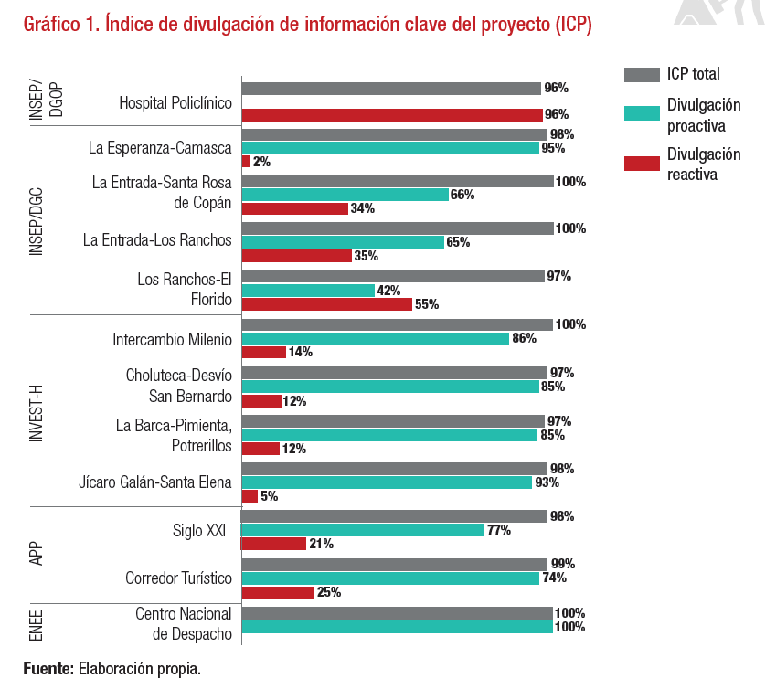

Figure 10: Proactive,Reactive and Total Disclosure infographics

(Honduras 2019)

## 3. Infographics that analyze trends in Reactive disclosure percentages and duration of response from the procuring entity

Figure 11: Duration of the response from PE in

Reactive Disclosure (Costa Rica 2019)

Figure 12: Infographic that clearly shows the average

(Thailand 2019)

## 4. Infographics that analyze trends in Proactive Publication of data and Reactive Disclosure percentages

Figure 13: Proactive trends infographics

(Uganda 2021)

## 5. Infographics that report on cost and time overruns

Figure 14: Cost overruns per project

(Afghanistan 2018)

Figure 15: Time overruns per project

(Afghanistan 2018)

Figure 16: Time overruns per project

(Thailand 2021)

## 6. Infographics that analyze causes of time delays

Figure 17 Underlying causes of time delays

(Afghanistan 2018)

## 7. Infographics that compare time progress versus % of physical and financial progress

Figure 18 Comparing time ´progress versus Physical progress

versus financial progress payments (Honduras 2019)

## 8. Infographics that analyze the correlation between two variables

Figure 19 Mapping number of bidders versus price competition

(Thailand 2019)

## 9. Infographics that analyze some aspects of the procurement process

Figure 20 Number of bidders that were initially interested

versus the ones that participated

(Honduras 2017)

Figure 21 Analysis of tendering duration with the average clearly shown

(Thailand 2021)

Figure 22 Analysis of time span from Contract Award to Start of Construction

(Thailand 2021)

## 10. Infographics that analyze price competition

Figure 23 Analysis of Frequency and Type of modifications

(Thailand 2023)

## 11. Infographics that analyze some aspects of the procurement process

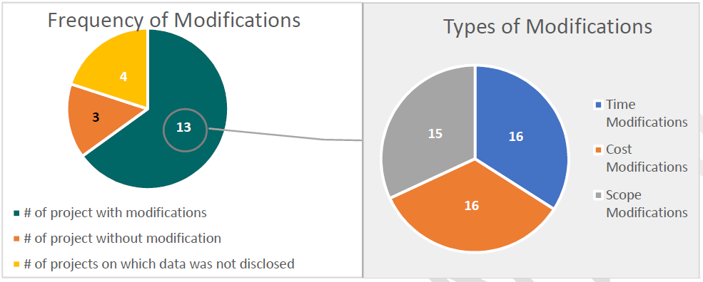

Figure 24 Analysis of Frequency and Type of modifications

(Thailand 2023)

## 12. Infographics that clearly communicate an important amount of information

Figure 25 Using infographics to present the information

summary of given project **(**Thailand 2019)