
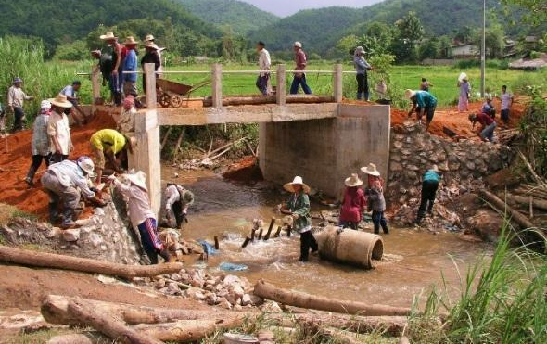




NTB – Indonesia

Infrastructure Transparency Index

2026 Report

The Infrastructure Transparency Index (ITI) is an instrument developed by CoST – the Infrastructure Transparency Initiative. It provides metrics of the levels of transparency and the quality of processes related to public infrastructure at national or sub-national levels. Applied consistently, it can be used to rank performance and monitor changes over time. Collaboratively designed and grounded in international good practice and lessons learned, its objective is to provide stakeholders with high-quality information that promotes transparency and drives improvements in the management of public infrastructure.

Research team:
Ahmad Muharror. Evaluation Coordinator. CoST
Moh. Aminullah. Evaluator. CoST
Fera F. Salsabila. Evaluator. CoST

National coordination:
Ahmad Muharror. CoST NTB Manager

International coordination:
David Zamora. International Consultant. CoST
Evelyn Hernandez. Head of Members and Affiliate Programmes. CoST

Disclaimer
This report presents the results of an evaluation of transparency in the infrastructure sector, providing information to help strengthen public institutions. Like other evaluation instruments, its impact will depend on how it is used. It is not a methodology for evaluating corruption, not an instrument of internal control, and does not assess perceptions. It does not evaluate public officials, nor does it measure the general quality of procuring entities. The evaluations and reports prepared using this methodology do not represent CoST's opinion on the administrative work of governments or procuring entities.

This work is licensed under a Creative Commons Attribution 4.0 International License.
April 2026
Table of Contents

Chapter 1 | Infrastructure Transparency Index 4
1.1 CoST Approach 4
1.1.1 About CoST NTB 5
1.2 Concept 6
1.3 Objectives 7
1.4 Principles 7
1.5 Structure and content 8
Chapter 2 | Methodology 12
2.1 Evaluation process 12
2.2 Data collection 13
2.3 Procuring entities sample 17
2.4 Infrastructure project sample 18
2.5 Interaction protocol 21
2.6 Challenges and limitations 22
Chapter 3 | Results 24
3.1 NTB ITI score 24
3.2 Procuring entities ITI score 35
3.3 Infrastructure projects score 49
Conclusions 57
Recommendations 60
Annex 1 | Evaluation instrument 62
Annex 2 | Procuring entities survey 78
Annex 3 | National ITI scores by indicator 91
Annex 4 | Procuring entities scorecards 99

Chapter 1 | Infrastructure Transparency Index
Executive Summary

The Infrastructure Transparency Index (ITI) is an instrument developed by CoST to measure the level of transparency and the quality of processes related to public infrastructure at national and sub-national levels. It provides a global standard for improving transparency, participation, and accountability, based on the CoST approach of disclosure, independent data review, multi-stakeholder collaboration, and social accountability. The final ITI score is calculated as a weighted sum of four dimensions: (1) enabling environment, (2) capacity and process, (3) citizen participation, and (4) information disclosure. West Nusa Tenggara (NTB) is among the provinces in Indonesia that has implemented this approach.

The methodology varies by dimension. Dimensions 1 (enabling environment) and 4 (information disclosure) are assessed through desk research, with each requiring at least two evaluators who independently conduct assessments and use supporting evidence to minimise bias. Dimensions 2 (capacity and process) and 3 (citizen participation) are evaluated through a survey administered once to an officer or group of officers in each Procuring Entity (PE), using self-assessment or interviews.

The findings show that NTB has a moderate level of infrastructure transparency, with a sub-national ITI score of 40.16, slightly below the international average of 42.73, indicating that foundational frameworks are in place but not yet fully translated into consistent outcomes. Performance is uneven, with stronger results in the enabling environment (56.60) and moderate institutional capacity (48.30), but weaker in citizen participation (31.61) and information disclosure (29.83), with practices remaining fragmented. The average PE score of 36.74, with a wide gap between the highest (57.02) and the lowest (18.65), highlights significant institutional disparities. In contrast, project scores show less variation (40.70–24.10), suggesting the influence of standardised procedures. Budget size has minimal impact on performance, and variations persist across sectors and institution types. The lack of an integrated transparency portal and dedicated staff further constrains progress, indicating that while minimum standards exist, stronger and more consistent institutional implementation is needed to reduce disparities and improve overall transparency.

Based on the ITI findings, which show a relatively strong enabling environment but weaker performance in citizen participation and information disclosure, Nusa Tenggara Barat (NTB) should prioritise establishing a Governor Regulation that mandates comprehensive, standards-aligned infrastructure data publication across the full project lifecycle through a centralised platform like INTRAS, with clear institutional responsibilities. Strengthening the capacity of Information Officers, institutionalising public consultations, and ensuring their participation in forums such as Musrenbang are essential to improve documentation and engagement. The INTRAS platform should be expanded and regularly updated, supported by automated systems, while a review of bureaucratic processes can address barriers to transparency. Efforts should also promote public awareness and expand data disclosure across all project stages, including supervision and monitoring, alongside institutionalising the biennial ITI to track and sustain progress.

1.1 CoST Approach
CoST –the Infrastructure Transparency Initiative has developed an approach that is flexible to suit the context and aims to complement and add value to recognised good practice. It provides a global standard for improving infrastructure transparency, participation, and accountability, based on CoST's four pillars: data publication, independent data review, multi-stakeholder working, and social accountability.
- Publication of Data from infrastructure projects. Sixty-seven data points are disclosed by procuring entities at key stages throughout the project cycle, in keeping with the CoST Infrastructure Data Standard (CoST IDS) and, increasingly, the Open Contracting for Infrastructure Data Standard (OC4IDS) format.
- Independent data review that highlights the accuracy and completeness of the disclosed data and turns it into compelling information that helps communicate issues of concern and areas of good practice.
- Multi-stakeholder working brings together government, the private sector and civil society in a concerted effort to pursue the common goal of improving transparency, accountability and ultimately performance in the preparation for and provision of public infrastructure. This is typically achieved through a multi-stakeholder group where each stakeholder has an equal voice in leading a CoST programme.
- Social accountability refers to efforts made to ensure that the disclosed data and assurance reports are taken up and used by stakeholders – including civil society, the private sector and government oversight bodies – to strengthen existing accountability mechanisms and prompt appropriate correction action, not only in relation to specific projects but also more broadly in the sector.

1.1.1 About CoST NTB
West Nusa Tenggara Province (NTB) joined CoST in early 2024, becoming one of the sub-national programmes committed to strengthening transparency, accountability, and participation in public infrastructure governance. The initiative was introduced as part of the province’s broader effort to improve infrastructure management practices and align them with international transparency standards promoted by CoST.
Following its participation in the CoST programme, the Provincial Government took several preparatory steps to support the implementation of the initiative. These included the issuance of a provincial decree to support the disclosure of infrastructure data, the development of the INTRAS platform to facilitate the publication of infrastructure data, and a series of capacity-building activities to strengthen understanding of the CoST Infrastructure Data Standard (CoST IDS) among relevant stakeholders.
The CoST NTB programme is guided by a Multi-Stakeholder Group (MSG) composed of representatives from the provincial government, civil society organisations, and the private sector. The MSG serves as the main coordination and decision-making platform for the programme, ensuring that transparency initiatives are implemented collaboratively and that different stakeholder perspectives are considered.
As part of the programme’s early implementation phase, NTB also conducted data publication exercises and participated in technical workshops and training sessions facilitated by CoST International. These activities supported the preparation and implementation of the Infrastructure Transparency Index (ITI) assessment, conducted between 2025 and 2026 to evaluate the province’s performance in infrastructure transparency, participation, and accountability.

1.2 Concept
CoST − the Infrastructure Transparency Initiative - works with government, the private sector and civil society to improve transparency, participation and accountability in public infrastructure investment. It achieves this by publishing, validating and using infrastructure data at each stage of the infrastructure project cycle. CoST’s experience indicates that this provides the evidence and process to drive reforms that reduce mismanagement, inefficiency, and corruption, thereby improving sector performance. Applying this approach results in cost savings, helping to close the infrastructure financing gap. It also helps deliver better quality infrastructure for millions of people.
CoST has developed the Infrastructure Transparency Index (ITI) to evaluate and monitor over time levels of infrastructure transparency and the quality of the associated processes that improve participation and accountability. It helps stakeholders from government, the private sector and civil society understand the relative strengths and weaknesses of transparency, participation and accountability mechanisms within the sector. As set out in this manual, the ITI instrument is used to derive the metric and has been designed collaboratively, based on international good practice and lessons learned.
This manual provides a methodology for calculating an ITI score for evaluated procuring entities, whether in a national or sub-national context. The individual scores are then used to rank the evaluated procuring entities. ITI scores are based on a combination of the enabling conditions for strengthening transparency in the sector and the transparency-related practices applied to recently completed infrastructure projects (see Annex 6 for ITI terminology). In its design, the manual interprets transparency in a broad and practical sense, not only by looking at it through the traditional lens of access to information, but also by considering associated enablers and capacities. These include citizen participation that creates public value through access to information.
The final ITI score (whether a national ITI score or a sub-National ITI score) is obtained from the weighted sum of four constituent ITI dimensions, namely:
- enabling environment;
- capacities and processes;
- citizen participation; and
- information disclosure.
Although the ITI was designed to help CoST members evaluate and strengthen their programmes, other interested parties can also use it to understand better and, hence, strengthen their institutions.

1.3 Objectives
The ITI aims to enable the level of transparency and accountability in public infrastructure to be assessed and monitored over time. The objectives are as follows:
- To provide a measure of the state of infrastructure transparency and the capacity to improve transparency among procuring entities.
- To track and encourage progress and facilitate peer learning, while helping to hold procuring entities to account.
- To raise awareness of transparency at the national and international level, building on existing data standards such as the CoST IDS and the OC4IDS.
- To allow consistent country comparisons at the international level to facilitate peer learning and the identification of common international strengths and weaknesses.
The ITI calculates a score on a scale of zero to one hundred (0-100) for a country’s national or sub-national public infrastructure, as well as individual Procuring Entity (PE) ITI scores for evaluated PEs. The scores are based on a large number of unique indicators. These are independently evaluated to assess PE practices and the conditions that promote transparency and accountability in the local infrastructure sector.
The score is then published as an index ranking procuring entities. The resulting highlighting and identification of shortcomings in existing practice can inform the development of an action plan to raise transparency and accountability standards within the country or sector and improve ongoing infrastructure management practices.
The ITI results provide information that can guide public leaders, international organisations, procurement entities, and others interested in strengthening infrastructure-related transparency and accountability. Follow-up ITI assessments should take place periodically and consistently, while allowing time for reforms to be introduced and take effect between evaluations.

1.4 Principles
The design and development of the ITI is based on the following principles:
- Relevance: it provides information on the state of the regulatory framework, the institutional capacity and the publication of information that relates to potential improvements in the management and implementation of infrastructure projects.
- Comprehensiveness: it uses a comprehensive set of indicators to provide a broad assessment of the sector and a detailed evaluation of a procuring entity.
- Simplicity, replicability and trustworthiness: the data collection and processing methods are simple; any person replicating the ITI methodology should be able to obtain the same results, so the results are easy to understand and can be used by different stakeholders.
- Objectivity: the methodology includes specific procedures designed to reduce subjectivity in data collection to ensure the reliability of the overall study.
Further principles are that the ITI implementation should be:
- Impartial: the coordination of the ITI methodology and its implementation is carried out by an independent third party with relevant expertise.
- Periodic: the evaluation is carried out regularly (every two years is recommended) to allow time between evaluations to improve transparency, accountability and management of infrastructure delivery.
- Accurate: the indicator scores are determined using primary sources of information stemming from national websites and surveys of key public officials.
- Specific: the score for each indicator is determined using a single piece of information. The same information is not reused to determine the score of other indicators.
- Informative: the results provide a snapshot of the procuring entities assessed, which provides a broader picture of the national or sub-national situation.
- Evolving: each ITI implementation includes for evaluation the procuring entities that have developed the most significant infrastructure projects during the study period, representing a degree of updating of the selected procuring entities from one ITI edition to another, to reflect the national or sub-national changes. In addition, in countries with many procuring entities, the number of entities assessed is expected to increase over time to provide a more complete representation of the national or sub-national context.
- Constructive: the ITI can help stakeholders work together to compare levels of transparency across procuring entities and countries, while monitoring how these change over time.
As with any other evaluation tool, the impact of an ITI evaluation depends on the extent to which its results are used by those responsible for decision-making.

1.5 Structure and content
The Infrastructure Transparency Index draws on four building blocks known as dimensions, namely:
- Enabling environment
- Capacities and processes
- Citizen participation
- Information disclosure.
The first dimension evaluates the national or sub-national context with its legal framework. The other three evaluate the capacities and transparency outcomes at the procuring entity level. Together, the four dimensions align with empirical studies showing that the quality of procurement outcomes depends on both the regulatory framework and institutional capacities.
Each of the four dimensions is divided into a series of components to enable comprehensive evaluation. The result is a four-level hierarchy: the dimensions are determined by variables, which are in turn shaped by sub-variables, which are derived from indicators (see Figure 1).
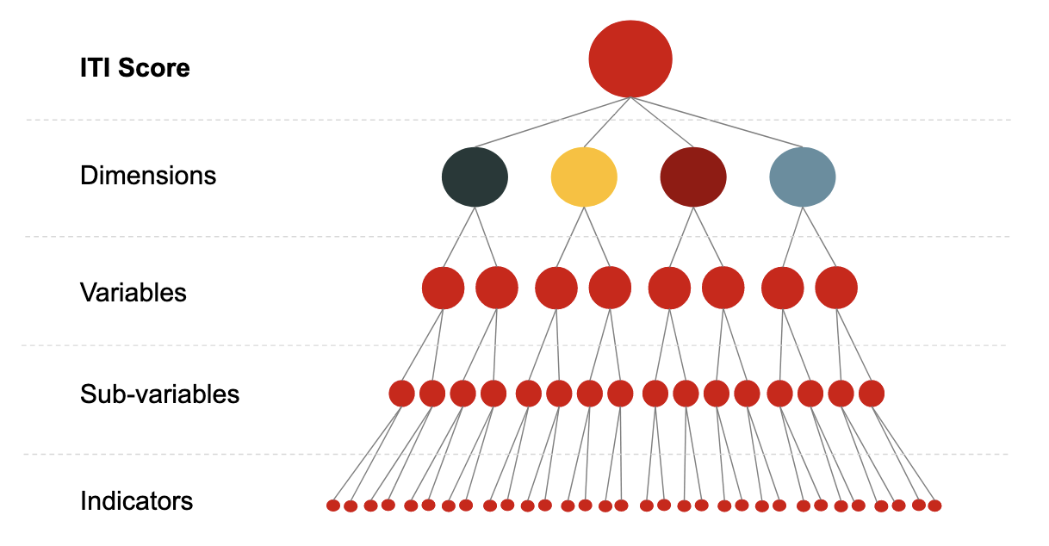
Figure 1. ITI hierarchy example
All indicators are evaluated and scored individually. A set of weighted indicator scores then gives a sub-variable score; a set of weighted sub-variable scores gives a variable score; and a set of weighted variable scores gives a dimension score. A national or sub-national ITI score is finally obtained from the weighted sum of the four-dimensional scores.

Dimensions
Dimension 1: Enabling environment
Dimension 1 assesses national or sub-national conditions that enable transparency in the infrastructure sector, considering the regulatory framework and centralised digital tools. It has one variable, three sub-variables and 12 indicators. The complete list of indicators is provided in Annex 1. The variable and sub-variables of the dimension are:
- Legal framework and digital tools
  - Regulatory framework for public access to information
  - Transparency standards in the public infrastructure sector
  - National digital information tools.
All indicators of this dimension apply at the national or sub-national level and are measured once at the country or local level, irrespective of the number of procuring entities selected for evaluation. Its results provide feedback to strengthen the national or sub-national environment, not processes within institutions. The score for the dimension is obtained by weighting the underlying indicators.
The indicators in this dimension are evaluated using information typically available from online sources, such as websites containing national regulatory frameworks and sector-related information, particularly those focused on transparency, public procurement, public infrastructure, and public finances.
Dimension 2: Capacities and processes
Dimension 2 assesses the soundness of procuring entities’ procedures and capabilities for disclosing data and information. It has two variables, five sub-variables and 25 indicators. The complete list of indicators is provided in Annex 1. The variables and sub-variables of the dimension are:
- Institutional capacities
  - Basic knowledge
  - Digital capacities
- Institutional processes
  - Procedures to disclose information
  - Enablers and barriers to the disclosure of information
  - Control over infrastructure projects disclosure.
All the indicators of this dimension evaluate procuring entities, not national or sub-national conditions. The indicators are evaluated once for each of “n_{e}'' selected procuring entities. The dimension results offer feedback to strengthen capacities and processes at the PE level. The dimension score is obtained by weighting the underlying indicators for each PE.
The data required to evaluate the indicators for this dimension are captured through a survey conducted by a selected government officer or a group of officers at each procuring entity, either via self-assessment or interview.
Dimension 3: Citizen participation
Dimension 3 evaluates the opportunities provided by PEs for citizen participation and how citizens can use the disclosed public information. It has one variable, two sub-variables and 12 indicators. The complete list of indicators is provided in Annex 1. The variable and sub-variables of the dimension are:
- Participation practices
  - Participation opportunities
  - Use of information by citizens.
All the indicators of this dimension evaluate PEs. The indicators are evaluated once for each of “n_{e}” selected PEs. The results from this dimension provide feedback to strengthen a PE's citizen participation practices. The score for this dimension is obtained by summing the weighted values of the underlying indicators for each PE.
The data required to evaluate the indicators from this dimension are captured by a survey (the same as for dimension 2) that must be undertaken by a selected government officer or a group of officers at each PE through either self-assessment or interview.
Dimension 4: Information disclosure
Dimension 4 assesses the extent to which project data and information are published by the PEs, in accordance with the CoST Infrastructure Data Standard (IDS) or the Open Contracting for Infrastructure Data Standard (OC4IDS). It has one variable, six sub-variables and 44 indicators. The complete list of indicators is provided in Annex 1. The variable and sub-variables of the dimension are:
- Disclosure practices
  - Project identification
  - Project preparation
  - Construction contract procurement
  - Supervision contract procurement
  - Construction contract implementation
  - Supervision contract implementation
All indicators of this dimension evaluate “n_{p}” infrastructure projects developed by each of “n_{e}” PEs. The dimension results offer feedback to the selected PEs to strengthen their information disclosure. The overall score for the dimension is obtained by averaging the weighted sum of the underlying indicators for each of the “n_{p}” projects.
The indices in this dimension are evaluated using information typically available from online sources, such as websites containing data on public infrastructure projects, public procurement, and other websites providing information related to these evaluation objects.
Table 1 below summarises the evaluation and the data collection methods adopted for each of the four dimensions.
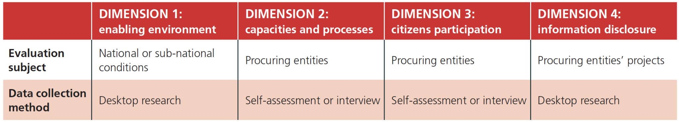
Table 1. Summary of what is being evaluated and the data collection methods adopted for each ITI dimension

Chapter 2 | Methodology

2.1 Evaluation process
Each of the four ITI dimensions has its own evaluation process, as follows.
Dimension 1: Enabling environment
Dimension 1 assessed the national conditions that enable transparency in the infrastructure sector. Its indicators were determined through desktop research. Each indicator required input from at least two evaluators, who independently conducted an initial evaluation with supporting evidence to avoid bias.
If the results from both evaluators for each indicator were the same, then the results were considered final. If there was a difference between them, a third evaluator resolved it. This third evaluation coincided with one of the first two and was considered the final score.
The quality of the collected data in dimension 1 was ensured by this approach, which ensured that two different evaluators independently obtained the same observation.
Dimension 2: Capacities and processes
Dimension 2 assessed the soundness of a PE's procedures and capacities to publish data and information. Its indicators were evaluated through a survey that was completed once by an officer or group of officers at each PE. The ITI looked for people familiar with the principles of transparency, accountability, open data, citizen participation, collaboration, and innovation.
The quality of the survey data was verified by triangulating the results with other sources of information. These include the following.
- Endorsement: Each officer who completed the survey endorsed the responses that they provided. Through the exchange of formal communications, this officer was also officially named by the PE to provide the information required by the ITI.
- Evidence that validates the assigned scores: Along with the survey responses, the officer also provided evidence (such as explanations, documents, websites, notice boards and newspapers) to validate their response to each question of the survey. The evaluation team reviewed this information. If the information did not match the score assigned by the officer, the evaluation team either went back to the officer to request more information and/or adjusted the score based on the evidence provided.

Dimension 3: Citizen participation
Dimension 3 assessed both the opportunities provided by PEs for citizen participation and citizens' use of published public information. Its indicators are evaluated through the same survey completed by the officer or group of officers for each PE.
The survey was undertaken either through self-assessment or interview.
Dimension 4: Information publication
Dimension 4 assessed the scope, quantity, and quality of data and information published by the selected PEs in accordance with the CoST Infrastructure Data Standard or the OC4IDS. Its indicators are evaluated through desktop research. These indicators require two or three evaluators, as in Dimension 1. Assessments of the quality of the collected data were derived using the same method, in which a single observation is obtained through independent evaluations by two different people.

2.2 Data collection
Desktop research
The evaluation of Dimension 1 involved searching/browsing official government websites using a computer network. Indicators for each variable and sub-variable were linked if it could be demonstrated that we have regulations and policies supporting the publication of public information.
In Dimension 4, the survey collected project data from 2022 to 2025 via the official website of the West Nusa Tenggara Provincial Government, known as LPSE (Electronic Procurement Services). Sampling was conducted from the collected data. One, two or three projects were sampled from each agency during the period. The first project was selected from the project with the highest contract value, followed by random sampling of the second or third projects. The number of projects per entity depended on the number of advanced infrastructure projects each entity had during the study period.
Projects one, two, or three were evaluated by examining indicators for predetermined variables. Project data was checked on the official website, specifically the LPSE page of the West Nusa Tenggara Provincial Government.
Several websites were used as data sources for the computer-based research, including:
- LPSE of West Nusa Tenggara Province. https://spse.inaproc.id/ntbprov/
The West Nusa Tenggara Province Electronic Procurement Service System (LPSE) is a government procurement system for goods/services in West Nusa Tenggara Province that is implemented electronically. This LPSE system aims to improve efficiency, effectiveness, quality, and transparency in the procurement of goods and services.
- https://peraturan.go.id/
The website of the Directorate General of Legislation features a Database of Legislation that includes information on types, statuses, relationships between regulations, and legislative statistics.
- https://intras.ntbprov.go.id/
The INTRAS (Infrastructure Transparency System) is a digital platform developed by the Government of West Nusa Tenggara Province to provide the public with access to information on infrastructure projects. It supports transparency by publishing project data across key stages of the project cycle, in line with the CoST IDS and the OC4IDS. The INTRAs were under redevelopment during the ITI assessment period and, therefore, could not be used for the ITI. However, observations were made on the platform regarding insufficient data, with more detailed data being published at the procurement stage, and less across other project phases.

Procuring entity survey
The survey began with training for officers from each agency who had been appointed by their leaders to participate in the ITI training/socialisation. The survey was then conducted by distributing self-assessment forms within a specified timeframe. Each officer in each agency was provided with the contact details of an ITI researcher. Officers at each agency could contact the researchers if they had any questions or if anything was unclear. For more details on the survey stages, see the following section.
- The CoST NTB Secretariat sent letters to all relevant agencies to appoint officers from each agency to complete the survey forms, which were distributed by the NTB ITI team secretariat.
- The agencies responded by sending the names of officers assigned to assist with completing the survey forms. The forms provided are for dimensions two and three and had to be completed by the designated personnel.
- The officers appointed by each agency answered all questions on the distributed forms. Questions were answered based on the current situation at the relevant agency.
- The ITI evaluation team communicated that if officers encountered difficulties completing the survey, they could directly contact and discuss the matter with the researchers assigned to each agency.
- The officers responsible at each agency office were given two weeks to answer and complete the survey.
- If the survey forms were not yet collected by the agreed time, the ITI team visited the officers at their offices to inquire about the issues.
- If the officers appointed by the agency were still unable to complete this, the ITI researchers directly assisted the officers in completing the existing forms through discussions and interviews.
- After the data was collected, the researchers analysed the data for each relevant agency.
No | Name and Contact Person | Position | Procurement Entity
1. | Septyan Nugraha, S.Pi | Fungsional Pengelola Kesehatan Ikan Ahli Pratama | Dinas Kelautan dan Perikanan Prov. NTB
2. | Putra Daironi, A.Md. | Fungsional Pranat Komputer Terampil | Dinas Koperasi dan Usaha Kecil Menengah Prov. NTB
3. | Normaya Saripurti, S.T. | Staff Bidang Cipta Karya | Dinas Pekerjaan Umum dan Penataan Ruang - Cipta Karya
4. | Agus Sukmayadi | Plt. Sekretaris Dinas | Dinas Pemuda dan Olahraga
5. | I Ng Muditha | Pelaksana/ Pengurus Barang | Dinas Pendidikan dan Kebudayaan Prov. NTB
6. | Sandra Khaldun, S.STP., M.M. | Perencana Ahli Muda | Dinas Perpustakaan dan Kearsipan Prov. NTB
7. | Resya Futri Hadi Febryana | Pranata Komputer Ahli Pertama | Dinas Lingkungan Hidup dan Kehutanan Prov. NTB
8. | Surya Setiawan | JF Adyatama KPEariwisataan dan Ekonomi Kreatif | Dinas Pariwisata Provinsi Nusa Tenggara Barat.
9. | Ni Luh Putri Utami, S.T., M.T., M.Sc. | Penata Kelola Jalan dan Jembatan Ahli Madya | Dinas Pekerjaan Umum dan Penataan Ruang - Bina Marga
10. | Mohamad Jamaludin | Staff | Dinas Perindustrian Provinsi NTB
11. | Achmad Arief | Staf PPID | Dinas Pertanian dan Perkebunan
12. | Kamardy Arief, A.Md. | Pengurus Barang | Rumah Sakit H.L. Manambai Abdul Kadir
13 | Poppy Pujawati | Kasubag Umum dan Kepegaiawaian | Badan Pengelolaan Pendapatan Daerah Prov. Nusa Tenggara Barat.
14. | Andika Zuhdi Ramdani, S.T. | JFT Ahli Pertama Teknik Pengairan | Dinas Pekerjaan Umum dan Penataan Ruang Bidang Sumber Daya Air
15. | Wahyudin Hariyadi | Staf PPID | Dinas Perumahan dan Pemukiman
16 | Firman Hermawan | JF Pembina Jasa Konstruksi | Rumah Sakit Umum Daerah Prov. NTB
18. | Arif Rahman, SH | Analis Hukum Ahli Pertama | Rumah Sakit Mandalika
17. | Novita Veranita | Kasubag Umpeg dan RT | Rumah Sakit Jiwa Mutiara Sukma Mataram
19. | Wandi, SIP | Staf | Sekretariat DPRD Prov. Nusa Tenggara Barat
Table 2. List of officials assigned officers at each entity

Data collection period
The survey data collection period for relevant agencies was:
- Survey form distribution : November 12, 2025
- Survey form submission deadline: December 31, 2025
- Survey results evaluation : January 1-14, 2025

The surveys for dimensions 2 and 3 captured each entity's current situation on the associated indicators. And the projects evaluated were contracted and completed during the 2022-2025 period.

2.3 Procuring entities sample
Procurement entities participating in the ITI were all agencies in West Nusa Tenggara Province that had infrastructure projects contracted during the period 2022-2025. For more details on the agencies participating in the ITI, see the following table.

No. | Procurement Entity Name
1. | Dinas Kelautan dan Perikanan Provinsi Nusa Tenggara Barat
2. | Dinas Koperasi Usaha Kecil dan Menengah Provinsi Nusa Tenggara Barat
3. | Dinas Pekerjaan Umum dan Penataan Ruang - Cipta Karya
4. | Dinas Pemuda Dan Olahraga Provinsi Nusa Tenggara Barat
5. | Dinas Pendidikan dan Kebudayaan Provinsi Nusa Tenggara Barat
6. | Dinas Perpustakaan dan Kearsipan
7. | Dinas Lingkungan Hidup dan Kehutanan Provinsi Nusa Tenggara Barat
8. | Dinas Pariwisata Provinsi Nusa Tenggara Barat
9. | Dinas Pekerjaan Umum dan Penataan Ruang (Bidang Bina Marga)
10. | Dinas Perindustrian Provinsi Nusa Tenggara Barat
11. | Dinas Pertanian dan Perkebunan Provinsi Nusa Tenggara Barat
12. | Rumah Sakit H.L. Manambai Abdul Kadir
13. | Badan Pengelolaan Pendapatan Daerah Provinsi Nusa Tenggara Barat
14. | Dinas Pekerjaan Umum dan Penataan Ruang (Bidang Sumber Daya Air)
15. | Dinas Perumahan Dan Pemukiman Provinsi Nusa Tenggara Barat
16. | Rumah Sakit Umum Daerah Provinsi Nusa Tenggara Barat
17. | Rumah Sakit Jiwa Mutiara Sukma Provinsi NTB
18. | Rumah Sakit Mandalika
19. | Sekrektariat Dewan Perwakilan Rakyat Daerah Prov. NTB
Table 3. List of ITI Procurement Entities 2025
The project selection process included:
- Record all project work for the 2022-2025 period.
- Collect project data for each agency/agency.
- Sort from highest to lowest project value for each agency/agency.
- Select one, two or three projects by entity according to how many projects were available.
- The first project was the one with the highest contract value, and the second and third projects were randomly selected.
- Conduct an evaluation according to the ITI indicators.
The criteria used considered Agencies that undertake infrastructure development projects funded by the West Nusa Tenggara Provincial Budget (APBD).
Data used:
- Infrastructure project value.
- Budgeting source data must have been sourced from the West Nusa Tenggara Provincial APBD.
- Project implementation is in West Nusa Tenggara.
- The project sector is public infrastructure development.

2.4 Infrastructure project sample
A sample of 1, 2, or 3 projects was selected for each Procurement Entity (PE), depending on the number of projects managed. The steps taken included:
- Data Collection.
Infrastructure project data was collected from several sources, including regionally owned enterprises (BUMD) in West Nusa Tenggara Province. Data was obtained from the LPSE (State-Owned Enterprises) (LPSE), which contains details such as name, type, sector, budget, implementation year, and funding source.
- Project Classification.
Projects were classified by sector (e.g., roads, buildings, water supply systems, irrigation networks, etc.) and by project budget.
- Project Selection.
One, two or three different projects were selected from each entity. The first selection was made for the highest-scoring projects, followed by random selection, with projects previously evaluated being eliminated.
The criteria for selecting infrastructure project samples included classification by Managing Entity (ME) and Budget Amount. Projects were selected to represent PEs at the provincial level, ensuring comprehensive coverage.
The data used for project selection includes information from the project database, project implementation stages, contract data, project name, budget, project sector, and implementation year.
It should be noted that the initial plan was to review 100 projects, but following the ITI evaluators' training in Lombok, and using the filtering methodology, targeting projects and entities from NTB between the period 2022 to 2025, a total of 19 entities and 32 projects were filtered that qualified to participate in the ITI. NTB has more than 30 entities, but not all of them have projects that fell within the period selected for the review.
The infrastructure project period was from 2022 to 2025 and represented only completed projects. A list of infrastructure project names, managing agencies, and budget amounts is presented in Table 4.

No | Project Name | Procurement Entity | Years | Budget
1. | Perpanjangan Dermaga dan Fasilitas Pendukungnya Pelabuhan Perikanan Pantai Labuhan Lombok (DAK) | Dinas Kelautan dan Perikanan | 2023 | 8.032.879.000
2. | Pengerukan Kolam Pelabuhan PP Sape | Dinas Kelautan dan Perikanan | 2024 | 2.900.000.000
3. | Revitalisasi Gedung Pusat Layanan Usaha Terpadu (PLUT) | Dinas Koperasi Usaha Kecil dan Menengah | 2024 | 3.600.000.000
4. | Bangunan Gedung PLUT KUKM Provinsi NTB | Dinas Koperasi Usaha Kecil dan Menengah | 2025 | 434.912.000
5. | Renovasi Gedung Kantor Gubernur Provinsi NTB | Dinas Pekerjaan Umum dan Penataan Ruang (Bidang Cipta Karya) | 2024 | 35.500.000.000
6. | Pembangunan Mako Brimob Kompi Lobar | Dinas Pekerjaan Umum dan Penataan Ruang (Bidang Cipta Karya) | 2022 | 3.000.000.000
7. | Rehabilitasi Masjid Raya At-Taqwa | Dinas Pekerjaan Umum dan Penataan Ruang (Bidang Cipta Karya) | 2024 | 1.500.000.000
8. | Pembangunan Lapangan Bulu Tangkis Yayasan Permata Hati Islamic School | Dinas Pemuda dan Olahraga | 2024 | 900.000.000
9. | Pembangunan Lapangan Futsal (Desa Bengkel) | Dinas Pemuda dan Olahraga | 2022 | 680.065.261
10. | Belanja Modal Pembangunan Unit Sekolah Baru (USB) SLBN 3 Mataram | Dinas Pendidikan dan Kebudayaan | 2023 | 8.051.901.000
11. | Pembangunan Gedung Perpustakaan | Dinas Perpustakaan dan Kearsipan | 2022 | 14.163.826.000
12. | Pengadaan Gedung Kantor BKPH Brang Rea Puncak Ngengas | Dinas Lingkungan Hidup dan Kehutanan | 2022 | 447.629.000
13. | Pembangunan Pasar Seni Senggigi | Dinas Pariwisata | 2024 | 2.300.000.000
14. | Paket 9: Pal IV - Lenangguar - Batu Rotok | Dinas Pekerjaan Umum dan Penataan Ruang (Bidang Bina Marga) | 2022s | 93.510.999.000
15. | Rekonstruksi Ruas Jalan Tanjung Geres - Pohgading - Pringgabaya | Dinas Pekerjaan Umum dan Penataan Ruang (Bidang Bina Marga) | 2025 | 26.964.918.389
16. | Penanganan Long Segment Ruas Jalan Rembiga - Pemenang | Dinas Pekerjaan Umum dan Penataan Ruang (Bidang Bina Marga) | 2024 | 11.800.000.000
17. | Revitalisasi Rumah Produksi Balai Kemasan | Dinas Perindustrian | 2024 | 5.700.000.000
18. | Pembangunan Ruang Produksi (Gudang) Tembakau | Dinas Perindustrian | 2022 | 400.658.000
19. | Pembangunan Kawasan Industri Hasil Tembakau (KIHT) | Dinas Pertanian dan Perkebunan Prov. NTB | 2022 | 24.756.228.000
20. | Pembangunan Laboratorium Agens Hayati | Dinas Pertanian dan Perkebunan Prov. NTB | 2023 | 1.851.727.000
21. | Pembangunan Gedung Perawatan TB dan Paru | Rumah Sakit H. L. Manambai Abdul Kadir | 2025 | 5.400.000.000
22. | Pembangunan Gedung Stroke Center | Rumah Sakit H. L. Manambai Abdul Kadir | 2024 | 1.700.000.000
23. | Bangunan Gedung Kantor (Pembangunan Kantor Samsat Praya) | Badan Pengelolaan Pendapatan Daerah Prov. NTB | 2025 | 6.204.682.000
24. | Rehabilitasi Jaringan Irigasi D.I. Daha I, II | Dinas Pekerjaan Umum dan Penataan Ruang (Bidang Sumber Daya Air) | 2023 | 11.385.000.000
25. | Rehabilitasi Jaringan Irigasi D,I, Rutus (Pulau Lombok) |  | 2024 | 5.300.000.000
26. | Pembangunan Jaringan Distribusi SPAM SkPEer Kabupaten Lombok Utara |  | 2025 | 3.985.000.000
27. | Paket 72.330 PPSU Kebon Kongok Kec. Gerung Kab. Lombok Barat | Dinas Perumahan dan Permukiman | 2025 | 688.150.000
28. | Pembangunan Lanjutan Gedung IGD Covid-19 & Trauma Center RSUD NTB | RSUD NTB | 2022 | 77.774.382.000
29. | Bangunan Baru Gedung Rehab Napza Sarana RS | Rumah Sakit Jiwa Mutiara Sukma Provinsi | 2025 | 12.697.561.000
30. | Pembangunan Gedung Rawat Inap | Rumah Sakit Mandalika | 2024 | 12.000.000.000
31. | Finishing Ruang Rawat Inap RS Mandalika | Rumah Sakit Mandalika | 2022 | 3.457.373.440
32. | Belanja Modal Bangunan Gedung Kantor - Renovasi Ruang Komisi | Sekretariat Dewan Perwakilan Rakyat Daerah | 2025 | 905.762.000
Total Budget |  |  | Rp. 387.993.653.090
Table 4. List of Infrastructure projects evaluated by PE for 2022-2025

2.5 Interaction protocol
The following were the stages and protocols for interaction with the Procurement Entities at each stage of the evaluation process:
- In the evaluation process, interaction with the PEs began by sending an official invitation to participate in the ITI survey and assigning the responsible officer in each agency/department. This survey covers dimensions 2 and 3, including questions on officer capacity, public participation, information transparency, and the processes involved in the infrastructure project.
- The process continued with a reminder sent to PEs who did not respond to the invitation within one week of the survey.
- Where the PE responded to the invitation, they were given a survey form and were asked to complete it according to the provided guidelines within one week.
- And in instances where the PE experienced a delay or did not respond within the specified time limit, the next step was sending a reminder letter and making further communication efforts to facilitate participation.
PEs Who Did Not Complete the ITI Survey:
Although efforts were made to invite and engage PEs, at times they were unable or unwilling to complete the ITI survey.
The nonresponsive PEs were engaged through the following process:
- In cases of late or unresponsive PEs, additional communication efforts were made to facilitate participation. This included sending further reminder letters, emails, WhatsApp messages, or phone calls where the PE's contact information was available.
- Throughout the communication process, the importance of their participation in the evaluation was emphasised to increase transparency in the infrastructure sector.
- A final warning was given via an official letter from the West Nusa Tenggara Province FLLAJ, acting as the CoST Host institution and Chair for West Nusa Tenggara.
- Positively, after these efforts, all PEs successfully completed the survey.

2.6 Challenges and limitations
Some of the challenges and limitations faced during the survey include the following:
- Selecting PEs:
One of the criteria for selecting PEs is the availability of data. There are several variations related to this data. Almost all existing PEs have data related to the infrastructure projects they manage. However, this data is not fully entered or uploaded to the available websites. Almost all entities do not include complete data on their websites. Some do not even include the data required by the ITI. This is one of the main challenges in PE selection: limited available data. Some PEs may not have complete or up-to-date data, preventing researchers from conducting a more comprehensive evaluation.
- Infrastructure Projects:
The availability of data also hampers the selection of infrastructure projects for sampling. This situation results in the selection of relevant infrastructure projects that do not support optimal evaluations of transparency. Infrastructure projects selected as samples are based solely on available data (incomplete, and some data is inaccessible).
- PE Support:
Policymakers in several PEs, including those at lower levels, lacked sufficient understanding of the objectives of the evaluation/survey. This resulted from changes in Department/Division Heads within the provincial government that occurred over a short period. Some of these changes occurred during the study. One effect was that the appointment of officers responsible for the study within that office was also hampered. While workshops and similar activities were held prior to the study, some officers had already changed during the study. Several offices appointed new staff to be responsible for the study, who had limited knowledge about the ITI and CoST. This required researchers to set aside time to meet, discuss, and re-explain the survey to be conducted, especially with the PE policyholders. Full support would have been provided if the policyholders had a comprehensive understanding of the survey.
- Determining Responsible Officers in Each Agency
Determining responsible officers in each agency presents significant challenges. Some agencies/agencies even replaced their officers after the survey had been running for some time. Some selected officers were inappropriate and lacked a thorough understanding of the survey. Some selected officers who did not attend the previous ITI training/socialisation. However, these challenges were overcome by re-explaining to the selected officers what the ITI and the survey will be, and how they will be conducted.
- Survey Completion by PEs:
Survey Complexity: ITI surveys include questions that require details or information requests for some PEs, which can slow completion. Detailed questions on the survey form often require officers to re-ask for items to be completed. In these situations, the evaluator/researcher took on the role of discussing this with the responsible officers in the agencies.
- Other specific challenges faced in implementing ITI:
Most agencies were unaware of CoST.

Chapter 3 | Results

3.1 NTB ITI score
Figure 2 presents the NTB Infrastructure Transparency Index score and the scores achieved across the four ITI dimensions.
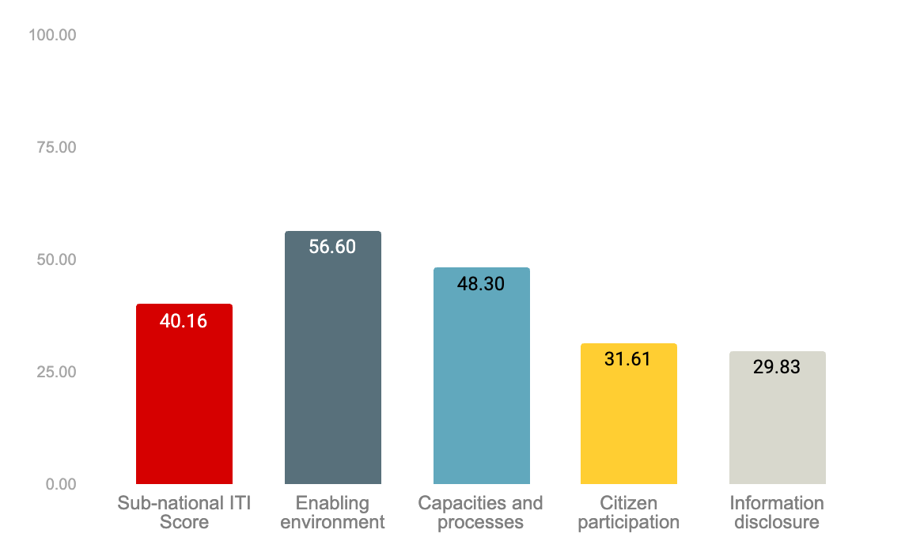
Figure 2. Sub-national ITI Score for NTB
The sub-national ITI Score for NTB is 40.16, indicating a moderate level of infrastructure transparency. This overall result reflects uneven performance across the four dimensions, with relatively stronger results in the foundational and institutional aspects and weaker outcomes in the participatory and disclosure practices.
Among the four dimensions, Enabling Environment records the highest score at 56.60. This suggests that NTB has made progress on its regulatory and institutional foundation to support transparency in the infrastructure sector. Legal frameworks, policy instruments, and centralised digital tools that enable transparency are comparatively more developed than other dimensions.
The Capacities and Processes dimension achieves a score of 48.30, indicating moderate institutional readiness among procuring entities. While basic capacities and internal processes for managing and publishing information exist, the score suggests that these practices are not yet fully standardised or consistently applied across institutions.
In contrast, Citizen Participation scores 31.61, highlighting limited opportunities for structured and meaningful public engagement in infrastructure decision-making and oversight. This result points to a relationship between information availability and its active use by citizens, as well as to limited institutional mechanisms for incorporating citizen feedback.
The lowest score is observed in Information Disclosure, at 29.83. Despite ongoing efforts to publish infrastructure data, this result indicates challenges related to data completeness, consistency, accessibility, and alignment with disclosure standards. It suggests that disclosure practices remain fragmented and have not yet reached a level that fully supports transparency and accountability.
Overall, the results indicate that while NTB has made notable progress in establishing enabling conditions and institutional capacities, further efforts are required to strengthen disclosure practices and deepen citizen participation. Addressing these gaps will be critical to improving the overall ITI performance and translating transparency commitments into tangible public value.
3.1.1 International comparison
Figure 3 compares the ITI Score of Indonesia (NTB) with the ITI scores of other international and sub-national CoST implementations.

Figure 3. ITI Score for all CoST Members
With an ITI Score of 40.16, NTB performs below the international average score of 42.73. This result places NTB among countries and sub-national entities with emerging transparency systems, where foundational elements are in place but not yet fully translated into comprehensive transparency outcomes.
Higher-performing countries such as Costa Rica (66.95), Guatemala (65.12), Ukraine (62.18), and Honduras (61.82) demonstrate the benefits of more mature transparency frameworks and sustained implementation of CoST principles over multiple years. These implementations show more balanced and consistently high performance across ITI dimensions.
NTB’s score is comparable to, though slightly above, several countries with similar levels of institutional maturity, including Ghana (35.76), El Salvador (36.77), and Uganda (32.26), and is notably higher than Malawi (25.41) and Ecuador (27.65). This suggests that NTB has achieved a moderate level of transparency relative to peers, particularly given its relatively recent engagement with the ITI process.
Overall, the comparison indicates that Indonesia (NTB) is progressing in line with international experience, while also highlighting the need to strengthen implementation depth to close the gap with higher-performing countries.
Figure 4 compares Indonesia (NTB)’s scores across the four ITI dimensions with the international average scores for each dimension.

Figure 4. Four ITI dimensions’ score for all CoST Members
In the Enabling Environment dimension, NTB achieves a score of 56.60, which is slightly below the international average of 60.56. This suggests that while NTB has established key legal, institutional, and policy foundations for transparency, further strengthening is needed to reach international benchmarks.
For Capacities and Processes, Indonesia (NTB) records a score of 48.30, which is significantly above the international average of 36.49. This indicates a relative strength in institutional capacity, internal processes, and operational readiness to support transparency in infrastructure delivery.
In contrast, Citizen Participation remains a weaker area, with a score of 31.61, marginally below the international average of 32.71. This reflects the limited institutionalisation of citizen engagement mechanisms and challenges in ensuring that public input meaningfully informs infrastructure decision-making.
The largest gap is observed in Information Disclosure, where NTB scores 29.83, substantially below the international average of 42.73. This result highlights persistent challenges related to data completeness, standardisation, accessibility, and sustainability of disclosure practices.
Taken together, the dimension-level comparison shows that NTB’s overall ITI performance is constrained primarily by weaknesses in Information Disclosure and Citizen Participation, despite comparatively strong performance in Capacities and Processes. Addressing these gaps will be critical for improving NTB’s standing relative to international peers and for advancing the impact of transparency reforms.
3.1.2 Enabling environment

Figure 5. Dimension 1 and all indicators’ scores
Based on the assessment results as shown in Figure 5, the Enabling Environment dimension records a total score of 56.60 out of 100, indicating that the regulatory and institutional foundations for infrastructure transparency in NTB are moderately well established. The results show that the basic legal framework for access to public information is clearly defined at the national level, supported by enforcement mechanisms and the availability of digital information platforms at both national and sub-national levels.
From a regulatory perspective, the right of citizens to access public information is guaranteed by a comprehensive legal framework that applies across public-sector institutions. This framework establishes clear procedures, timelines, and sanctions for non-compliance, which provides legal certainty and strengthens accountability. In addition, the existence of centralised digital information platforms contributes to improving public access to infrastructure-related information, although their scope and functionality remain uneven.
To further clarify the factors influencing this dimension, several key indicators are highlighted below.
A. Indicators with the highest scores
- Access-to-public information regulatory framework – 100 points
This indicator confirms the existence of a strong national legal framework guaranteeing public access to information held by public authorities.
- Sanctions over non-compliance with access to public information mandates – 100 points
The presence of formal sanctions demonstrates a clear commitment to enforcing transparency obligations.
- Right to request public information – 80 points
Citizens are legally entitled to request information without providing justification, with defined response timelines applicable to all public institutions.
- Easy access to information on digital information platforms – 80 points
Existing digital platforms provide relatively easy access to information, including structured and downloadable data, although not yet fully comprehensive.
B. Indicators with the lowest scores
- Infrastructure projects geographic information system (GIS) – 0 points
The absence of a GIS-based platform significantly limits spatial transparency and the public’s ability to visualise and monitor infrastructure projects geographically.
- Infrastructure data disclosure standard – 0 points
There is no formal, mandatory infrastructure data disclosure standard applicable to all procuring entities and projects.
- Infrastructure data disclosure standard requesting open data – 0 points
The lack of open data requirements reduces the usability and analytical value of published infrastructure information.
- Organisation responsible for overseeing the infrastructure data disclosure standard – 60 points
While an institutional arrangement exists, its effectiveness is constrained by the absence of a clearly mandated and enforceable disclosure standard.
The lowest-scoring indicators highlight structural weaknesses rather than regulatory intent. In particular, the absence of a GIS-based system reflects the lack of advanced digital tools needed to present infrastructure information in an accessible and user-friendly manner. Similarly, the lack of standardised infrastructure data disclosure frameworks results in fragmented, inconsistent, and difficult-to-compare information across institutions and projects.
Overall, the Enabling Environment assessment indicates that NTB has made significant progress in establishing general transparency regulations and enforcement mechanisms. However, to fully leverage this legal foundation, further efforts are required to institutionalise infrastructure-specific data disclosure standards, strengthen open data provisions, and develop advanced digital tools. Addressing these gaps would substantially enhance the effectiveness of transparency measures and support improved public oversight of infrastructure development in NTB.
3.1.3 Capacities and processes
The Capacities and Processes dimension records a total score of 48.30 out of 100, indicating a moderate level of institutional readiness to manage, disclose, and oversee infrastructure data and information. Figure 6 shows that performance across sub-variables is uneven, with relatively strong results in digital capacities and procedures for disclosing information, while weaknesses persist in control mechanisms and enablers of disclosure.

Figure 6. Dimension 2: Capacities and Processes’ Score
The strongest sub-variable is Digital capacities, which scores 68.42, reflecting the availability of basic digital infrastructure within public institutions. Indicators related to computer equipment (69.47), internet connectivity (85.26), and institutional websites (89.47) show that most entities are technically equipped to manage and publish information. Similarly, information systems for infrastructure projects (63.16) and the use of digital information systems (67.37) indicate that digital tools are already in use, although not yet fully optimised for transparency purposes.
The sub-variable Procedures to disclose information also performs relatively well, with a score of 61.68. This reflects the existence of documented procedures, designated information officers (81.05), and follow-up mechanisms for information requests (75.79). However, the effectiveness of these procedures is constrained by weaker results in the proactive publication of information (37.89) and in clearly defined responsibilities for disclosure (47.37).
In contrast, the weakest sub-variable is Enablers and barriers to disclose information, which records a low score of 28.00. This result indicates that internal policies, disclosure training programmes (9.47), and formal plans to address limitations in publishing information (9.47) are largely absent or underdeveloped. The lack of structured internal support significantly reduces the consistency and sustainability of disclosure practices.
Similarly, Control over infrastructure projects disclosure scores only 35.26, reflecting limited mechanisms for monitoring compliance with disclosure requirements. Indicators related to the level of disclosed infrastructure projects (35.79) and the share of investment represented by disclosed projects (34.74) suggest that, despite existing capacities, disclosure remains neither systematic nor comprehensive across all projects.
To further clarify the results, the following indicators stand out.
A. Indicators with the highest scores
- Institutional websites – 89.47 points
- Connectivity to the internet – 85.26 points
- Information officer profile – 81.05 points
These indicators demonstrate that institutional and technical capacities exist and provide a solid operational foundation for transparency.
B. Indicators with the lowest scores
- Disclosure training programme – 9.47 points
- Plan to mitigate limitations for publishing information – 9.47 points
- Visualisations based on infrastructure projects data – 21.05 points
The lowest-scoring indicators highlight that capacity challenges are less about hardware or access to technology, and more about institutional processes, skills development, and active use of data for transparency and public communication.
Overall, the results suggest that NTB possesses adequate technical infrastructure and basic procedures to support transparency, but lacks strong internal enablers and control mechanisms to ensure these capacities translate into consistent, comprehensive disclosure. Strengthening internal policies, training programmes, and monitoring systems will be critical to improving performance in this dimension and enhancing the effectiveness of transparency efforts in practice.
3.1.4 Citizen participation
The Citizen Participation dimension scores 31.61 out of 100, indicating that citizen engagement in public infrastructure governance remains limited in both depth and impact. While several participation mechanisms formally exist, the results suggest they are not yet effectively linked to infrastructure decision-making processes.
Figure 7 highlights a clear imbalance between the availability of participation channels and their actual use. The sub-variable Participation opportunities records a score of 40.84, reflecting the presence of basic institutional mechanisms for engagement. These include permanent participation arrangements, citizen service offices, and online consultation tools. However, more substantive forms of participation—such as citizens being directly involved in the planning, monitoring, or evaluation of infrastructure projects—remain underdeveloped.

Figure 7 Dimension 3: Citizen Participation’s Score
This limitation is further reflected in the sub-variable Use of information by citizens, which scores only 24.05. Although information related to infrastructure projects is disclosed and access-to-information requests are generally processed, there is limited evidence that citizens use this information to influence project decisions or that public institutions systematically integrate citizen feedback into infrastructure reforms.
To further clarify the results, the following indicators stand out.
A. Indicators with the highest scores
- Permanent and inclusive citizen participation – 51.58 points
- Citizen attention office – 48.42 points
- Online form for consultation or requests – 45.26 points
These results indicate that participation is largely formalised through administrative mechanisms rather than through active or deliberative engagement in infrastructure projects.
B. Indicators with the lowest scores
- Evidence of joint projects – 0.00 points
- Improvements as a response to citizen participation – 11.58 points
- Use of information by citizens – 25.26 points
The lowest-scoring indicators highlight a critical gap between participation and impact. In particular, the absence of joint projects and the limited evidence of project improvements in response to citizen input indicate that participation mechanisms have not yet been embedded in infrastructure governance processes.
Overall, the results suggest that while NTB has established basic channels for citizen participation, these mechanisms remain largely consultative and have limited influence on infrastructure planning, implementation, and oversight. Strengthening this dimension will require moving beyond formal participation toward mechanisms that ensure citizen inputs are meaningfully considered and reflected in infrastructure project outcomes.
3.1.5 Information disclosure
The Information Disclosure dimension achieves a total score of 29.83 out of 100, indicating a generally low level of transparency in the disclosure of infrastructure project information. Figure 8 presents the scores of the variables and sub-variables, showing that disclosure practices are uneven and concentrated primarily at the project identification and construction contract procurement stages, while information related to project preparation, supervision, and contracts implementation is largely missing.
At the variable level, Project Identification records a moderate score (51.27 points), reflecting relatively strong disclosure of basic project identifiers such as project reference numbers, names, locations, and ownership. Construction Contract Procurement performs better (67.75 points), driven by full disclosure of procurement processes, bidding participation, and contract values. In contrast, Project Preparation scores 29.18 points, indicating weak disclosure of preparatory documentation, while Supervision Contract Procurement, Construction Contract Implementation, and Supervision Contract Implementation all score 0.00, revealing complete transparency gaps in these areas among all evaluated PEs.

Figure 8 Dimension 4: Information Disclosure
Overall, the results suggest that information disclosure is front-loaded, focusing on early administrative and procurement requirements, but failing to extend across the full infrastructure project lifecycle. This limits the ability of citizens and oversight actors to monitor project impacts, implementation performance, and accountability.
To better understand the disclosure patterns, indicators are grouped into three performance levels: highest-score values, lowest-score values (non-zero), and null-score values.
A. Indicators with the highest scores
These indicators score 100.00 points, demonstrating strong and consistent disclosure practices.
- Project reference number
Each project is assigned a unique identifier that is publicly disclosed, allowing clear traceability across project documentation.
- Project owner
The entity responsible for project development and execution is clearly identified.
- Number of firms bidding
Information on bidder participation in procurement processes is fully disclosed, supporting competition and transparency.
- Contract price
The final contract value for infrastructure execution is clearly stated and publicly available.
- Funding sources
Sources of financing, such as national budgets or external funding, are explicitly identified.
These results indicate that disclosure is strongest for administrative and financial information related to procurement outcomes.
B. Indicators with the lowest scores (non-zero)
These indicators show partial disclosure, suggesting that information is available but incomplete, unclear, or inconsistently published.
- Project name – 64.91 points
While project names are disclosed, inconsistencies in naming across documents reduce clarity.
- Project description – 31.93 points
Descriptions exist but provide a limited explanation of scope, outputs, or expected benefits.
- Project purpose – 28.95 points
Social and economic objectives are weakly articulated, limiting understanding of the project rationale.
- Contact details of responsible officers – 1.58 points
Disclosure of accountable individuals is extremely limited, weakening institutional accountability.
C. Indicators with zero score values
These scores indicate that although disclosure occurs, it is often procedural rather than informative, insufficient to support meaningful public understanding or engagement.
These indicators score 0.00 points, indicating a complete absence of proactive disclosure.
- Environmental impact
No environmental impact assessments or related documentation are disclosed.
- Land and settlement impact
Information on land acquisition, resettlement, or social impacts is not publicly available.
- Supervision contract procurement (all indicators)
There is no disclosure regarding procurement processes, contract scope, duration, or contractors responsible for project supervision.
- Execution contract implementation (all indicators)
No information is disclosed on contract variations related to price, duration, or scope during implementation.
- Supervision contract implementation (all indicators)
Oversight activities, supervision contract performance, and any related contract changes are entirely undisclosed.
These scores reveal critical transparency gaps during the implementation and oversight phases, which are essential for detecting delays, cost overruns, and deviations from approved plans.
The three-level classification highlights a structural weakness in information disclosure practices. While strong performance in procurement-related indicators demonstrates compliance with formal disclosure requirements, the absence of information during project preparation, supervision, and implementation severely limits transparency.
This pattern restricts public oversight to the moment of contract award, preventing citizens from assessing whether infrastructure projects are delivered as planned, within budget, and with acceptable social and environmental outcomes. Addressing the null-score indicators—particularly those related to environmental impacts, supervision contracts, and contract variations—should be prioritised to strengthen accountability and align disclosure practices with CoST IDS and OC4IDS standards.

3.2 Procuring entities ITI score
This section presents the ITI results by procuring entities (PEs) and analyses their relative performance. The analysis is based on 19 procuring entities evaluated under the ITI framework. The results are presented through rankings, score distribution, quartile analysis, and sub-rankings to provide a comprehensive overview of performance differences among PEs.
- Ranking of Procuring Entities
Table 5 presents the top 10 Procuring Entities (PEs) ranked by their Infrastructure Transparency Index (ITI) scores, along with their scores in Dimensions 2 (Capacities and Processes), 3 (Citizen Participation), and 4 (Information Disclosure).
Rank | Procuring Entity | ITI Score | DIMENSION 2 Capacities and processes | DIMENSION 3 Citizen participation | DIMENSION 4 Information disclosure
1 | Dinas Pekerjaan Umum dan Penataan Ruang (Bidang Bina Marga) | 57.02 | 72.63 | 75.9 | 31.57
2 | Rumah Sakit Mandalika | 55.4 | 77.17 | 67.1 | 29.05
3 | Rumah Sakit Jiwa Mutiara Sukma Provinsi | 51.79 | 71.33 | 60.8 | 29.05
4 | Dinas Kelautan dan Perikanan | 51.42 | 71.11 | 58.45 | 29.8
5 | Dinas Pekerjaan Umum dan Penataan Ruang (Bidang Sumber Daya Air) | 47.85 | 62.79 | 57.25 | 28.9
6 | Dinas Pertanian dan Perkebunan | 47.23 | 49.27 | 69.05 | 31.8
7 | Badan Pengelolaan Pendapatan Daerah | 42.38 | 79.54 | 11.7 | 29.05
8 | Dinas Lingkungan Hidup dan Kehutanan | 39.73 | 59.55 | 32.2 | 27.1
9 | Dinas Pendidikan dan Kebudayaan | 39.19 | 41.88 | 33 | 40.7
10 | Dinas Perindustrian | 33.58 | 55.53 | 16.8 | 24.85
Table 5. Top 10 Procuring Entities by ITI Score
The top three positions are occupied by Dinas Pekerjaan Umum dan Penataan Ruang - Bidang Bina Marga (Public Works and Spatial Planning Office - Highway Division), Rumah Sakit Mandalika (Mandalika Hospital), and Rumah Sakit Jiwa Mutiara Sukma Provinsi (Mutiara Sukma Provincial Mental Hospital).
These entities demonstrate relatively strong institutional capacities and higher levels of citizen participation compared to other PEs. Across the ranking, Dimension 2 and Dimension 3 scores tend to be substantially higher than Dimension 4 scores, indicating that while internal capacities and participation mechanisms are relatively developed, the disclosure of infrastructure project information remains more limited.
b. Positive and Negative ITI Scores and Score Gaps
Considering all 19 procuring entities, none obtained a substantive negative ITI score, indicating that all evaluated PEs have at least a minimum level of transparency and integrity practices in place. However, the absence of these strong negative scores does not imply uniform performance. A clear gap between PEs is evident, as reflected in the difference between the highest ITI score (57.02), the lowest score within the top 10 (33.58), and the lowest score among all evaluated entities (18.75). This gap demonstrates significant disparities in the implementation of ITI principles. This gap suggests uneven institutional capacities, differences in disclosure practices, and varying levels of commitment to citizen participation across procuring entities.
c. Distribution of ITI Scores by Quartiles
To provide an additional perspective on the distribution of ITI scores, Procuring Entities were grouped into four quartiles based on their overall ITI performance. The quartiles were constructed by ranking all 19 Procuring Entities by ITI score from highest to lowest and dividing them into four groups with approximately equal numbers of entities in each. Table 6 summarises the average ITI score for each quartile.
Rank | Procuring Entity | ITI Score | Average
Quartile 1
1 | Dinas Pekerjaan Umum dan Penataan Ruang (Bidang Bina Marga) | 57.02 | 52.70
2 | Rumah Sakit Mandalika | 55.4 | 52.70
3 | Rumah Sakit Jiwa Mutiara Sukma Provinsi | 51.79 | 52.70
4 | Dinas Kelautan dan Perikanan | 51.42 | 52.70
5 | Dinas Pekerjaan Umum dan Penataan Ruang (Bidang Sumber Daya Air) | 47.85 | 52.70
Quartile 2
1 | Dinas Pertanian dan Perkebunan | 47.23 | 40.42
2 | Badan Pengelolaan Pendapatan Daerah | 42.38 | 40.42
3 | Dinas Lingkungan Hidup dan Kehutanan | 39.73 | 40.42
4 | Dinas Pendidikan dan Kebudayaan | 39.19 | 40.42
5 | Dinas Perindustrian | 33.58 | 40.42
Quartile 3
1 | Dinas Pemuda dan Olahraga | 32.93 | 29.16
2 | Dinas Koperasi Usaha Kecil dan Menengah | 32.67 | 29.16
3 | Dinas Pariwisata | 30.71 | 29.16
4 | Dinas Perumahan dan Permukiman | 24.8 | 29.16
5 | Rumah Sakit H. L. Manambai Abdul Kadir | 24.69 | 29.16
Quartile 4
1 | Sekretariat Dewan Perwakilan Rakyat Daerah | 23.78 | 21.66
2 | RSUD NTB | 23.2 | 21.66
3 | Dinas Perpustakaan dan Kearsipan | 21 | 21.66
4 | Dinas Pekerjaan Umum dan Penataan Ruang (Bidang Cipta Karya) | 18.65 | 21.66
Table 6. ITI Score Distribution by Quartiles
The quartile analysis reveals a steady and pronounced decline in average ITI scores from Quartile 1 to Quartile 4. The difference between the highest and lowest quartiles exceeds 30 points, indicating that stronger transparency practices are concentrated among a relatively small group of PEs. The lower quartiles reflect more limited capacities, weaker participation mechanisms, and less comprehensive disclosure practices. This distribution underscores that improvements in transparency are progressing at different speeds across PEs and that targeted efforts are required to support entities positioned in the lower quartiles.
3.2.1 Results by procuring entities' budget
To further examine whether budget size is associated with transparency performance, project budgets were grouped into three analytical categories: Low (IDR 0–10 billion), Medium (>10–50 billion), and High (>50 billion). These groupings were developed based on the observed distribution of project values within the dataset. The average ITI score was calculated for each group.
Procuring Entity | Sum of Budget | Budget Category | ITI Score
Badan Pengelolaan Pendapatan Daerah | Rp 6,204,682,000.00 | Low | 42.38
Dinas Kelautan dan Perikanan | Rp 39,766,895,899.00 | Medium | 51.42
Dinas Koperasi Usaha Kecil dan Menengah | Rp 4,034,912,000.00 | Low | 32.67
Dinas Lingkungan Hidup dan Kehutanan | Rp 447,629,000.00 | Low | 39.73
Dinas Pariwisata | Rp 2,300,000,000.00 | Low | 30.71
Dinas Pekerjaan Umum dan Penataan Ruang | Rp 100,749,663,000.00 | High | 18.65
Dinas Pekerjaan Umum dan Penataan Ruang (Highway Division) | Rp 559,083,590,743.00 | High | 57.02
Dinas Pekerjaan Umum dan Penataan Ruang (Water Resources Division) | Rp 76,316,994,057.00 | High | 47.85
Dinas Pemuda dan Olahraga | Rp 7,543,965,959.00 | Low | 32.93
Dinas Pendidikan dan Kebudayaan | Rp 8,051,901,000.00 | Low | 39.19
Dinas Perindustrian | Rp 6,100,658,000.00 | Low | 33.58
Dinas Perpustakaan dan Kearsipan | Rp 14,163,826,000.00 | Medium | 21.00
Dinas Pertanian dan Perkebunan | Rp 32,126,565,625.00 | Medium | 47.23
Dinas Perumahan dan Permukiman | Rp 688,150,000.00 | Low | 24.80
RSUD NTB | Rp 77,774,382,000.00 | High | 23.20
Rumah Sakit H. L. Manambai Abdul Kadir | Rp 9,291,557,000.00 | Low | 24.69
Rumah Sakit Jiwa Mutiara Sukma Provinsi | Rp 12,697,561,000.00 | Medium | 51.79
Rumah Sakit Mandalika | Rp 28,406,569,666.00 | Medium | 55.40
Sekretariat Dewan Perwakilan Rakyat Daerah | Rp 905,762,000.00 | Low | 23.78
Grand Total | Rp 986,655,264,949.00
Table 7. ITI Scores by Budget Category of Procuring Entities
After classifying Procuring Entities into budget categories (High, Medium, and Low), the average ITI score was calculated for each category to examine whether budget size is associated with transparency performance.
Budget Category | Average of ITI Score
High | 36.68
Low | 32.45
Medium | 45.37
Average | 36.74
Table 8. Average ITI Scores by Budget Category

Figure 9. Average ITI Score by Budget Category
Figure 9 shows the average ITI score by budget category. Procuring entities with medium budgets achieved the highest average ITI score, followed by high-budget entities, while low-budget entities recorded the lowest average ITI score.
The results show that the Medium-budget group achieved the highest average ITI score (45.37), followed by the High-budget group (36.68) and the Low-budget group (32.45). This indicates that a larger budget does not automatically translate into stronger transparency performance. While high-budget PEs manage larger financial resources, they do not necessarily achieve the highest ITI scores. In contrast, medium-budget PEs appear to perform better in terms of transparency, capacities, and disclosure practices. This may indicate that PEs with moderate budget levels are more effective at managing transparency mechanisms, possibly due to lower project complexity or more focused institutional capacities.
The results imply that improving transparency is not solely a matter of increasing financial resources but rather depends on how effectively PEs allocate their capacities, processes, and governance practices. Therefore, policy interventions aimed at improving transparency should not only target high-budget entities but also strengthen institutional capacity and transparency systems across all budget categories.
3.2.2 Results by procuring entity type
To assess whether transparency performance differs by institutional structure, Procuring Entities (PEs) were grouped into four type categories, and the average ITI score was calculated for each category.

Procuring Entity | Type Category | Average ITI Score
Badan Pengelolaan Pendapatan Daerah | Revenue and Financial Agencies | 42.38
Dinas Kelautan dan Perikanan | Local Government Agencies (Dinas) | 36.68
Dinas Koperasi Usaha Kecil dan Menengah | Local Government Agencies (Dinas) | 36.68
Dinas Lingkungan Hidup dan Kehutanan | Local Government Agencies (Dinas) | 36.68
Dinas Pariwisata | Local Government Agencies (Dinas) | 36.68
Dinas Pekerjaan Umum dan Penataan Ruang | Local Government Agencies (Dinas) | 36.68
Dinas Pekerjaan Umum dan Penataan Ruang (Highway Division) | Local Government Agencies (Dinas) | 36.68
Dinas Pekerjaan Umum dan Penataan Ruang (Water Resources Division) | Local Government Agencies (Dinas) | 36.68
Dinas Pemuda dan Olahraga | Local Government Agencies (Dinas) | 36.68
Dinas Pendidikan dan Kebudayaan | Local Government Agencies (Dinas) | 36.68
Dinas Perindustrian | Local Government Agencies (Dinas) | 36.68
Dinas Perpustakaan dan Kearsipan | Local Government Agencies (Dinas) | 36.68
Dinas Pertanian dan Perkebunan | Local Government Agencies (Dinas) | 36.68
Dinas Perumahan dan Permukiman | Local Government Agencies (Dinas) | 36.68
RSUD NTB | Public Hospitals | 38.77
Rumah Sakit H. L. Manambai Abdul Kadir | Public Hospitals | 38.77
Rumah Sakit Jiwa Mutiara Sukma Provinsi | Public Hospitals | 38.77
Rumah Sakit Mandalika | Public Hospitals | 38.77
Sekretariat Dewan Perwakilan Rakyat Daerah | Legislative Institutions | 23.78
Table 9. Average ITI Scores by Type Category

Figure 10. Average ITI Score by Type Category
Figure 10 shows that Revenue and Financial Agencies achieved the highest average ITI score (42.38). Public Hospitals follow with an average score of 38.77, while Local Government Agencies (Dinas) recorded an average of 36.68. Legislative Institutions have the lowest average ITI score (23.78).
The differences across PE types highlight that institutional mandates and administrative structures may influence transparency performance. Entities with financial and revenue responsibilities tend to have more structured accountability systems, which may positively affect their ITI performance. On the other hand, legislative institutions may require targeted improvements in information disclosure frameworks and citizen engagement mechanisms.
These findings imply that policy interventions should be tailored according to institutional type. Strengthening transparency standards and improving digital disclosure systems, particularly for lower-performing categories, could help reduce disparities in ITI performance across procuring entities.
3.2.3 Results by procuring entities sector
To explore whether transparency performance varies across policy areas, Procuring Entities (PEs) were grouped into sector categories, and the average ITI score was calculated for each sector.
Procuring Entity | Sector Category | Average ITI Score
Dinas Pendidikan dan Kebudayaan | Education | 46.90
Dinas Perpustakaan dan Kearsipan | Education | 46.90
Dinas Pekerjaan Umum dan Penataan Ruang (Bidang Sumber Daya Air) | Water and Waste | 36.20
Dinas Lingkungan Hidup dan Kehutanan | Water and Waste | 36.20
Dinas Kelautan dan Perikanan | Transport | 24.68
Dinas Pekerjaan Umum dan Penataan Ruang (Bidang Bina Marga) | Transport | 24.68
Dinas Perumahan dan Permukiman | Housing | 57.02
Dinas Pekerjaan Umum dan Penataan Ruang (Bidang Cipta Karya) | Governance | 39.99
Badan Pengelolaan Pendapatan Daerah | Governance | 39.99
Sekretariat Dewan Perwakilan Rakyat Daerah | Governance | 39.99
Dinas Koperasi Usaha Kecil dan Menengah | Economy | 33.94
Dinas Perindustrian | Economy | 33.94
Dinas Pertanian dan Perkebunan | Economy | 33.94
RSUD NTB | Health | 31.12
Rumah Sakit H. L. Manambai Abdul Kadir | Health | 31.12
Rumah Sakit Jiwa Mutiara Sukma Provinsi | Health | 31.12
Rumah Sakit Mandalika | Health | 31.12
Dinas Pemuda dan Olahraga | Culture, Sports and Recreation | 39.59
Dinas Pariwisata | Culture, Sports and Recreation | 39.59
Table 10. Average ITI Scores by Sector Category

Figure 11. Average ITI Score by Sector Category
The results show notable differences across sectors. Housing records the highest average ITI score (57.02), followed by Education (46.90). A middle-performing group includes Governance (39.99) and Culture, Sports and Recreation (39.59), while Water and Waste averages 36.20 and Economy averages 33.94. The lowest averages are observed in Health (31.12) and, in particular, in Transport (24.68).
These findings suggest that transparency performance may vary substantially across sectors. While sectors involving large-scale infrastructure projects may face greater complexity and procurement risks, the relatively low performance observed in the transport sector is particularly noteworthy given its direct impact on citizens’ daily lives. As a sector that frequently generates public complaints and requires high levels of service responsiveness, transport should be more open to public scrutiny and demonstrate stronger transparency practices. Conversely, sectors such as housing and education appear to demonstrate stronger compliance and governance practices.
From a policy perspective, these results indicate the need for sector-specific strategies to improve procurement transparency and accountability. Special attention should be directed toward sectors with lower ITI scores, particularly transport and health, to strengthen monitoring systems, procurement planning, and institutional capacity.
3.2.4 Sub-rankings
sub-ranking tables with the top positions for each PE type.
Revenue and Financial Agencies
Rank | Procuring Entity | ITI Score
1 | Badan Pengelolaan Pendapatan Daerah | 42.38
Table 11. Revenue and Financial Agencies ITI Score
As the only revenue agency assessed, the Regional Revenue Management Agency obtained a moderate ITI score (42.38). While comparison within the same type is not possible, its score is higher than the average of several local government agencies, suggesting relatively stronger procurement transparency and compliance practices.
Local Government Agencies (Dinas)
Rank | Procuring Entity | ITI Score
1 | Dinas PU (Highway Division) | 57.02
2 | Dinas PU (Water Resources Division) | 47.85
3 | Dinas Kelautan dan Perikanan | 51.42
4 | Dinas Pertanian dan Perkebunan | 47.23
5 | Dinas Pendidikan dan Kebudayaan | 39.19
6 | Dinas Lingkungan Hidup dan Kehutanan | 39.73
7 | Dinas Perindustrian | 33.58
8 | Dinas Koperasi dan UKM | 32.67
9 | Dinas Pemuda dan Olahraga | 32.93
10 | Dinas Pariwisata | 30.71
11 | Dinas Perumahan dan Permukiman | 24.8
12 | Dinas Perpustakaan dan Kearsipan | 21
13 | Dinas PU (General) | 18.65
Table 12. Local Government Agencies (Dinas) ITI Score
Significant variation is observed among local government agencies, with ITI scores ranging from 18.65 to 57.02. Infrastructure-related divisions (Highway and Water Resources) tend to perform better, possibly due to higher regulatory oversight and larger procurement volumes. In contrast, smaller technical or administrative offices score lower, indicating uneven implementation of procurement transparency standards.
Public Hospitals
Rank | Procuring Entity | ITI Score
1 | Rumah Sakit Mandalika | 55.4
2 | Rumah Sakit Jiwa Mutiara Sukma Provinsi | 51.79
3 | Rumah Sakit H. L. Manambai Abdul Kadir | 24.69
4 | RSUD NTB | 23.2
Table 13. Public Hospitals ITI Score
Hospitals show a polarised pattern. Two hospitals demonstrate strong performance (above 50), while the others score below 25. This suggests differences in procurement management capacity, digitalisation, or leadership commitment to transparency within the health sector.
Legislative Institutions
Rank | Procuring Entity | ITI Score
1 | Sekretariat DPRD | 23.78
Table 14. Legislative Institutions ITI Score
The legislative institution obtained a relatively low ITI score (23.78), indicating potential gaps in procurement transparency and accountability mechanisms. This may reflect lower procurement intensity or weaker institutionalised procurement systems.
The top positions for each ITI dimension
The three sub-rankings highlight that leadership varies significantly across dimensions, meaning that a PE can perform very strongly in one topic while lagging behind in another. This confirms that ITI performance is multidimensional, and improvements require targeted actions rather than a one-size-fits-all approach.
Rank | Procuring Entity | DIMENSION 2 Capacities and processes
1 | Badan Pengelolaan Pendapatan Daerah | 79.54
2 | Rumah Sakit Mandalika | 77.17
3 | Dinas Pekerjaan Umum dan Penataan Ruang (Bidang Bina Marga) | 72.63
4 | Rumah Sakit Jiwa Mutiara Sukma Provinsi | 71.33
5 | Dinas Kelautan dan Perikanan | 71.11
6 | Dinas Pekerjaan Umum dan Penataan Ruang (Bidang Sumber Daya Air) | 62.79
7 | Dinas Lingkungan Hidup dan Kehutanan | 59.55
8 | Dinas Perindustrian | 55.53
9 | Dinas Pertanian dan Perkebunan | 49.27
10 | Dinas Pemuda dan Olahraga | 45.41
11 | Dinas Pendidikan dan Kebudayaan | 41.88
12 | Dinas Koperasi Usaha Kecil dan Menengah | 38.95
13 | Dinas Pariwisata | 35.89
14 | Dinas Perumahan dan Permukiman | 35.29
15 | RSUD NTB | 33.09
16 | Rumah Sakit H. L. Manambai Abdul Kadir | 29.2
17 | Dinas Perpustakaan dan Kearsipan | 20.58
18 | Sekretariat Dewan Perwakilan Rakyat Daerah | 20.22
19 | Dinas Pekerjaan Umum dan Penataan Ruang (Bidang Cipta Karya) | 18.21
Table 15. Sub-Ranking of Top Procuring Entities in Dimension 2 (Capacities and Processes)
For Dimension 2 (Capacities and Processes), the Regional Revenue Management Agency (BPPD) ranks first (79.54), followed by Mandalika Hospital (77.17) and Public Works and Spatial Planning – Bina Marga (72.63). This indicates that some entities have comparatively strong internal systems, technical knowledge, and procedures that enable disclosure. However, strong capacity does not necessarily translate into strong participation or disclosure outcomes, suggesting that institutional readiness alone is insufficient unless it is paired with active engagement practices and consistent publication routines.
Rank | Procuring Entity | DIMENSION 3 Citizen participation
1 | Dinas Pekerjaan Umum dan Penataan Ruang (Bidang Bina Marga) | 75.9
2 | Dinas Pertanian dan Perkebunan | 69.05
3 | Rumah Sakit Mandalika | 67.1
4 | Rumah Sakit Jiwa Mutiara Sukma Provinsi | 60.8
5 | Dinas Kelautan dan Perikanan | 58.45
6 | Dinas Pekerjaan Umum dan Penataan Ruang (Bidang Sumber Daya Air) | 57.25
7 | Dinas Pendidikan dan Kebudayaan | 33
8 | Dinas Lingkungan Hidup dan Kehutanan | 32.2
9 | Dinas Pemuda dan Olahraga | 22.05
10 | Dinas Koperasi Usaha Kecil dan Menengah | 22.05
11 | Dinas Pariwisata | 22.05
12 | Sekretariat Dewan Perwakilan Rakyat Daerah | 20.35
13 | Dinas Perindustrian | 16.8
14 | Badan Pengelolaan Pendapatan Daerah | 11.7
15 | Dinas Perpustakaan dan Kearsipan | 9.9
16 | Dinas Pekerjaan Umum dan Penataan Ruang (Bidang Cipta Karya) | 9.6
17 | Rumah Sakit H. L. Manambai Abdul Kadir | 9.0
18 | Dinas Perumahan dan Permukiman | 3.3
19 | RSUD NTB | 0
Table 16. Sub-Ranking of Top Procuring Entities in Dimension 3 (Citizen participation)
For Dimension 3 (Citizen Participation), Public Works and Spatial Planning – Bina Marga leads (75.90), followed by Agriculture and Plantation (69.05) and Mandalika Hospital (67.10). The ranking shows a very wide performance spread, with several entities scoring low and one entity scoring zero. This suggests that citizen participation remains the most uneven area across PEs, and that many institutions still lack structured mechanisms to inform, consult, and involve citizens, or do not yet enable citizens to effectively use disclosed information.
Rank | Procuring Entity | DIMENSION 4 Information disclosure
1 | Dinas Pendidikan dan Kebudayaan | 40.7
2 | Dinas Koperasi Usaha Kecil dan Menengah | 33.8
3 | Dinas Pertanian dan Perkebunan | 31.8
4 | Dinas Pariwisata | 31.6
5 | Dinas Pekerjaan Umum dan Penataan Ruang (Bidang Bina Marga) | 31.57
6 | Rumah Sakit H. L. Manambai Abdul Kadir | 30.55
7 | Dinas Kelautan dan Perikanan | 29.8
8 | Rumah Sakit Mandalika | 29.05
9 | Rumah Sakit Jiwa Mutiara Sukma Provinsi | 29.05
10 | Sekretariat Dewan Perwakilan Rakyat Daerah | 29.05
11 | Badan Pengelolaan Pendapatan Daerah | 29.05
12 | Dinas Perumahan dan Permukiman | 29.05
13 | RSUD NTB | 29.05
14 | Dinas Pekerjaan Umum dan Penataan Ruang (Bidang Sumber Daya Air) | 28.9
15 | Dinas Pemuda dan Olahraga | 28.8
16 | Dinas Perpustakaan dan Kearsipan | 28.3
17 | Dinas Lingkungan Hidup dan Kehutanan | 27.1
18 | Dinas Perindustrian | 24.85
19 | Dinas Pekerjaan Umum dan Penataan Ruang (Bidang Cipta Karya) | 24.7
Table 17. Sub-Ranking of Top Procuring Entities in Dimension 4 (Information disclosure)
For Dimension 4 (Information Disclosure), the top performer is Dinas Pendidikan dan Kebudayaan (Department of Education and Culture) (40.70), followed by Dinas Koperasi Usaha Kecil dan Menengah (Department of Cooperatives and Small and Medium Enterprises) (33.80) and Dinas Pertanian dan Perkebunan (Department of Agriculture and Plantation) (31.80).
Compared to Dimensions 2 and 3, the scores in Dimension 4 are clustered within a relatively narrow range, with many PEs grouped around similar values. This pattern implies that disclosure practices may be influenced by common external constraints (such as availability of project data online, standard formats, or platform limitations), and that disclosure improvements may require system-wide measures (standard templates, clearer minimum disclosure requirements, and stronger publication mandates), not only PE-specific efforts.
Overall, the sub-rankings suggest three practical lessons. First, benchmarking should be dimension-specific: for example, BPPD can serve as a reference for institutional process strength (Dim 2), while Bina Marga can serve as a reference for participation practices (Dim 3), and Education and Culture can serve as a reference for disclosure outputs (Dim 4). Second, entities with strong Dim 2 but weak Dim 3 or Dim 4 likely need support in translating capacity into outward-facing transparency. Third, because Dim 3 shows the sharpest gaps, strengthening citizen participation mechanisms could deliver substantial gains for several PEs, while improvements in Dim 4 may benefit from harmonised disclosure standards and shared digital solutions across institutions.

3.3 Infrastructure projects scores
Rank | PE Name | PE Project Name | Project Score
1 | Dinas Pendidikan dan Kebudayaan | 5.1 Belanja Modal Pembangunan Unit Sekolah Baru (USB) SLBN 3 Mataram | 40.70
2 | Dinas Pekerjaan Umum dan Penataan Ruang (Bidang Bina Marga) | 9.2 Rekonstruksi Ruas Jalan Tanjung Geres - Pohgading - Pringgabaya | 35.60
3 | Dinas Koperasi Usaha Kecil dan Menengah | 2.2 Bangunan Gedung PLUT KUKM Provinsi NTB | 35.30
4 | Dinas Pertanian dan Perkebunan | 11.2 Pembangunan Laboratorium Agens Hayati | 34.10
5 | Dinas Koperasi Usaha Kecil dan Menengah | 2.1 Revitalisasi Gedung Pusat Layanan Usaha Terpadu (PLUT) | 32.30
6 | Rumah Sakit H. L. Manambai Abdul Kadir | 12.2 Pembangunan Gedung Stroke Center | 32.20
7 | Dinas Pariwisata | 8.1 Pembangunan Pasar Seni Senggigi | 31.60
8 | Dinas Pemuda dan Olahraga | 4.1 Pembangunan Lapangan Bulu Tangkis Yayasan Permata Hati Islamic School | 30.80
9 | Dinas Kelautan dan Perikanan | 1.1 Perpanjangan Dermaga dan Fasilitas Pendukungnya Pelabuhan Perikanan Pantai Labuhan Lombok (DAK) | 29.80
10 | Dinas Kelautan dan Perikanan | 1.2 Pengerukan Kolam Pelabuhan PP Sape | 29.80
Table 18. Top 10 Infrastructure Projects Based on ITI Score
The ranking shows a clear differentiation in project transparency performance. The top performer is Dinas Pendidikan dan Kebudayaan (Department of Education and Culture) with the project “Belanja Modal Pembangunan Unit Sekolah Baru (USB) SLBN 3 Mataram” (Construction of New School Unit (USB) SLBN 3 Mataram), achieving the highest score of 40.70. This is followed by Dinas Pekerjaan Umum dan Penataan Ruang (Department of Public Works and Spatial Planning (Roads and Bridges Division)) with the project “Rekonstruksi Ruas Jalan Tanjung Geres - Pohgading - Pringgabaya” (Road Reconstruction Project: Tanjung Geres - Pohgading - Pringgabaya), scoring 35.60. The third position is held by Dinas Koperasi Usaha Kecil dan Menengah (Department of Cooperatives and Small and Medium Enterprises) with the project “Bangunan Gedung PLUT KUKM Provinsi NTB” (Construction of PLUT KUKM Building), scoring 35.30.
Other projects in the top ten include those implemented by Dinas Pertanian dan Perkebunan (Agriculture and Plantation Department), Dinas Koperasi Usaha Kecil dan Menengah (Department of Cooperatives and Small and Medium Enterprises), Rumah Sakit H. L. Manambai Abdul Kadir (H. L. Manambai Abdul Kadir Hospital), Dinas Pariwisata (Department of Tourism), Dinas Pemuda dan Olahraga (Department of Youth and Sports), Dinas Pekerjaan Umum dan Penataan Ruang (Department of Public Works and Spatial Planning), and Dinas Kelautan dan Perikanan (Department of Marine and Fisheries), with scores ranging from 34.10 to 29.80. .
However, it is important to note that even the highest-scoring project remains below the 50-point benchmark, indicating that transparency performance is still relatively low across all projects and does not yet meet a level that could be considered fully transparent.
In terms of sectoral distribution, the top-performing projects originate from the education, transport, and economic development sectors. While these sectors appear in the upper ranks, the overall low score range suggests that transparency practices remain inconsistent and insufficient across sectors. Therefore, these projects should be understood as relatively better performers within the sample, rather than examples of fully transparent projects.
Rank | PE Name | Project Name | Project Score
30 | Dinas Pekerjaan Umum dan Penataan Ruang (Bidang Cipta Karya) | 3.2 Pembangunan Mako Brimob Kompi Lobar | 25.3
31 | Dinas Perindustrian | 10.2 Pembangunan Ruang Produksi (Gudang) Tembakau | 24.1
32 | Dinas Pekerjaan Umum dan Penataan Ruang (Bidang Cipta Karya) | 3.3 Rehabilitasi Masjid Raya At-Taqwa | 23.5
Table 19. Three Lowest-Ranked Infrastructure Projects Based on ITI Score
At the other end of the ranking, the last three projects include two projects under the Cipta Karya Division, “Renovasi Gedung Kantor Gubernur Provinsi NTB” (the Governor’s Office renovation) and “Pembangunan Mako Brimob Kompi Lobar” (the Brimob HQ construction), both scoring 25.3, and the Industry Department project “Pembangunan Ruang Produksi (Gudang) Tembakau “(Tobacco production warehouse construction), scoring 24.1. These results indicate that certain projects have substantially weaker transparency performance, likely reflecting gaps in the completeness, timeliness, or accessibility of disclosed information.

Discussion
Overall, the spread between the top project (40.7) and the lowest-ranked project (24.1) is 16.6 points, indicating variation in project-level transparency. The presence of multiple projects from the same PE in the top 10 (e.g., the Cooperatives/SMEs Department and the Marine and Fisheries Department) suggests that institutional routines and systems may influence the consistency with which projects achieve better disclosure performance. Likewise, the two lowest-ranked projects from the same PE division (Cipta Karya) may indicate common bottlenecks affecting disclosure practices within that unit, such as standard documentation, publication procedures, or project data management. These findings support using high-performing projects as practical benchmarks and focusing improvement efforts on the recurring gaps observed in lower-performing projects, especially by strengthening standardised disclosure requirements and ensuring project information is consistently published and easy to access.
Positive and negative scores, and the gap between projects' ITI scores
The evaluation covered 32 infrastructure projects. All projects obtained positive ITI scores, with no substantive negative values recorded. This indicates that none of the assessed projects falls into a critically poor governance category, suggesting that a minimum level of transparency and accountability has been achieved across all evaluated projects.
The highest project score is 40.70, while the lowest is 23.50, resulting in a gap of 17.20 points. This range indicates a moderate level of variation in project-level governance performance. However, the overall scores remain within a relatively modest performance band, with most projects clustering around the 28–30 range. This suggests that, despite the absence of critically low scores, transparency practices across projects are still generally limited and have not yet reached a high-performance threshold.
In contrast, the gap between Procuring Entities (PEs) is significantly wider. The highest PE score is 57.02, while the lowest is 18.65, producing a disparity of 38.37 points. This substantial difference reflects considerable variation in institutional governance capacity. Compared to the narrower spread at the project level, this suggests that differences in organisational performance do not fully translate into equally extreme differences in project outcomes, possibly due to the influence of standardised procedures or regulatory frameworks that moderate project-level performance.

Quartile Analysis of PE Project ITI Scores
PE Name | PE Project Name | Project Score | Quartile Average Score
Dinas Pendidikan dan Kebudayaan | 5.1 Belanja Modal Pembangunan Unit Sekolah Baru (USB) SLBN 3 Mataram | 40.70 | 34.08
Dinas Pekerjaan Umum dan Penataan Ruang (Bidang Bina Marga) | 9.2 Rekonstruksi Ruas Jalan Tanjung Geres - Pohgading - Pringgabaya | 35.60 | 34.08
Dinas Koperasi Usaha Kecil dan Menengah | 2.2 Bangunan Gedung PLUT KUKM Provinsi NTB | 35.30 | 34.08
Dinas Pertanian dan Perkebunan | 11.2 Pembangunan Laboratorium Agens Hayati | 34.10 | 34.08
Dinas Koperasi Usaha Kecil dan Menengah | 2.1 Revitalisasi Gedung Pusat Layanan Usaha Terpadu (PLUT) | 32.30 | 34.08
Rumah Sakit H. L. Manambai Abdul Kadir | 12.2 Pembangunan Gedung Stroke Center | 32.20 | 34.08
Dinas Pariwisata | 8.1 Pembangunan Pasar Seni Senggigi | 31.60 | 34.08
Dinas Pemuda dan Olahraga | 4.1 Pembangunan Lapangan Bulu Tangkis Yayasan Permata Hati Islamic School | 30.80 | 34.08
Dinas Pekerjaan Umum dan Penataan Ruang (Bidang Bina Marga) | 9.3 Penanganan Long Segment Ruas Jalan Rembiga - Pemenang | 30.80 | 29.51
Dinas Kelautan dan Perikanan | 1.1 Perpanjangan Dermaga dan Fasilitas Pendukungnya Pelabuhan Perikanan Pantai Labuhan Lombok (DAK) | 29.80 | 29.51
Dinas Kelautan dan Perikanan | 1.2 Pengerukan Kolam Pelabuhan PP Sape | 29.80 | 29.51
Dinas Pertanian dan Perkebunan | 11.1 Pembangunan Kawasan Industri Hasil Tembakau (KIHT) | 29.50 | 29.51
Badan Pengelolaan Pendapatan Daerah | 13.1 Bangunan Gedung Kantor (Pembangunan Kantor Samsat Praya) | 29.05 | 29.51
Dinas Pekerjaan Umum dan Penataan Ruang (Bidang Sumber Daya Air) | 14.1 Rehabilitasi Jaringan Irigasi D.I. Daha I, II | 29.05 | 29.51
Dinas Perumahan dan Permukiman | 15.1 Paket 72.330 PPSU Kebon Kongok Kec. Gerung Kab. Lombok Barat | 29.05 | 29.51
RSUD NTB | 16.1 Pembangunan Lanjutan Gedung IGD Covid-19 & Trauma Center RSUD NTB | 29.05 | 29.51
Rumah Sakit Jiwa Mutiara Sukma Provinsi | 17.1 Bangunan Baru Gedung Rehab Napza Sarana RS | 29.05 | 28.88
Rumah Sakit Mandalika | 18.1 Pembangunan Gedung Rawat Inap | 29.05 | 28.88
Rumah Sakit Mandalika | 18.2 Finishing Ruang Rawat Inap RS Mandalika | 29.05 | 28.88
Sekretariat Dewan Perwakilan Rakyat Daerah | 19.1 Belanja Modal Bangunan Gedung Kantor - Renovasi Ruang Komisi | 29.05 | 28.88
Dinas Pekerjaan Umum dan Penataan Ruang (Bidang Sumber Daya Air) | 14.3 Pembangunan Jaringan Distribusi SPAM Skeper Kabupaten Lombok Utara | 29.05 | 28.88
Rumah Sakit H. L. Manambai Abdul Kadir | 12.1 Pembangunan Gedung Perawatan TB dan Paru | 28.90 | 28.88
Dinas Pekerjaan Umum dan Penataan Ruang (Bidang Sumber Daya Air) | 14.2 Rehabilitasi Jaringan Irigasi D,I, Rutus (Pulau Lombok) | 28.60 | 28.88
Dinas Perpustakaan dan Kearsipan | 6.1 Pembangunan Gedung Perpustakaan | 28.30 | 28.88
Dinas Pekerjaan Umum dan Penataan Ruang (Bidang Bina Marga) | 9.1 Paket 9: Pal IV - Lenangguar - Batu Rotok | 28.30 | 25.75
Dinas Lingkungan Hidup dan Kehutanan | 7.1 Pengadaan Gedung Kantor BKPH Brang Rea Puncak Ngengas | 27.10 | 25.75
Dinas Pemuda dan Olahraga | 4.2 Pembangunan Lapangan Futsal (Desa Bengkel) | 26.80 | 25.75
Dinas Perindustrian | 10.1 Revitalisasi Rumah Produksi Balai Kemasan | 25.60 | 25.75
Dinas Pekerjaan Umum dan Penataan Ruang (Bidang Cipta Karya) | 3.1 Renovasi Gedung Kantor Gubernur Provinsi NTB | 25.30 | 25.75
Dinas Pekerjaan Umum dan Penataan Ruang (Bidang Cipta Karya) | 3.2 Pembangunan Mako Brimob Kompi Lobar | 25.30 | 25.75
Dinas Perindustrian | 10.2 Pembangunan Ruang Produksi (Gudang) Tembakau | 24.10 | 25.75
Dinas Pekerjaan Umum dan Penataan Ruang (Bidang Cipta Karya) | 3.3 Rehabilitasi Masjid Raya At-Taqwa | 23.5 | 25.75
Table 20. Project ITI Scores and Quartile Average by Procuring Entity

Figure 12. Average ITI Project Scores by Quartile
The quartile analysis provides an additional view of how project transparency performance is distributed across the assessed infrastructure projects. The results show a gradual decline in average scores from Quartile 1 (34.08) to Quartile 4 (25.75), indicating a clear gap between relatively higher- and lower-performing projects within the sample. However, it is important to emphasise that all quartiles remain well below the 50-point benchmark, suggesting that overall transparency performance is consistently low across the entire distribution.
At the same time, the differences between the middle quartiles are relatively small (29.51 in Quartile 2 versus 28.88 in Quartile 3), indicating that many projects cluster around a similar mid-range level of disclosure. The overall gap between the highest and lowest quartiles is 8.33 points, reflecting a moderate level of dispersion at the project level. This pattern suggests that while a subset of projects performs relatively better, a large proportion of projects follow comparable disclosure practices, potentially due to shared institutional routines or similar constraints in information management and publication.
These findings imply that improving overall project transparency requires addressing common weaknesses observed across mid- and lower-quartile projects, such as incomplete or inconsistent publication of key project information. At the same time, projects in the top quartile can serve as practical benchmarks for strengthening disclosure practices and improving transparency performance across the board.
Budget Category | Number of Projects | Avg ITI Score
High Budget | 2 | 28.68
Medium Budget | 8 | 29.58
Low Budget | 22 | 29.63
Table 21. Number of Projects and Average ITI Score by Budget Category

Figure 13. Project Budget vs ITI Project Score
The comparison of ITI project scores across budget categories reveals only marginal differences. High-budget projects (20 projects) obtained an average ITI score of 28.68, while medium-budget projects (7 projects) achieved an average of 29.41. Low-budget projects (2 projects) recorded the highest average score at 29.96.
However, the overall gap between the highest and lowest average scores is only 1.28 points, suggesting that project budget size does not significantly influence governance performance.
The scatter plot analysis further confirms the absence of a strong relationship between project budget and ITI project score: the distribution of points shows no clear upward or downward trend, meaning that larger financial allocations do not necessarily correspond to better governance outcomes.
Notably, some of the highest-budget projects achieved only moderate ITI scores, and the highest project score was not associated with the largest budget, suggesting that governance quality is relatively independent of financial magnitude. At the same time, the low-budget category includes only two projects, which limits the representativeness of that group and requires caution in interpreting its slightly higher average.
Overall, the findings suggest that transparency and accountability mechanisms operate relatively consistently across projects of different budget scales, although high-budget projects may still entail greater governance risk exposure due to their financial weight.

Conclusions
- NTB’s sub-national ITI score indicates moderate transparency but remains slightly below the international average.
The sub-national ITI score for NTB, at 40.16 out of 100, indicates a moderate level of infrastructure transparency. While this score is slightly below the international ITI average of 42.73, it places NTB among countries and locations with emerging transparency systems, where foundational institutional elements are already established but not yet fully translated into comprehensive transparency outcomes. The result also reflects uneven performance across the four ITI dimensions, with relatively stronger scores in enabling and institutional aspects, and weaker outcomes in citizen participation and information disclosure. Overall, this suggests that NTB has made progress in establishing the basic framework for infrastructure transparency but still needs to strengthen implementation to close the gap with higher-performing CoST members.
- The average ITI score across the 19 Procuring Entities (PEs) is 36.74 out of a maximum of 100.
Although all PEs made some progress, this average indicates a moderate level of transparency performance. The gap between the highest-scoring PE (57.02) and the lowest (18.65) is 38.37 points, showing substantial institutional disparities in governance capacity and transparency practices.
- Dimension 1 Enabling Environment records the highest score among all dimensions.
Dimension 1 achieved a score of 56.60, indicating that NTB has relatively stronger regulatory and institutional foundations supporting infrastructure transparency. This includes legal frameworks, policy instruments, and centralised digital tools that enable access to information. As this dimension is assessed at the sub-national level and applies uniformly to all Procuring Entities, the result reflects the overall enabling environment rather than institutional performance.
- Dimension 2 Capacities and Processes indicate moderate institutional readiness among Procuring Entities.
The dimension records a score of 48.30, suggesting that basic internal capacities and procedures for managing and disclosing information are already in place in many institutions. However, these practices are not yet fully standardised or consistently implemented across Procuring Entities, indicating the need to strengthen institutional capacity and procedural alignment to support more systematic transparency practices.

- Dimension 3 Citizen Participation highlights limited institutional mechanisms for public engagement.
With a score of 31.61, this dimension indicates that opportunities for structured and meaningful citizen participation in infrastructure decision-making and oversight remain limited. The findings suggest that while some information may be available, mechanisms to actively involve citizens and incorporate public feedback are not yet systematically established across Procuring Entities.
- Dimension 4 Information Disclosure reveals significant challenges in the quality and consistency of disclosed infrastructure data.
With a score of 29.83, this dimension records the lowest performance among the four dimensions. Although some infrastructure information is publicly available, disclosure practices remain fragmented and often incomplete, inconsistent, and inaccessible, indicating limited alignment with recognised disclosure standards such as CoST IDS or OC4IDS.
- Quartile analysis reveals a strong concentration of performance among higher-ranked entities.
The average ITI score in Quartile 1 is 52.70, while Quartile 4 averages 21.66. The gap between the highest and lowest quartiles is 31.04 points, indicating uneven progress in implementing transparency across institutions.
- At the project level, all 32 infrastructure projects obtained some level of progress.
The highest project score is 40.70, and the lowest is 24.10, producing a gap of 16.60 points. Compared to the institutional gap (38.37 points), project-level performance is less polarised, suggesting that project governance may be moderated by standardised procedures, regulatory frameworks, and/or centralised information disclosure platforms.
- Project quartile analysis shows moderate dispersion.
Quartile 1 projects average 34.54, while Quartile 4 projects average 26.35, resulting in a gap of 8.19 points. The relatively small difference between Quartile 2 (29.58) and Quartile 3 (28.96) suggests that many projects cluster within a similar mid-range performance level.
- Budget size does not significantly influence transparency performance at either the institutional or project level.
At the PE level, medium-budget entities achieved the highest average ITI score (45.37), followed by high-budget (36.68) and low-budget (32.45).
At the project level, the difference between the highest and lowest budget category averages is only 1.28 points, indicating no strong relationship between financial magnitude and governance quality.
- Transparency performance varies across institutional types and sectors.
Revenue and Financial Agencies achieved the highest average ITI score (42.38), although this value remains below the 50-point benchmark, indicating that performance across all institutional types is generally low. Legislative Institutions recorded the lowest average score (23.78). By sector, Housing and Education show relatively higher scores in the dataset, while Transport and Health record lower average performance.
- No evidence was found of a fully integrated infrastructure transparency portal covering the entire project cycle.
Although the Infrastructure Transparency Initiative of Nusa Tenggara Barat (INTRAs) represents an important step toward improving infrastructure transparency at the regional level, the findings of this study indicate that it does not yet function as a fully integrated platform covering the entire project cycle. Transparency remains fragmented, with publicly available information still concentrated mainly at the procurement stage, while other stages of the project cycle are less systematically disclosed.
- There is no indication of dedicated staff specifically assigned to manage infrastructure transparency and information requests.
The absence of specialised information management roles may contribute to inconsistencies in disclosure practices and updating procedures.
- Overall, the findings indicate that while minimum transparency standards are present across all entities and projects, significant institutional disparities remain.
The wider gap at the institutional level than at the project level suggests that governance capacity differences are more structural than project-specific, and that sustained institutional strengthening is required to achieve more balanced transparency performance.

Recommendations
Based on the ITI findings, particularly the relatively stronger enabling environment and the weaker performance in citizen participation and information disclosure, the following recommendations are proposed to strengthen infrastructure transparency in NTB.
- Develop and enact a Governor Regulation on public infrastructure data publication.
This regulation should establish a comprehensive, mandatory framework for all Procuring Entities (PEs) to publish infrastructure project data throughout the project lifecycle. It should define minimum data standards aligned with CoST IDS/OC4IDS, set clear requirements for timely and regular data publication, and mandate the use of platforms such as INTRAS as the central publication system. The regulation should also assign clear institutional responsibilities within each PE, including the designation of dedicated personnel for data management and reporting, to ensure consistency, accountability, and sustainability of transparency practices across the province.
- Strengthen the capacity of appointed Information Officers.
Targeted training programs should be conducted to improve knowledge on infrastructure data publication standards (such as CoST IDS or OC4IDS), public information laws, and applicable sanctions for non-compliance. In addition, specific training on using the INTRAS platform should be provided to ensure that Information Officers can effectively input, manage, and update project data. These capacity-building initiatives will help ensure consistency, accuracy, and compliance in the publication of infrastructure data across all Procuring Entities.
- Institutionalise public consultations for all infrastructure projects.
Public consultation mechanisms should be mandatory at key stages of the project cycle. Information Officers should be involved to ensure proper documentation, archiving, and publication of consultation outcomes.
- Ensure Information Officers participate in participatory planning forums (e.g., Musrenbang).
Information Officers should attend Musrenbang and other public participation activities to systematically document discussions, proposals, and decisions related to infrastructure development.
- Strengthen and scale up the Infrastructure Transparency Initiative of Nusa Tenggara Barat (INTRAs)
The existing INTRAs platform should be further developed as the central infrastructure transparency portal in NTB by enhancing its integration across all stages of the project cycle — from planning and procurement to implementation and completion. Its coverage should also be expanded to all regencies in NTB to ensure comprehensive, consistent data availability. In addition, the platform should continue to align with recognised standards, such as CoST IDS or OC4IDS, and promote open, user-friendly access to infrastructure data.
- Implement periodic data updates.
Infrastructure data published on the transparency portal should be updated regularly, at a minimum once every three months, to ensure relevance, accuracy, and reliability. Automated update mechanisms should be prioritised to improve efficiency and consistency in data publication.
- Conduct a bureaucratic process review related to infrastructure information disclosure.
A study should be undertaken to identify administrative bottlenecks, overlapping mandates, and procedural barriers that hinder the effective implementation of transparency. The review should also explore opportunities to streamline processes through automated systems.
- Promote public awareness and utilisation of transparency portals.
Socialisation and outreach activities should be conducted to inform civil society organisations, academics, media, and community members about available transparency platforms and how to use the disclosed data effectively.
- Expand data disclosure across all stages of the infrastructure project cycle.
Transparency efforts should extend beyond the procurement (tender) phase to include planning, budgeting, contract execution, monitoring, and project completion. NTB should promote the adoption of an infrastructure data disclosure standard (a formal disclosure requirement).
- Ensure specific disclosure of project supervision and monitoring data.
Dedicated transparency mechanisms should be developed to publish supervision reports, progress monitoring data, contract variations, and evaluation results to enhance accountability during project implementation. In addition, the Government of Nusa Tenggara Barat is encouraged to institutionalise the regular implementation of the Infrastructure Transparency Index (ITI) every two years to systematically assess progress in infrastructure transparency performance and to track improvements over time.

Annex 1 | Evaluation instrument
The Infrastructure Transparency Index (ITI) score (range 0−1) is calculated as follows:
ITI score = ∑wd ( ∑wv ( ∑wsv ( ∑wi.i ) ) )
Where wi is the weighting for each evaluated indicator score i (range 0−1) within each sub-variable, wsv is the weighting for each sub-variable score within each variable, wv is the weighting for each variable score within each dimension, and wd is the weighting for each dimension score within the ITI.
All dimensions, variables, sub-variables, indicators, indicator points, scale and weightings are shown in the following table.
When calculating a national or sub-national ITI score, the scores for dimensions 2 and 3 are calculated by summing the respective dimension scores for each procurement entity, then dividing each by the number of procuring entities (ne) to obtain the average values. For dimension 4, the scores for each project are added together and then divided by the number of projects (n_{p}).
When calculating a procuring entity ITI score (individually or in groups), dimension 1 and its indicators, sub-variables, and variables are not included, and larger values of wd are used for dimensions 2, 3, and 4 (see the weighting column in the table below). Again, for dimension 4, the scores for each project are added together and then divided by the number of projects (n_{p}).

No. | Level | Name | Description | Indicator evaluation source | Indicator scoring scale (0 points = 0, 1 point = 0.2, 2 points = 0.4, 3 points = 0.6, 4 points = 0.8, 5 points = 1) | Weighting | Indicator type
1 | Dimension | Enabling environment | Evaluates national or sub-national conditions enabling transparency for the infrastructure sector, considering the legal and regulatory framework and the centralised digital information tools. |  | The indicators of this dimension are evaluated just once at the national or sub-national level. | 0.20 when calculating the national or sub-national ITI score  0.00 when calculating the procuring entity score (i.e. not used)
1.1 | Variable | Legal framework and digital tools |  |  |  | 1.00
1.1.1 | Sub-variable | Access to the public information regulatory framework | Evaluates the existence of a national regulation on access to public information, or other related regulation, relevant to the infrastructure sector. |  |  | 0.30
1.1.1.1 | Indicator | Access-to-public information regulatory framework | There is a regulatory framework that guarantees access to public information in all public sector institutions, which applies to all material held by or on behalf of public authorities, with only a few exceptions contained in the same law. | Official websites on national legislation | 0 = The regulation does not exist; 2 = It exists, but based on the text does not apply to all public institutions and does not apply to all material; 3 = It exists and complies with only one of the two previous conditions; 5 = It exists and complies with the two conditions. | 0.25 | National or sub-national
1.1.1.2 | Indicator | Right to request public information | There exists within the national regulatory framework the right of citizens to request and obtain non-published public information with  · access to both information and records/documents  · no need to provide reasons for their requests  · clear maximum timelines  · access to all public institutions. | Official websites on national legislation | 0 = This provision does not exist in the regulation or there is no regulation of access to information; 1 = The provision to request non-published information exists but none of the four conditions are covered; 2 = The provision exists but only one condition is covered; 3 = The provision and two conditions are covered; 4 = The provision and three conditions are covered; 5 = The provision and the four conditions are covered. | 0.25 | National or sub-national
1.1.1.3 | Indicator | Sanctions for non-compliance with access to public information mandates | Within the national regulatory framework, there are sanctions for non-compliance with the mandates of access to public information. | Official websites on national legislation | 0 = No sanctions exist in the regulation or no regulation of access to information exists; 3 = The sanctions only apply to some of the mandates, and/or do not apply to all public sector institutions; 5 = There are sanctions in the regulation for non-compliance with any of the mandates, and they apply to all public sector institutions. | 0.25 | National or sub-national
1.1.1.4 | Indicator | The organisation guaranteeing the sanctions | Within the national regulatory framework, there are organisations or mechanisms that are  · protected against political and financial interference  · responsible for overseeing the compliance of access-to-information requirements  · compliant with the sanctions determined by law. | Official websites on national legislation | 0 = There is no organisation or mechanism in charge of enforcing compliance with the access-to- information regulation, or there is no access to information regulation; 1 = There are organizations or mechanisms but none of the three conditions are covered; 2 = There are organisations or mechanisms with only one of the three conditions covered; 3 = There are organisations or mechanisms with two of the three conditions covered; 5 = There are organisations or mechanisms with the three conditions covered. | 0.25 | National or sub-national
1.1.2 | Sub-variable | Transparency standards in the public infrastructure sector | Evaluates the existence of laws and regulations that guarantee access to information in accordance with a transparency data standard for public infrastructure. |  |  | 0.40
1.1.2.1 | Indicator | Proactive publication of information on public procurement processes | There is a regulatory framework that guarantees proactive disclosure of public procurement information:  · in all public sector institutions  · in purchases of all goods and services (including public infrastructure)  · in all procurement stages (namely: tendering, awarding, contracting and implementation). | Official websites on national legislation | 0 = It is not required by the regulation, or there is no regulation of access to information; 1 = It is required but none of the three conditions are covered; 2 = It is required but only one condition is covered; 3 = It is required but only two conditions are covered; 5 = It is required and the three conditions are covered. | 0.20 | National or sub-national
1.1.2.2 | Indicator | Proactive publication of information on public infrastructure projects | There is a regulatory framework that specifically guarantees proactive disclosure of all public infrastructure projects in all public sector institutions, considering the complete project's cycle (identification, preparation, implementation, completion). | Official websites on national legislation | 0 = It is not required by the regulation, or there is no regulation of access to information; 1 = It is required but none of the three conditions are specified (all projects, all stages, and all institutions) 2 = It is required but only one of the three conditions is covered; 3 = It is required but only two conditions are covered; 5 = It is required and the three conditions are covered by the regulation. | 0.20 | National or sub-national
1.1.2.3 | Indicator | Infrastructure data disclosure standard | There is a regulatory framework that defines a data disclosure standard in public infrastructure (such as a formal disclosure requirement (FDR)):  · based on CoST IDS or OC4IDS  · that must be complied with by all procuring entities  · in all public infrastructure projects. | Official websites on national legislation | 0 = The FDR or infrastructure disclosure standard does not exist in the regulation; 1 = Exists but none of the three conditions is covered; 2 = Exists but only one condition is covered; 3 = Exists but only two conditions are covered; 5 = Exists and the three conditions are covered. | 0.20 | National or sub-national
1.1.2.4 | Indicator | Infrastructure data disclosure standard requests open data | The national regulatory framework, with the infrastructure data disclosure standard, requests proactive disclosure of all infrastructure projects as open data. | Official websites on national legislation | 0 = Formal disclosure of open data is not required, or there is no regulation providing the standard for the data publication; 3 = Formal disclosure of open data is specifically required but with partial coverage, because does apply to all public sector, or does not apply to the full data standard (that is the CoST IDS or OC4IDS), or does not apply to all infrastructure projects, or the definition of open data is incomplete; 5 = It requires the publication of all the data standard (that is the CoST IDS or OC4IDS) as open data in all public sector entities and all infrastructure projects. | 0.20 | National or sub-national
1.1.2.5 | Indicator | Organisation responsible for the infrastructure data disclosure standard | Within the regulatory framework, there is an organisation responsible for overseeing the compliance of the publication of information according to the infrastructure data disclosure standard. | Official websites on national legislation | 0 = There is no organisation responsible for overseeing compliance with the regulation, or there is no relation between an existing organisation and the standard for data publication; 3 = There is an organisation related to the data disclosure standard, but it does not have the power to oversee compliance; 5 = There is an organisation, and it oversees compliance with the standard. | 0.20 | National or sub-national
1.1.3 | Sub-variable | National digital information tools | Evaluates the availability of national digital tools that facilitate transparency in public infrastructure. |  |  | 0.30
1.1.3.1 | Indicator | Centralised digital information platforms | There are centralised national or sub-national digital platforms (one or more) with complete information on public infrastructure projects, covering:  · all public sector procuring entities  · all projects’ lifecycle (identification, preparation, implementation and completion)  · without missing data fields in those included in the platform. | National websites | 0 = There are none; 2 = There are, but with limitations on the three items; 3 = There are, but with limitations on two items; 4 = There are, but with limitations on one item; 5 = There are, and the access to information they offer is complete. | 0.30 | National or sub-national
1.1.3.2 | Indicator | Easy access to information in digital information platforms | The information that the centralised digital information platforms offer is:  · easily accessible for the average citizen  · available in an orderly and structured manner  · available to download in machine-readable format  · updated. | National websites | 0 = There are no centralised digital information platforms; 1 = There are, but with limitations on the four items; 2 = There are but with limitations on three items; 3 = There are but with limitations on two items; 4 = There are but with limitations on one item; 5 = There are and do not have limitations on the four items. | 0.40 | National or sub-national
1.1.3.3 | Indicator | Infrastructure projects geographic information system (GIS) | There is a web platform tailored to the needs of citizens that allows access to a GIS database of infrastructure projects with:  · all public sector procuring entities  · all infrastructure projects  · key information on works under execution or recently executed  · easily accessible for the average citizen  · updated. | National websites | 0 = There is no platform for geographical visualisation; 1 = There is but with limitations on the five items; 2 = There is but with limitations on four items; 3 = There is but with limitations on three or two items; 4 = There is but with limitations on one item; 5 = There is and do not have limitations on the five items. | 0.30 | National or sub-national
2 | Dimension | Capacities and processes | Evaluates the soundness of procuring entities’ procedures and capacities to disclose data and information. |  | The indicators of this dimension are evaluated “n_{e}” times at the procuring entity level. | 0.25 when calculating the national or sub-national ITI score  0.35 when calculating the procuring entity ITI score
2.1 | Variable | Institutional capacities |  |  |  | 0.40
2.1.1 | Sub-variable | Basic knowledge | Assesses the knowledge of public officers on subjects of access to information and transparency in public infrastructure. |  |  | 0.5
2.1.1.1 | Indicator | Knowledge about the access-to-information regulatory framework | The officer who completes the survey knows the national access-to-information regulation on public information and the main provisions on:  · proactive publication  · Request for access  · response periods  · roles and responsibilities  · sanctions over non-compliance  · an organisation that guarantees compliance. | Survey of public officials | 0 = The officer does not know the regulation; 1 = Only knows it exists without being able to quote its content; 2 = Can quote key elements on one or two provisions; 3 = Can quote key elements on three provisions; 4 = Can quote key elements on four or five provisions; 5 = Describes key elements on the six provisions. | 0.2 | Institutional
2.1.1.2 | Indicator | Knowledge about transparency initiatives in the infrastructure sector | The officer who completes the survey knows the existence of the transparency initiative in the infrastructure sector, including its features on:  · What is CoST  · the multisectoral group  · the data disclosure  · the assurance  · the social accountability. | Survey of public officials | 0 = The officer does not know about CoST initiative; 1 = Only knows it exists, without being able to quote on its scope; 2 = Can quote key elements on one feature; 3 = Can quote key elements on two or three features; 4 = Can quote key elements on four features; 5 = Describes key elements on the five features. | 0.2 | Institutional
2.1.1.3 | Indicator | Knowledge about the transparency data standard in the infrastructure sector | The officer who completes the survey knows the national or sub-national transparency data standard for the infrastructure sector and its requirements. | Survey of public officials | 0 = The officer does not know it or it does not exists; 1 = Only knows it exists without being able to quote its scope; 3 = Can quote the framework that contains it and its scope; 4 = besides the previous, can quote some of its data points by stage; 5 = Besides the previous, indicates the level of adoption of his/her institution; or knows there is no data standard (if it were so). | 0.2 | Institutional
2.1.1.4 | Indicator | Knowledge about sanctions due to non-compliance with the access-to-public-information regulatory framework | The officer who completes the survey knows the sanctions applied for non-compliance with the standards of access to public information and/or State contracts, including their:  · processes  · roles and responsibilities  · penalties. | Survey of public officials | 0 = The officer does not know about sanctions; 2 = Knows there are sanctions but cannot quote key elements; 3 = Knows key elements of one feature; 4 = Knows key elements of two features; 5 = Knows key elements of the three features, or knows that the regulations do not include sanctions (if they did). | 0.2 | Institutional
2.1.1.5 | Indicator | Knowledge about different data categories | The officer who completes the survey knows what constitutes and the differences between:  · public data  · personal data  · sensitive data  · confidential data  · state secret data. | Survey of public officials | 0 = The officer does not know what the quoted type of data is; 1 = Knows the categories but cannot mention key elements; 2 = Knows key elements on one category; 3 = Knows key elements on two or three categories; 4 = Knows key elements on four categories; 5 = Knows key elements on the five categories. | 0.2 | Institutional
2.1.2 | Sub-variable | Digital capacities | Assesses institutional capacities on the use of digital technologies to facilitate efficiency and transparency. |  |  | 0.5
2.1.2.1 | Indicator | Computer equipment | The entity has functional computer equipment for all personnel performing any type of administrative work. | Survey of public officials | 0 = There is no access to functional computer equipment for any officer at the entity; 2 = A portion lower than half of officers performing administrative work have functional computer equipment; 3 = About half of officers performing administrative work have computer equipment; 4 = A portion above half of officers performing administrative work have computer equipment; 5 = All officers performing administrative work have functional computer equipment. | 0.2 | Institutional
2.1.2.2 | Indicator | Connectivity to the internet | The entity has an internet connection that offers an adequate bandwidth:  · for the systems operations  · the personnel labour  · with minimum or no downtimes. | Survey of public officials | 0 = There is no access to the internet; 2 = There is access, but there are limitations on the three items; 3 = There is access, but there are limitations on two items; 4 = There is access, but there are limitations on one item; 5 = The bandwidth is optimal for the entity´s activity. | 0.2 | Institutional
2.1.2.3 | Indicator | Institutional website | The institution has its own website and is capable of managing its content and services in real time. | Survey of public officials | 0 = The institution does not have a website; 2 = Does have a website but depends on a third party for content management; 4 = Does have a website and manages its content internally but with limitations; 5 = Has total control internally and can update information in real time. | 0.2 | Institutional
2.1.2.4 | Indicator | Information systems for infrastructure projects | The institution has a functional digital system to record all information related to public infrastructure projects. | Survey of public officials | 0 = The institution records are on paper; 2 = Some records are digital; 3 = Records are mainly digital on spreadsheets, like Excel or others; 5 = All the records are in information systems. | 0.1 | Institutional
2.1.2.5 | Indicator | Use of information systems | Officers use available information systems for activities related to public infrastructure projects. | Survey of public officials | 0 = Information systems are not used, or there are no systems; 3 = The systems are only partially used; 5 = They are fully used. | 0.1 | Institutional
2.1.2.6 | Indicator | Infrastructure open data publication | The entity publishes data of all its infrastructure projects complying with the following conditions:  · structured  · updated  · processable by computer  · free of payment  · with a license allowing their free use  · using the IDS or OC4IDS standards  · on all the entity’s projects. | Survey of public officials | 0 = The entity does not publish infrastructure data; 1 = The entity publishes data but only complies with one condition; 2 = Publishes data and complies with two or three conditions; 3 = Publishes data and complies with four or five conditions; 4 = Publishes data and complies with six conditions; 5 = Publishes infrastructure data complying with all seven conditions. | 0.1 | Institutional
2.1.2.7 | Indicator | Visualisations based on infrastructure projects data | The entity uses visualisations that facilitate the presentation and interpretation of information referring to public infrastructure projects. | Survey of public officials | 0 = The entity does not publish visualisations on this subject; 3 = Publishes but not regularly; 5 = Publishes visualisations regularly on its different projects (it can be on the web or other media such as print). | 0.1 | Institutional
2.2 | Variable | Institutional processes |  |  |  | 0.60
2.2.1 | Sub-variable | Procedures to disclose information | Evaluates institutional procedures to guarantee transparency of data and information related to public infrastructure. |  |  | 0.35
2.2.1.1 | Indicator | Procedure for the publication of information | There is a documented and formalised institutional procedure for the proactive disclosure of information on public infrastructure projects. | Survey of public officials | 0 = There is no procedure, or the officer does not know if any exists; 2 = There is a procedure, but it does not cover the projects` cycle (e.g. only covers procurement) and is not formalized 3 = There is a procedure but either covers the project's life cycle or it is formalized; 5 = The procedure covers the project's life cycle and is formalized. | 0.2 | Institutional
2.2.1.2 | Indicator | Responsibilities for disclosure | The procedure for proactive disclosure refers to named officers (or roles) who are responsible for the various stages of the proactive disclosure of infrastructure projects. | Survey of public officials | 0 = There is no procedure, or the procedure does not name anybody; 3 = The procedure names only some people/roles; 5 = The procedure names all people/roles per stage, so there is always someone accountable. | 0.2 | Institutional
2.2.1.3 | Indicator | Information officer profile | There is a documented and formalised professional profile in the institution for an “information officer”, “information unit”, or similar, that describes the professional requirements and main tasks for this person or unit. | Survey of public officials | 0 = There is no documented profile or the officer does not know if there is any; 3 = There is a profile, but it is not formalised or in practice includes unrelated responsibilities (other activities besides the ones related to public information access); 5 = There is a formal profile, and all performed responsibilities in practice are related to it. | 0.2 | Institutional
2.2.1.4 | Indicator | Information officer | There is a person nominated for the position of information officer, and the person fully complies with the job profile. | Survey of public officials | 0 = There is no person assigned, or there is no profile; 3 = There is an assigned person but does not comply with the profile requirements; 5 = The assigned person complies with all requirements. | 0.2 | Institutional
2.2.1.5 | Indicator | Procedure for information requests | There is a documented and formalised institutional procedure to attend to and track information requests on infrastructure projects that come from citizens or any other actor. | Survey of public officials | 0 = There is no procedure or tracking mechanism on information requests, or the officer does not know if one exists; 3 = There is a tracking mechanism but presents weaknesses that might result in a lack of response; 5 = There is an internal tracking mechanism on which no information request can be lost or unanswered. | 0.2 | Institutional
2.2.2 | Sub-variable | Enablers and barriers to disclosing information | Evaluates conditions at the entity facilitating or limiting the public information publication. |  |  | 0.35
2.2.2.1 | Indicator | Internal policy to publish infrastructure information | There is in the entity an internal policy or an internal officialisation of a national or sub-national regulation, issued by the institutional authorities, for the publication of information containing, among other data, that referring to infrastructure projects. | Survey of public officials | 0 = There is no internal policy or officialization of a regulation or standard, or the officer does not know if any exists; 2 = There is one, but the entity does not fully comply with it; 3 = There is one and the entity fully complies in practice with it; 5 = There is one, it is based on the IDS or OC4IDS, and the entity fully complies in practice with it. | 0.2 | Institutional
2.2.2.2 | Indicator | Disclosure training programme | There is an internal disclosure training programme or dissemination process that makes personnel aware at all levels of matters of access to public information that includes infrastructure projects. | Survey of public officials | 0 = There is no training programme, or the officer does not know if there is one; 3 = There is a programme, but it is only applied to some personnel; 5 = There is a programme and is applied to all institutional personnel. | 0.2 | Institutional
2.2.2.3 | Indicator | Identification of limitations for publishing information | The internal limitations to publishing infrastructure project information have been clearly identified. | Survey of public officials | 0 = The officer does not recognise the existence of limitations; 3 = The officer knows the limitations but does not describe them adequately; 5 = The officer knows the limitations, describes them, and they are documented, or the officer may prove there are no limitations. | 0.15 | Institutional
2.2.2.4 | Indicator | Plan to mitigate limitations for publishing information | There is a document that contains the plan to reduce or eliminate the present limitations to publishing information that includes infrastructure projects. | Survey of public officials | 0 = There is no documented plan to reduce or eliminate the limitations; 2 = There is a plan but it is not comprehensive and there is no evidence of its implementation; 3 = There is a non-comprehensive plan but there is evidence of its implementation; 4 = There is a comprehensive plan but there is no evidence of its implementation; 5 = There is a comprehensive plan and there is evidence of its implementation. | 0.15 | Institutional
2.2.2.5 | Indicator | Bureaucratic barriers to publishing information | The process of proactive and reactive publication of public information, in practice, is not hindered by internal bureaucracy, for example, when it is necessary to obtain approval from multiple parties. | Survey of public officials | 0 = The process is highly bureaucratic, or the officer cannot describe whether this type of problem is present; 3 = It is considered that these obstacles are few; 5 = It is considered that there are no bureaucratic obstacles to publishing public information. | 0.15 | Institutional
2.2.2.6 | Indicator | Documentation and reaction to non-compliance and sanctions | There is documentation at the entity acknowledging, reacting and following up on non-compliance and sanctions imposed by controlling entities due to non-compliance with the access-to-information and/or state contracts regulatory framework. | Survey of public officials | 0 = There is no documentation, or the officer does not know if there is some; 2 = There is documentation but no reaction and follow-up (of the non-compliances and/or sanctions), or the follow-up cannot be described; 3 = There is documentation, reaction and follow-up (of the non-compliances and/or sanctions); 5 = The officer can show from the specific documentation that they have not received sanctions from controlling entities at the present year. | 0.15 | Institutional
2.2.3 | Sub-variable | Control over infrastructure projects disclosure | Assesses the awareness of how much information related to all the entities' infrastructure projects is disclosed. |  |  | 0.3
2.2.3.1 | Indicator | Level of disclosed infrastructure projects | Proportion of projects on which information is disclosed, complying with the national or sub-national infrastructure data standard, compared with the total number of projects managed by the procuring entity, expressed as a percentage. | Survey of public officials and/or national or sub-national websites | 0 = 0-10%, or if the officer could not give any numbers; 1 = 11-29%; 2 = 30-49%; 3 = 50-65%; 4 = 66-85%; 5 = 86-100% (approximate calculations according to the available information). | 0.5 | Institutional
2.2.3.2 | Indicator | Level of investment represented by disclosed infrastructure projects | Amount of investment represented by projects on which information is proactively disclosed by the procuring entity, complying with the national or sub-national infrastructure data standard, as a proportion of the total amount of investment on infrastructure projects, expressed as a percentage. | Survey of public officials and/or national or sub-national websites | 0 = 0-10%, or if the officer could not give any numbers; 1 = 11-29%; 2 = 30-49%; 3 = 50-65%; 4 = 66-85%; 5 = 86-100% (approximate calculations according to the available information). | 0.5 | Institutional
3 | Dimension | Citizen participation | Evaluates the opportunities provided by procuring entities for citizen participation and how citizens use the disclosed public information. |  | The indicators of this dimension are evaluated “n_{e}” times at the procuring entity level. | 0.20 when calculating the national or sub-national ITI score  0.25 when calculating the procuring entity ITI score
3.1 | Variable | Participation practices |  |  |  | 1.00
3.1.1 | Sub-variable | Participation opportunities | Assesses the formalisation of citizens' participation opportunities and online mechanisms to facilitate this participation. |  |  | 0.45
3.1.1.1 | Indicator | Citizen participation regulatory framework | There are formal citizen participation opportunities based on the existing regulatory framework that allow the procuring entity to listen and implement requests from the citizens, which may be used for public infrastructure projects. | Survey of public officials | 0 = There are no laws, regulations, or policies that can be used as foundation for citizens participation; 2 = There is only a national or sub-national regulatory framework for participation, with no internal (institutional) framework; 3 = There are both, external and internal frameworks for participation; 5 = There are both external and internal frameworks and there are also efficient documented procedures for citizens’ participation. | 0.2 | Institutional
3.1.1.2 | Indicator | Permanent and inclusive citizen participation | The citizens' participation opportunities (instruments of citizens' engagement) are permanently available or are available with a constant periodicity through a variety of inclusive channels (such as digital and non-digital), that may be used for public infrastructure projects. | Survey of public officials | 0 = There are no formal participation opportunities; 2 = There are participation opportunities, but they are not permanent and are not available through a variety of inclusive channels; 3 = Participation opportunities are either permanent or available through a variety of inclusive channels; 5 = Participation spaces are both permanent and available throughout different participation inclusive channels. | 0.1 | Institutional
3.1.1.3 | Indicator | Citizen participation in infrastructure projects | The entity conducts formal citizen consultation processes to identify, define, prioritise, and monitor public infrastructure projects. | Survey of public officials | 0 = The entity does not conduct these consultation processes on infrastructure projects, or the officer is not sure if they do them; 2 = The entity has consultation in infrastructure projects, but is not for all project stages and is not for all projects; 3 = The entity has consultation in infrastructure projects in all project stages, but is not applied to all infrastructure projects, or the opposite; 5 = The consultation applies to all infrastructure project stages and to all infrastructure projects. | 0.25 | Institutional
3.1.1.4 | Indicator | Citizen attention office | There is in the entity an office for citizen service (called the Transparency Office, Complaints Office, Information Office, etc.) that can see, online and offline, subjects related to infrastructure projects. | Survey of public officials | 0 = There is no office, or the officer is not sure if there is one; 3 = There is one, but it has limitations to serve the citizens (e.g. only works offline); 5 = There is one, and it serves citizens efficiently. | 0.15 | Institutional
3.1.1.5 | Indicator | Online engagement form | There is an online form by which any person may request information, perform a consultation, or present a complaint or a recommendation referring to an infrastructure project and receive an effective response. | Survey of public officials | 0 = The entity does not have an online form, or has one that does not work; 2 = It has one but has to be downloaded, printed, completed and scanned or physically taken to the entity; 3 = The entity does have an online form but without a follow-up mechanisms (such as request identity number); 5 = The online form has a specific follow-up mechanism for the applicant. | 0.1 | Institutional
3.1.1.6 | Indicator | Promotion of participation opportunities | The institution makes an effort to ensure that citizens are aware of existing participation opportunities and of the availability of information related to infrastructure projects. | Survey of public officials | 0 = The entity does not make any effort, or the officer does not know if it has; 3 = The entity makes an effort but not in a consistent, permanent and/or inclusive manner; 5 = Makes consistent, permanent and inclusive efforts for both things. | 0.2 | Institutional
3.1.2 | Sub-variable | Use of information by citizens | Assesses the use of information related to infrastructure projects by citizens, stemming from case evidence. |  |  | 0.55
3.1.2.1 | Indicator | Actions from citizen complaints | There is a mechanism that documents citizens’ complaints related to public infrastructure projects, generates a log, manages responses in an orderly fashion, and reports what actions were taken. | Survey of public officials | 0 = There is no centralisation of citizens’ complaints, or there is no evidence of its existence; 2 = There is one, but it does not work optimally; 3 = There is one, it works optimally, but it does not generate of a report with actions that were taken for specific infrastructure projects; 5 = It exists, works optimally and reports the actions that we take on specific infrastructure projects. | 0.1 | Institutional
3.3.2.2 | Indicator | Access to information performance | Access-to-information requests and responses are categorised and recorded, and generate metrics of the entity’s performance. | Survey of public officials | 0 = The officer cannot show how many requests were there, or there is no record of requests; 3 = The officer can show how many requests and how many responses were there, but with no specific categorisation and/or performance analysis; 5 = The officer can show how many of the total responses were positive (that is, containing the information requested by the citizens), how many were referred to other agencies (because they were the wrong agency) and how many requests were about the same information, with the responses performance metrics. | 0.1 | Institutional
3.3.2.3 | Indicator | Institutional response capacity | The response to citizens’ access-to-information requests is provided according to the period established by the regulatory framework. | Survey of public officials | 0 = There is no capacity of response in the period established by the regulatory framework, or there is no control over the response time, or there is no information about requests; 2 = Only some cases receive response within the established period; 4 = Most cases are responded within the established period; 5 = 100% of cases are responded to within the period established by the regulatory framework. | 0.15 | Institutional
3.3.2.4 | Indicator | Institutional use of evidence | The institution provides the public with feedback, such as reports or announcements, on how citizens’ inputs have been used in infrastructure projects. | Survey of public officials | 0 = There is no feedback made public, or it is not known if there is internal use of citizens participation; 2 = There is internal use of citizens participation that can be referenced, but is not well documented; 3 = There is internal use and is documented, but not made public; 5 = The internal documented use of citizens participation in infrastructure projects is made public. | 0.15 | Institutional
3.3.2.5 | Indicator | Knowledge of citizens' use | The information made public regarding infrastructure projects is used by the citizens, civil society organisations, academia, media, private sector, or any other actor. | Survey of public officials | 0 = The officer does not know if there is any type of use; 3 = The officer knows and quotes an example in this present year; 5 = The officer knows and quotes more than one example in this present year. | 0.15 | Institutional
3.3.2.6 | Indicator | Evidence of joint projects | The entity has developed joint projects with other actors outside the entity as a result of the disclosed information on infrastructure projects. | Survey of public officials | 0 = The officer does not know if there has been a joint project; 3 = The officer knows and quotes an example in this present year; 5 = The officer knows and quotes more than an example in this present year. | 0.15 | Institutional
3.3.2.7 | Indicator | Improvements as a response to citizen participation | Changes or reforms have been made to infrastructure projects in response to feedback, evaluation, or some other type of citizen participation. | Survey of public officials | 0 = There are no cases, or the officer does not know if there are any; 3 = There is evidence in a project in this current year; 5 = There is evidence of improvement in more than one project during this present year. | 0.2 | Institutional
4 | Dimension | Information disclosure | Evaluates the amount of data and information disclosed by procuring entities on infrastructure projects according to the CoST IDS or the OC4IDS. |  | The indicators of this dimension are evaluated “n_{p}” times at the infrastructure project level of each of the “n_{e}” evaluated procuring entities. | 0.35 when calculating the national or sub-national ITI score  0.40 when calculating the procuring entity ITI score
4.1 | Variable | Disclosure practices |  |  |  | 1.00
4.1.1 | Sub- variable | Project identification |  |  |  | 0.1
4.1.1.1 | Indicator | Project reference number | There is a number or code assigned to the project that uniquely identifies it. | Project data on the web | 0 = It is not available; 3 = It is available, but it changes, or it is not the same in all registries; 5 = It is always available and the same. | 0.075 | Institutional by project
4.1.1.2 | Indicator | Project owner | The entity in charge of the project development and execution contract is clearly identified. | Project data on the web | 0 = It is not available; 5 = It is available. | 0.1 | Institutional by project
4.1.1.3 | Indicator | Sector and sub-sector | The sector and sub-sector are identified according to the government structure, for which the project is being developed (e.g. transport, road transport). | Project data on the web | 0 = They are not available; 3 = Only one is available; 5 = Both are available. | 0.1 | Institutional by project
4.1.1.4 | Indicator | Project name | The project is clearly identified with the same name throughout the project cycle. | Project data on the web | 0 = It is not identified; 3 = It is identified, but it changes; 5 = It is identified with no changes through the project cycle. | 0.075 | Institutional by project
4.1.1.5 | Indicator | Project location | The physical location of the project is clearly identified. | Project data on the web | 0 = It is not available; 5 = It is available. | 0.15 | Institutional by project
4.1.1.6 | Indicator | Project description | The project´s description is available, indicating what it is about and the infrastructure outputs that are part of it. | Project data on the web | 0 = It is not available; 3 = It is available, but it is insufficient; 5 = It is available, clear and comprehensive. | 0.25 | Institutional by project
4.1.1.7 | Indicator | Purpose | There is a project purpose expressed in terms of public infrastructure and its intended social and economic impact. | Project data on the web | 0 = It is not available; 3 = It is available, but it is insufficient; 5 = It is available, clear and comprehensive. | 0.25 | Institutional by project
4.1.2 | Sub-variable | Project preparation |  |  |  | 0.15
4.1.2.1 | Indicator | Environmental impact | A document that identifies, evaluates and describes the environmental impacts produced by the project on its surroundings is available, including reference to relevant additional studies (soil, topography, hydrogeology, etc.).) | Project data on the web | 0 = It is not available; 3 = Only a summary is available; 5 = The document is available, is clear and comprehensive. | 0.3 | Institutional by project
4.1.2.2 | Indicator | Land and settlement impact | A document that identifies, assesses and describes the impacts on human settlements and population centres, produced by the project, is available. | Project data on the web | 0 = It is not available; 3 = Only a summary is available; 5 = The document is available, is clear and comprehensive. | 0.3 | Institutional by project
4.1.2.3 | Indicator | Contact details | Information identifies the contact details of the officer responsible for the project in the procuring entity. | Project data on the web | 0 = It is impossible to know who is responsible; 2 = Only names are available; 3 = Only names and positions are available; 5 = All names, positions and contact information are available. | 0.1 | Institutional by project
4.1.2.4 | Indicator | Project budget and date of approval | The total required budget for the development of the project and its date of approval are available. | Project data on the web | 0 = They are not available; 3 = Only one of the two is available; 5 = Both are available. | 0.2 | Institutional by project
4.1.2.5 | Indicator | Funding sources | The sources from which the funds are coming are identified (e.g. from the national budget, cooperation, multilateral organisations, or others). | Project data on the web | 0 = It is not available; 5 = It is available | 0.1 | Institutional by project
4.1.3 | Sub-variable | Construction contract procurement |  |  |  | 0.3
4.1.3.1 | Indicator | Procuring entity and contact details | The entity in charge of contracting the construction of the infrastructure project and its contact details are clearly identified. | Contract data on the web | 0 = They are not identified; 3 = Only one of the two data points is identified; 5 = Both are identified. | 0.1 | Institutional by project
4.1.3.2 | Indicator | Procurement process | The type of procurement process that was applied to award the contract is clearly identified (e.g. international bidding, national bidding). | Contract data on the web | 0 = It is not identified; 5 = It is identified. | 0.1 | Institutional by project
4.1.3.3 | Indicator | Number of firms bidding | The number of companies participating in the bidding process for the infrastructure construction is clearly identified. | Contract data on the web | 0 = It is not identified; 5 = It is identified. | 0.1 | Institutional by project
4.1.3.4 | Indicator | Contract type | The type of contract to be signed is clearly identified (e.g. design, construction, supervision). | Contract data on the web | 0 = It is not identified; 5 = It is identified. | 0.1 | Institutional by project
4.1.3.5 | Indicator | Contract title | The official name of the signed contract is clearly identified. | Contract data on the web | 0 = It is not identified; 5 = It is identified. | 0.1 | Institutional by project
4.1.3.6 | Indicator | Contract price | The final amount of the construction contract is clearly stated. | Contract data on the web | 0 = It is not identified; 5 = It is identified. | 0.1 | Institutional by project
4.1.3.7 | Indicator | Contract start date | The date when the construction contract started is clearly identified. | Contract data on the web | 0 = It is not identified; 5 = It is identified. | 0.1 | Institutional by project
4.1.3.8 | Indicator | Contract duration | The contract duration is clearly identified. | Contract data on the web | 0 = It is not identified; 5 = It is identified, either because it is clearly provided or because it can be calculated with a starting and ending date. | 0.1 | Institutional by project
4.1.3.9 | Indicator | Contractor(s) | The  · name  · identification number  · contact information  of the winning contractor is clearly identified. | Contract data on the web | 0 = They are not identified; 2 = Only one of the three data points are identified; 3 = Two of the three data points are identified; 5 = The three data points are identified. | 0.1 | Institutional by project
4.1.3.10 | Indicator | Contract scope of work | The description of the work, services and outputs (including type and quantity of units) that the firm has to provide under the signed contract is clearly identified. | Contract data on the web | 0 = It is not identified; 3 = It is identified but is not comprehensive; 5 = It is identified, clear and comprehensive. | 0.1 | Institutional by project
4.1.4 | Sub-variable | Supervision contract procurement |  |  |  | 0.2
4.1.4.1 | Indicator | Procuring entity and contact details | The entity in charge of contracting the supervision of the infrastructure and its contact details is clearly identified. | Contract data on the web | 0 = They are not identified; 3 = Only one of the two data points is identified; 5 = Both are identified. | 0.1 | Institutional by project
4.1.4.2 | Indicator | Procurement process | The type of procurement process applied to award the contract is clearly identified (e.g. international bidding, national bidding). | Contract data on the web | 0 = It is not identified; 5 = It is identified. | 0.1 | Institutional by project
4.1.4.3 | Indicator | Number of firms/individuals bidding | The number of companies or individuals participating in the bidding process for the supervision is clearly identified. | Contract data on the web | 0 = It is not identified; 5 = It is identified. | 0.1 | Institutional by project
4.1.4.4 | Indicator | Contract type | The type of contract signed is clearly identified (e.g. design, construction, supervision). | Contract data on the web | 0 = It is not identified; 5 = It is identified. | 0.1 | Institutional by project
4.1.4.5 | Indicator | Contract title | The official name of the signed contract is clearly identified. | Contract data on the web | 0 = It is not identified; 5 = It is identified. | 0.1 | Institutional by project
4.1.4.6 | Indicator | Contract price | The final amount of the supervision contract is clearly stated. | Contract data on the web | 0 = It is not identified; 5 = It is identified. | 0.1 | Institutional by project
4.1.4.7 | Indicator | Contract start date | The date when the supervision contract started is clearly identified. | Contract data on the web | 0 = It is not identified; 5 = It is identified. | 0.1 | Institutional by project
4.1.4.8 | Indicator | Contract duration | The contract duration is clearly identified. | Contract data on the web | 0 = It is not identified; 5 = It is identified, either because it is clearly provided or because it can be calculated with a starting and ending date. | 0.1 | Institutional by project
4.1.4.9 | Indicator | Contract firm/individual | The name, the professional (in case of companies) and contact information of the awarded company or individual to implement the supervision contract are clearly identified. | Contract data on the web | 0 = It is not identified; 3 = Only the name is identified, without all the details; 5 = The name, contact information and professional in charge are identified. | 0.1 | Institutional by project
4.1.4.10 | Indicator | Contract scope of work | The description of the work, services and outputs that the firm or individual has to provide under the signed contract is clearly identified. | Contract data on the web | 0 = It is not identified; 3 = It is identified but has deficiencies; 5 = It is identified, clear and comprehensive. | 0.1 | Institutional by project
4.1.5 | Sub-variable | Construction contract implementation |  |  |  | 0.15
4.1.5.1 | Indicator | Variation to the construction contract price | It is clearly indicated whether variations to the contract price have been made. | Contract data on the web | 0 = There is no price information, or price variations are not pointed out when there is evidence that they exist, or the price at the end of the contract is not available (to compare with the initial awarded price); 5 = The price variations are clearly pointed out if there is evidence that they exist, or no price variations were observed. | 0.1 | Institutional by project
4.1.5.2 | Indicator | Reasons for construction price changes | Justifications with arguments why changes were made to the contract price are available. | Contract data on the web | 0 = There is no price information, or the reasons for price changes are not available and price changes were observed, or the payed price at the end of the contract is not available (to compare with awarded price); 3 = There are reasons for price changes, but they are partial; 5 = The reasons for all changes are available and reasonable, or there were no changes to the contracted price. | 0.25 | Institutional by project
4.1.5.3 | Indicator | Variation to the construction contract duration | Contract duration modifications are clearly indicated, if made. | Contract data on the web | 0 = There is no duration information, or variations to the contract duration are not pointed out when there is evidence that they exist, or the duration at the end of the contract is not available (to compare with the awarded duration); 5 = Variations are clearly pointed out if there is evidence that they exist, or no variations to the contract duration were observed. | 0.1 | Institutional by project
4.1.5.4 | Indicator | Reasons for construction duration changes | Justifications with arguments why changes were made to the contract duration are available. | Contract data on the web | 0 = There is no duration information, or the reasons for changes in the duration are not available and term changes were observed, or the duration at the end of the contract is not available (to compare with the awarded duration); 3 = There are reasons for term changes, but they are partial; 5 = The reasons for all changes are available and reasonable, or no changes to the contracted term were observed. | 0.25 | Institutional by project
4.1.5.5 | Indicator | Variation to the construction contract scope | Modifications to the project scope, if they exist, are clearly indicated. | Contract data on the web | 0 = There is no scope information, or variations to the contract scope are not pointed out when there is evidence that they exist, or the scope/outputs at the end of the contract are not available (to compare with the awarded scope); 5 = Variations are clearly pointed out if there is evidence that they exist, or no variations to the contract scope were observed. | 0.1 | Institutional by project
4.1.5.6 | Indicator | Reasons for construction scope changes | Justifications with arguments why changes were made to the project scope are available. | Contract data on the web | 0 = There is no scope information, or the reasons for changes in the project scope are not available and changes were observed, or the scope/outputs at the end of the contract are not available (to compare with the awarded scope); 3 = There are reasons for scope changes, but they are partial; 5 = The reasons for all changes are available and reasonable, or no changes to the contracted scope were observed. | 0.2 | Institutional by project
4.1.6 | Sub-variable | Supervision contract implementation |  |  |  | 0.1
4.1.6.1 | Indicator | Variation to the supervision contract price | It is clearly indicated whether variations to the contract price have been made. | Contract data on the web | 0 = There is no price information, or price variations are not pointed out when there is evidence that they exist, or the price at the end of the contract is not available (to compare with the initial awarded price); 5 = The price variations are clearly pointed out if there is evidence that they exist, or no price variations were observed. | 0.1 | Institutional by project
4.1.6.2 | Indicator | Reasons for supervision price changes | Justifications with arguments why changes were made to the contract price are available. | Contract data on the web | 0 = There is no price information, or reasons for price changes are not available and price changes were observed, or payed price at the end of the contract is not available (to compare with the awarded price); 3 = There are reasons for price changes, but they are partial; 5 = The reasons for all changes are available, or no changes to the contracted price were observed. | 0.25 | Institutional by project
4.1.6.3 | Indicator | Variation to the supervision contract duration | Contract duration modifications are clearly pointed out, if made. | Contract data on the web | 0 = There is no duration information, or variations to the contract duration are not pointed out when there is evidence that they exist, or the duration at the end of the contract is not available (to compare with the awarded duration); 5 = Variations are clearly pointed out if there is evidence that they exist, or no variations to the contract duration were observed. | 0.1 | Institutional by project
4.1.6.4 | Indicator | Reasons for supervision duration changes | Justifications with arguments why changes were made to the contract duration are available. | Contract data on the web | 0 = There is no duration information, or the reasons for changes in the duration are not available and duration changes were observed, or the duration at the end of the contract is not available (to compare with the awarded duration); 3 = There are reasons for term changes, but they are partial; 5 = The reasons for all changes are available, or no changes to the contracted term were observed. | 0.25 | Institutional by project
4.1.6.5 | Indicator | Variation to the supervision contract scope | Modifications to the project scope, if they exist, are clearly pointed out. | Contract data on the web | 0 = There is no scope information, or variations to the contract scope are not pointed out when there is evidence that they exist, or the scope/outputs at the end of the contract are not available (to compare with the awarded scope); 5 = Variations are clearly pointed out if there is evidence that they exist, or no variations to the contract scope were observed. | 0.1 | Institutional by project
4.1.6.6 | Indicator | Reasons for supervision scope changes | Justifications with arguments why changes were made to the project scope are available. | Contract data on the web | 0 = There is no scope information, or the reasons for changes in the project scope are not available and they were observed, or the scope/outputs at the end of the contract are not available (to compare with the awarded scope); 3 = There are reasons for scope changes, but they are partial; 5 = The reasons for all changes are available, or no changes to the contracted scope were observed. | 0.2 | Institutional by project

Annex 2 | Procuring entities survey
Infrastructure Transparency Index Survey
Statement of veracity of information
The honest and accurate completion of this questionnaire will make an essential contribution to evaluating the CoST Infrastructure Transparency Index (ITI). The ITI is designed to assess the knowledge, procedures, digital capabilities, spaces for citizen participation and uses that are given to public information. The results of the ITI evaluation serve to clarify where and how transparency in public infrastructure can be improved, with the ultimate goal of collaboratively increasing the social and economic value of public resources.
The answers to the questions of this survey must be provided in a truthful, objective and concise manner that provides information that is up to date, clear and internally consistent. While some questions require reference to be made to supporting evidence (such as sections of documents, websites, notice boards and newspapers), all require a short description to elaborate on the response and validate it for subsequent analysis.
The scope of the information referred to in this questionnaire is limited to what is required to be made public according to applicable national laws and regulations.
Can you please confirm that the information you are going to share in this survey accurately characterises the entity and your knowledge? 🔲

Please complete the following information:
Procuring entity name ________________________________________
Name of the surveyed person ________________________________________
Position of the surveyed person ________________________________________
Telephone of the surveyed person ________________________________________
Email of the surveyed person ________________________________________
Name of the evaluator ________________________________________
Place and date ________________________________________

Variable 2.1: Institutional capacities
Sub-variable 2.1.1: Basic knowledge
The 5 questions of this sub-variable must be answered with the knowledge that you possess and in your own words. Please do not search or copy texts from other sources to really and honestly understand what the current situation is.

1. Do you know the national regulatory framework for access to public information?
( ) Yes
( ) No

1.1. If you answered yes, can you briefly describe the following points accordingly: i) proactive publication, ii) requests for public information, iii) response times, iv) roles and responsibilities of key stakeholders, v) sanctions for non-compliance, and vi) organisation that ensures compliance?
_________________________________________________________________________

2. Do you know the existence of the initiative for transparency in the infrastructure sector, also called CoST?
( ) Yes
( ) No

2.1. If you answered yes, can you briefly describe the following points: i) what is CoST, ii) the multi-stakeholder group, iii) disclosure, iv) assurance, and v) social audit?
_________________________________________________________________________

3. Do you know the CoST Infrastructure Data Standard, also known as IDS or OC4IDS (according to its English name)?
( ) Yes
( ) No

3.1. If you answered yes, can you briefly describe: i) what it is, ii) which regulatory framework contains it, iii) what type of data is required by the standard, iv) what is the level of adoption of your entity?
_________________________________________________________________________

4. Do you know the sanctions applied for non-compliance with the information disclosure obligations included in the access to public information and government contracts regulatory frameworks?
( ) Yes
( ) No

4.1 If you answered yes, can you briefly describe: i) the processes for its application, ii) the roles and responsibilities of the actors involved, iii) the penalties that apply?
_________________________________________________________________________

5. Do you know the differences between: public data, personal data, sensitive data, confidential data, and State secret data?
( ) Yes
( ) No

5.1. If you answered yes, can you briefly describe each of them?
_________________________________________________________________________

Sub-variable 2.1.2: Digital capacities
The 7 questions of this sub-variable are not technical, but may require support (if considered necessary) from other units, for example, the information technology department, to offer descriptions or evidence.

1. Is there in the procuring entity, individual and functional computer equipment for all the personnel who perform some type of administrative work?
( ) There is no access to computer equipment for any officer at the procuring entity
( ) Less than half of the officials who perform administrative work have functional equipment
( ) Nearly half of the officers who perform administrative work have functional equipment
( ) More than half of the officials who perform administrative work have functional equipment
( ) All officers who perform administrative work have functional computer equipment

Description/evidence:
_________________________________________________________________________

2. Does the entity have an Internet connection that offers optimal bandwidth for: i) the operation of its information systems; ii) the tasks carried out by all the staff, and iii) has minimal or zero downtime?
( ) There is no internet access
( ) There is internet access, but it has limitations at the three points
( ) There is access, but it has limitations at two points
( ) There is access, but it has limitations at one point
( ) The bandwidth is optimal, with no limitations and no downtime

Description/evidence:
_________________________________________________________________________

3. Does the entity have its own website, and are at least some officers able to manage its content and apply changes in real time?
( ) The entity does not have a website
( ) There is one, but the entity depends on third parties to apply changes
( ) There is one, and the entity can apply changes internally, but there are limitations
( ) There is one, and the entity has full control in real time

Description/evidence:
_________________________________________________________________________

4. Is there a digital information system or platform to record all information about public infrastructure projects?
( ) Records are kept on paper
( ) Some records are digital
( ) Records are predominantly on spreadsheets, like Excel or others
( ) All records are on information systems

Description/evidence:
_________________________________________________________________________

5. Do the government officers at the entity use the available digital information systems for activities related to public infrastructure projects?
( ) Systems are not used, or there are no systems for infrastructure projects whatsoever
( ) They are only partially used
( ) They are fully used

Description/evidence:
_________________________________________________________________________

6. Does the entity publish infrastructure projects information as open data?
( ) Yes
( ) No

6.1. If you answered yes, does the information of all infrastructure projects meet the following conditions: i) structured, ii) updated, iii) processable by computer, iv) free of charge, v) with a license that allows its free use, vi) based on the IDS or OC4IDS standards, and vii) for all the entity's projects?
( ) The entity does not publish infrastructure data
( ) The entity publishes data, but only meets one condition
( ) Publishes data and meets two or three conditions
( ) Publishes data and meets four or five conditions
( ) Publishes data and meets six conditions
( ) Publishes data for all its projects and meets the seven conditions

Description/evidence:
_________________________________________________________________________

7. Does the entity publish visualisations on its website or other places (for example, physical) that can graphically facilitate the presentation and interpretation, by citizens, of information on infrastructure projects?
( ) The entity does not publish visualisations on this topic
( ) Published but not regularly
( ) Publishes visualisations regularly on its different projects (it can be on the web or in other media, such as printed)

Description/evidence:
_________________________________________________________________________

Variable 2.2: Institutional processes
Sub-variable 2.2.1: Procedures to disclose information
The 5 questions of this sub-variable must be answered according to the entity’s formalised documentation, based on the active and reactive publication of information, and on how the procedures work in practice.

1. Is there an internal documented procedure for the proactive disclosure of information on public infrastructure projects?
( ) There is no procedure, or you do not know if one exists
( ) There is a procedure, but it is not formalised, and it does not cover the life cycle of the projects (eg, it only covers contracting and not previous or subsequent stages)
( ) There is a procedure, but it only meets one of these two conditions: either it is formalised, or it covers the life cycle of the project (not both)
( ) The procedure is formalised and covers the life cycle of the project

Description/evidence:
_________________________________________________________________________

2. Does the entity’s procedure for proactive information disclosure have the names (or roles) of the officers who are responsible for the different stages of this procedure?
( ) There is no procedure, or the procedure does not name anyone
( ) The procedure names only a few people/roles, so there are small gaps
( ) The procedure names all persons/roles per stage, so that there is always someone responsible

Description/evidence:
_________________________________________________________________________

3. Is there a documented professional profile in the entity for an “information officer”, “information unit”, or similar title, that describes the professional requirements and main tasks of this person/unit?
( ) There is no documented profile, or you do not know if one exists
( ) There is a profile, but it is not formalised, or in practice, it includes other responsibilities (other activities outside of those related to access to public information)
( ) There is a formal profile, and all the responsibilities performed in practice are related to it

Description/evidence:
_________________________________________________________________________

4. Is there a person assigned to the position of information officer, and does the person fully comply with the profile conditions?
( ) There is no person assigned to the position, or the profile or position does not exist
( ) There is a person assigned, but he/she does not meet the profile requirements
( ) The assigned person meets all the requirements

Description/evidence:
_________________________________________________________________________

5. Is there a formalised internal procedure to receive and track requests for information on infrastructure projects that come from citizens or any other actor?

( ) There is no tracking mechanism on information requests, or you do not know if one exists
( ) There is a tracking mechanism, but it presents weaknesses that might result in a lack of response
( ) There is a tracking mechanism on which no information request can be lost or unanswered

Description/evidence:
_________________________________________________________________________

Sub-variable 2.2.2: Enablers and barriers to disclosing information
The 6 questions of this sub-variable are answered according to the entity's documentation and according to how the different consulted aspects work in practice.

1. Does the entity have an internal policy or an internal formalisation of a national or subnational regulation, issued by the authorities of the entity, for the publication of information that contains, among other data, information related to infrastructure projects?
( ) There is no internal policy, nor is there a formalisation of a national regulation, nor do you know if there is any similar instrument
( ) There is one, but the entity does not fully comply with it in practice
( ) There is one, and the entity fully complies with it in practice
( ) There is one; the entity fully complies with it in practice, and it is based on the IDS or OC4IDS infrastructure data standard

Description/evidence:
_________________________________________________________________________

2. Is there an internal training program or similar that makes the personnel aware at all levels of matters of access to public information, including infrastructure projects?
( ) There is no training programme, or you do not know if one exists
( ) There is one, but it is only applied to some of the personnel
( ) There is one, and it is applied to all the entity’s personnel

Description/evidence:
_________________________________________________________________________

3. Are there internal limitations to publishing the information related to public infrastructure projects?
( ) Yes
( ) No

If you answered yes, can you describe them and/or provide documentary evidence?
If you answered no, can you describe why and/or provide evidence?
_________________________________________________________________________

4. Is there a document that contains a plan to reduce or eliminate the present limitations to publishing infrastructure project information?
( ) There is no document with a mitigation plan
( ) There is a plan, but it is not comprehensive, and there is no evidence of its implementation
( ) There is a non-comprehensive plan, but there is evidence of its implementation
( ) There is a comprehensive plan, but there is no evidence of its implementation
( ) There is a comprehensive plan, and there is evidence of its implementation

Description/evidence:
_________________________________________________________________________

5. Does the process of proactive and reactive publication become slow or hindered because of internal bureaucracy, for example, by obtaining approvals from different bosses?
​​( ) The process is highly bureaucratic, or you do not know if it has these types of problems
( ) The bureaucratic obstacles are very few
( ) There are no bureaucratic obstacles to publishing public information

Description/evidence:
_________________________________________________________________________

6. Is there some type of documentation at the entity acknowledging and following up on non-compliances and sanctions dictated by controlling entities, due to non-compliance with the access-to-information and/or state contracts regulatory framework?

( ) There is no documentation, or you do not know if there is
( ) There is documentation of non-compliance, but there is no documentation of the reaction or follow-up by the entity
( ) There is documentation of non-compliance, together with documentation of the reaction and follow-up by the entity
( ) You can demonstrate that the entity has not received sanctions from the control entities in the last year

Description/evidence:
_________________________________________________________________________

Sub-variable 2.2.3: Control over infrastructure projects disclosure
The 4 questions of this sub-variable are answered according to the amount of information on infrastructure projects that is proactively published. If you do not know or cannot identify the exact numbers, you can answer with approximate numbers.

1. How many public infrastructure projects are managed by the entity this year and in the previous year? (If the exact number is not known, a precise approximation is valid)
This year: ______
Previous year: ______
( ) You cannot approximate a number

1.1 How many of those projects disclosed information according to the infrastructure data standard (based on CoST IDS or OC4IDS)?
This year: ______
Previous year: ______
( ) You cannot approximate a number, or you do not know the data standard

Description/evidence:
_________________________________________________________________________

2. What is the investment amount for infrastructure projects managed by the entity in this year and in the previous year? (If the exact number is not known, a precise approximation is valid)
This year: ______
Previous year: ______
( ) You cannot approximate a number

2.1 What is the investment amount of those projects in which information is disclosed according to the infrastructure data standard (based on CoST IDS or OC4IDS)?
This year: ______
Previous year: ______
( ) You cannot approximate a number, or you do not know the data standard

Description/evidence:
_________________________________________________________________________

Variable 3.1: Citizen participation
Sub-variable 3.1.1: Participation opportunities
The 6 questions of this sub-variable are answered according to the entity's documentation and according to how the different consulted aspects work in practice.

1. Is there a regulatory framework that requires formal spaces for citizen participation that allow the entity to listen and implement citizen requests in public infrastructure projects?
( ) There are no laws, regulations or policies that can serve as a basis for citizen participation
( ) There is only a national or subnational regulatory framework for participation, without an internal regulatory framework (generated by the entity)
( ) There are both external (national) and internal (generated by the entity) regulatory frameworks
( ) There are external and internal regulatory frameworks, as well as documented procedures in the entity, that are efficient for citizen participation

Description/evidence:
_________________________________________________________________________

2. Are the spaces for citizen participation (and instruments) permanently available, or are they available with constant periodicity through a variety of inclusive channels (such as digital and non-digital), which can be used for public infrastructure projects?
( ) There are no formal opportunities for participation
( ) There are opportunities for participation, but they are not permanent and are not available through a variety of inclusive channels
( ) Participation opportunities are permanent or are available through a variety of inclusive channels (only fulfilling one of the two conditions)
( ) Participation opportunities are permanent and available through different inclusive participation channels

Description/evidence:
_________________________________________________________________________

3. Does the entity conduct formal citizen consultation processes to identify, define, prioritise, and monitor public infrastructure projects?
( ) The entity does not carry out these consultation processes in infrastructure projects, or you are not sure if they are carried out
( ) The entity consults on infrastructure projects, but does not do so in all project stages, nor all its infrastructure projects
( ) The entity consults on infrastructure projects at all project stages, but it does not do so in all infrastructure projects, or the opposite (in all projects but not in all stages)
( ) The citizen consultation is conducted in all stages of the infrastructure projects and for all infrastructure projects

Description/evidence:
_________________________________________________________________________

4. Is there in the entity an office for citizen service (called the Transparency Office, Complaints Office, Information Office, etc.) that can see, online and offline, subjects related to infrastructure projects?
( ) There is no office, or you do not know if there is one
( ) There is one, but it has limitations to do its job (e.g. it only works offline)
( ) There is one who efficiently attends to the citizens

Description/evidence:
_________________________________________________________________________

5. Is there an online engagement form through which any person may request information, ask questions, present a complaint or a recommendation referring to an infrastructure project, and receive an effective response?
( ) There is no online form, or there is one, but it does not work
( ) There is one, but it has to be downloaded, printed, completed, scanned and submitted or physically taken to the entity
( ) There is one, but it has no follow-up mechanism (this mechanism allows the applicant to later identify his/her request, such as a request ID number)
( ) There is one and it has a specific follow-up mechanism for the applicant

Description/evidence:
_________________________________________________________________________

6. Does the entity conduct any type of effort for the citizens to know the existing participation opportunities and the availability of information related to infrastructure projects?
( ) There is no effort, or you do not know if any effort is made
( ) There are efforts, but they are not consistent, permanent, and inclusive
( ) There are consistent, permanent, and inclusive efforts for citizens to know about the participation spaces and the information on infrastructure projects

Description/evidence:
_________________________________________________________________________

Sub-variable 3.1.2: Use of information by citizens
The 7 questions of this sub-variable are answered based on capacities for citizen participation, and specific valuable cases of participation or co-creation. If there is documentary evidence of the cases, for example, the press, it is important to attach it. Otherwise, the cases must be described for evaluation.

1. Is there a mechanism that documents citizens’ complaints referring to public infrastructure projects, which generates a log, manages responses in an orderly fashion, and informs about what actions were taken?
( ) There is no mechanism that centralises and manages citizen complaints, nor is there evidence of its existence
( ) There is one, but it does not work optimally
( ) There is one that works properly, but it does not generate a report with the actions taken in specific infrastructure projects
( ) There is one that works optimally, and reports the actions that were carried out in specific infrastructure projects

Description/evidence:
_________________________________________________________________________

2. Are access to information requests and responses categorised and recorded, and do they generate performance metrics for the entity?
( ) You do not know how many requests for access to information there were in the last year, or there is no record of the number of requests
( ) You know how many requests the entity received in the last year, and how many responses were there, but without specific categorisation and/or performance metrics
( ) You know how many of the total responses were positive (that is, containing the information requested by citizens), how many were sent to other agencies (the correct one to resolve the request), how many were on the same type of information (several people requesting the same data), among other categories; and for all categories there are response performance metrics

Description/evidence:
_________________________________________________________________________

3. Are the responses to citizens' information requests provided according to the period established by the regulatory framework?
( ) There is no capacity to answer within the period established by the regulatory framework, or there is no control over the response time, or there is no information about requests
( ) Only some cases receive a response within the period established by the framework
( ) Most cases are responded to within the period established by the framework
( ) 100% of cases are responded to within the period established by the framework

Description/evidence:
_________________________________________________________________________

4. Does the entity provide the public with feedback, such as reports or announcements, on how citizens’ contributions have been used in infrastructure projects?
( ) Feedback is not made public, or you do not know if there is internal use of citizen participation, or there is no citizen participation
( ) There is an internal use of citizen participation that can be referred to, but it is not well-documented
( ) Internal use is well documented, but not made public
( ) The internally documented use of citizen participation in infrastructure projects is made public

Description/evidence:
_________________________________________________________________________

5. Do you know if the information that is made public about infrastructure projects is used in any way by citizens, civil society organisations, academia, the media, the private sector or any other actor?
( ) You do not know if there was any type of use last year
( ) You know and can describe one example from last year
( ) You know and can describe more than one example from last year

Description/evidence:
_________________________________________________________________________
_________________________________________________________________________

6. Do you know if the entity has developed projects together with other actors outside the entity (as a co-creation project with a civil society organisation or academia, for example), to generate some kind of value from the public information on infrastructure projects?
( ) You do not know if there was a co-creation project last year
( ) You know and can describe one example from last year
( ) You know and can describe more than one example from last year

Description/evidence:
_________________________________________________________________________
_________________________________________________________________________

7. Is there evidence of changes or reforms that have been made to infrastructure projects in response to feedback, evaluation, or some other type of citizen participation?
( ) There are no cases, or you do not know if there are any from last year
( ) There is evidence of improvements in one project from last year
( ) There is evidence of improvements in more than one project from last year

Description/evidence:
_________________________________________________________________________
_________________________________________________________________________

Annex 3 | National ITI scores by indicator

No. | Level | Name | Description | Indonesia - West Nusa Tenggara Score
 |  | Sub-national ITI Score |  | 40,16
1 | Dimension | Enabling environment | Evaluates national or sub-national conditions enabling transparency for the infrastructure sector, considering the legal and regulatory framework and the centralised digital information tools. | 56,60
1,1 | Variable | Legal framework and digital tools |  | 56,60
1.1.1 | Sub-variable | Access to the public information regulatory framework | Evaluates the existence of a national regulation on access to public information, or other related regulation, relevant to the infrastructure sector. | 80,00
1.1.1.1 | Indicator | Access-to-public-information law | There is a national law that guarantees access to public information in all public sector institutions, which applies to all material held by or on behalf of public authorities, with only a few exceptions contained in the same law. | 100,00
1.1.1.2 | Indicator | Right to request public information | There exists within the national legal framework the right of citizens to request and obtain non-published public information with  · access to both information and records/documents  · no need to provide reasons for their requests  · clear maximum timelines  · access to all public institutions. | 80,00
1.1.1.3 | Indicator | Sanctions for non-compliance with access to public information mandates | Within the national legal framework, there are sanctions for non-compliance with proactive and reactive disclosure of information. | 100,00
1.1.1.4 | Indicator | The organisation guaranteeing the sanctions | Within the national legal framework, there are organisations or mechanisms that are  · protected against political and financial interference  · responsible for overseeing the compliance with access-to-information requirements  · compliant with the sanctions determined by law. | 40,00
1.1.2 | Sub-variable | Transparency standards in the public infrastructure sector | Evaluates the existence of laws and regulations that guarantee access to information in accordance with a transparency data standard for public infrastructure. | 44,00
1.1.2.1 | Indicator | Proactive publication of information on public procurement processes | There is a national act or regulation that guarantees proactive disclosure of public procurement information in all public sector institutions. | 100,00
1.1.2.2 | Indicator | Proactive publication of information on public infrastructure projects | There is a national act or regulation that guarantees proactive disclosure on public infrastructure projects in all public sector institutions. | 60,00
1.1.2.3 | Indicator | Infrastructure data disclosure standard | There is a national act or regulation that defines a data disclosure standard in public infrastructure (such as a formal disclosure requirement (FDR) requesting the data of CoST IDS or OC4IDS), that must be complied with by all national or sub-national procuring entities. | 0,00
1.1.2.4 | Indicator | Infrastructure data disclosure standard proactively published as open data | The national act or regulation with the infrastructure data disclosure standard requests proactive disclosure of infrastructure projects as open data. | 0,00
1.1.2.5 | Indicator | Organisation responsible for the infrastructure data disclosure standard | Within the law or regulation, there is an organisation responsible for overseeing compliance with the publication of information according to the infrastructure data disclosure standard. | 60,00
1.1.3 | Sub-variable | National digital information tools | Evaluates the availability of national digital tools that facilitate transparency in public infrastructure. | 50,00
1.1.3.1 | Indicator | Centralised digital information platforms | There are centralised national or sub-national digital platforms with information on public infrastructure projects. | 60,00
1.1.3.2 | Indicator | Easy access to information in digital information platforms | The information that offers the details of public infrastructure projects, used for example for verification reports, is easily accessible, complete and available in an orderly manner in digital format. | 80,00
1.1.3.3 | Indicator | Infrastructure projects geographic information system (GIS) platform | There is a web platform tailored to the needs of citizens that allows, in a simple and visual manner, access to a GIS database of infrastructure projects with key information on works under execution or recently executed. | 0,00
2 | Dimension | Capacities and processes | Evaluates the soundness of procuring entities’ procedures and capacities to disclose data and information. | 48,30
2,1 | Variable | Institutional capacities |  | 57,79
2.1.1 | Sub-variable | Basic knowledge | Assesses the knowledge of public officers on subjects of access to information and transparency in public infrastructure. | 47,16
2.1.1.1 | Indicator | Knowledge about the access-to-information law | The officer who completes the survey knows the national access-to-information law on public information and the main provisions. | 63,16
2.1.1.2 | Indicator | Knowledge about transparency initiatives in the infrastructure sector | The officer who completes the survey knows the existence of the transparency initiatives in the infrastructure sector and their objectives. | 24,21
2.1.1.3 | Indicator | Knowledge about the transparency data standard in the infrastructure sector | The officer who completes the survey knows the national or sub-national transparency data standard for the infrastructure sector and its requirements. | 24,21
2.1.1.4 | Indicator | Knowledge about sanctions due to non-compliance with the access-to-public-information law | The officer who completes the survey knows the sanctions applied for non-compliance with the standards of access to public information and/or State contracts. | 55,79
2.1.1.5 | Indicator | Knowledge about different data categories | The officer who completes the survey knows what constitutes and the differences between: public data, personal data, sensitive data, confidential data and reserved data. | 68,42
2.1.2 | Sub-variable | Digital capacities | Assesses institutional capacities on the use of digital technologies to facilitate efficiency and transparency. | 68,42
2.1.2.1 | Indicator | Computer equipment | The entity has computer equipment for all personnel performing any type of administrative work. | 69,47
2.1.2.2 | Indicator | Connectivity to the internet | The entity has an internet connection that offers an adequate bandwidth for the system's operations and the personnel. | 85,26
2.1.2.3 | Indicator | Institutional website | The institution has its own website and is capable of managing its content and services in real time. | 89,47
2.1.2.4 | Indicator | Information systems for infrastructure projects | The institution has a digital system to record all information related to public infrastructure projects. | 63,16
2.1.2.5 | Indicator | Use of digital information systems | Officers use available digital systems for activities related to public infrastructure projects. | 67,37
2.1.2.6 | Indicator | Infrastructure open data publication | The entity publishes information on its infrastructure projects in this format, complying with the following conditions:  · tabulated  · updated  · complete  · processable by computer  · free of payment  · with a license allowing their free use. | 44,21
2.1.2.7 | Indicator | Visualisations based on infrastructure projects data | The public entity uses visualisations that facilitate the presentation and interpretation of information referring to public infrastructure projects. | 21,05
2,2 | Variable | Institutional processes |  | 41,97
2.2.1 | Sub-variable | Procedures to disclose information | Evaluates institutional procedures to guarantee transparency of data and information related to public infrastructure. | 61,68
2.2.1.1 | Indicator | Procedures for the publication of information | There is a documented institutional procedure for the proactive disclosure of information linked to public infrastructure projects. | 37,89
2.2.1.2 | Indicator | Responsibilities for disclosure | The procedure for proactive disclosure refers to named officers who are responsible for the various stages of the proactive disclosure of information process. | 47,37
2.2.1.3 | Indicator | Information officer profile | There is a documented professional profile in the institution for an “information officer”, “information unit”, or similar, that describes the professional requirements and main tasks for this person or unit. | 66,32
2.2.1.4 | Indicator | Information officer | There is a person nominated for the position of information officer, and the person fully complies with the job profile. | 81,05
2.2.1.5 | Indicator | Follow-up mechanisms on information requests | There are procedures to provide an internal follow-up to public infrastructure project information requests that come from citizens or other actors. | 75,79
2.2.2 | Sub-variable | Enablers and barriers to disclosing information | Evaluates conditions at the entity facilitating or limiting the public information publication. | 28,00
2.2.2.1 | Indicator | Internal policy for information publication | There is in the entity an internal policy, issued by the institutional authorities, for the publication of information containing, among other data, that referring to infrastructure projects. | 26,32
2.2.2.2 | Indicator | Disclosure training programme | There is an internal disclosure training programme or dissemination process that makes personnel aware at all levels of matters of access to public information that includes infrastructure projects. | 9,47
2.2.2.3 | Indicator | Identification of limitations for publishing information | The internal limitations to publishing infrastructure project information have been clearly identified. | 55,79
2.2.2.4 | Indicator | Plan to mitigate limitations for publishing information | There is a document that contains the plan to reduce or eliminate the present limitations to publishing information related to infrastructure projects. | 9,47
2.2.2.5 | Indicator | Bureaucratic barriers to publishing information | The process of proactive and reactive publication of public information, in practice, is not hindered by internal bureaucracy, for example, when it is necessary to obtain approval from multiple parties. | 44,21
2.2.2.6 | Indicator | Documentation of non-compliance and sanctions | There is documentation at the entity acknowledging and following up on non-compliance and sanctions imposed by controlling entities due to non-compliance with the access-to-information standards and/or state contracts. | 29,47
2.2.3 | Sub-variable | Control over infrastructure projects disclosure | Assesses the existence of disclosure control mechanisms and their practical impact in improving data disclosure. | 35,26
2.2.3.1 | Indicator | Level of disclosed infrastructure projects | Proportion of projects on which information is disclosed, complying with the infrastructure data standard, compared with the total number of projects managed by the procuring entity, expressed as a percentage. | 35,79
2.2.3.2 | Indicator | Level of investment represented by disclosed infrastructure projects | Amount of investment represented by projects on which information is proactively disclosed by the procuring entity, complying with the infrastructure data standard, as a proportion of the total amount of investment on infrastructure projects, expressed as a percentage. | 34,74
3 | Dimension | Citizen participation | Evaluates the opportunities provided by procuring entities for citizen participation and how citizens use the disclosed public information. | 31,61
3,1 | Variable | Participation practices |  | 31,61
3.1.1 | Sub-variable | Participation opportunities | Assesses the formalisation of citizens' participation opportunities and online mechanisms to facilitate this participation. | 40,84
3.1.1.1 | Indicator | Institutionalised citizen participation | The institution has formal citizen participation opportunities that allow the procuring entity to listen and implement requests from the citizens, which may be used for public infrastructure projects. | 38,95
3.1.1.2 | Indicator | Permanent and inclusive citizen participation | The citizens' participation opportunities are permanently available or are available with a constant periodicity through a variety of inclusive channels. | 51,58
3.1.1.3 | Indicator | Citizen participation in infrastructure projects | The entity conducts formal citizen consultation processes to identify, define, prioritise, and monitor public infrastructure projects. | 31,58
3.1.1.4 | Indicator | Citizen attention office | There is in the institution an office for citizen service (called the Transparency Office, Complaints Office, Information Office, etc.) that sees subjects related to infrastructure projects. | 48,42
3.1.1.5 | Indicator | Online form for consultation or requests | There is an online form by which any person may request information, perform a consultation, or present a complaint referring to an infrastructure project and receive an effective response. | 45,26
3.1.1.6 | Indicator | Awareness of participation opportunities | The institution makes an effort to ensure that citizens are aware of existing participation opportunities and of the availability of information related to infrastructure projects. | 41,05
3.1.2 | Sub-variable | Use of information by citizens | Assesses the use of information related to infrastructure projects by citizens, stemming from case evidence. | 24,05
3.1.2.1 | Indicator | Centralised citizen complaints | There is a mechanism that documents citizens’ complaints related to public infrastructure projects, generates a log and manages responses in an orderly fashion. | 36,84
3.3.2.2 | Indicator | Requests and responses for access to information | Access- to information requests and responses from the entity are recorded. | 30,53
3.3.2.3 | Indicator | Institutional response capacity | The response to citizens’ access-to-information requests is provided according to the period established by law. | 43,16
3.3.2.4 | Indicator | Institutional use of evidence | The institution provides the public with feedback, such as reports or announcements, on how citizens’ inputs have been used in infrastructure projects. | 31,58
3.3.2.5 | Indicator | Citizens use evidence | The information made public regarding infrastructure projects is used by the citizens, civil society organisations, academia, media, private sector, or any other actor. | 25,26
3.3.2.6 | Indicator | Evidence of joint projects | The institution has developed joint projects with other actors outside the institution as a result of the information on infrastructure projects. | 0,00
3.3.2.7 | Indicator | Improvements as a response to citizen participation | Changes or reforms have been made to infrastructure projects in response to feedback, evaluation, or some other type of citizen participation. | 11,58
4 | Dimension | Information disclosure | Evaluates the amount of data and information disclosed by procuring entities on infrastructure projects according to the CoST IDS or the OC4IDS. | 29,83
4,1 | Variable | Disclosure practices |  | 29,83
4.1.1 | Sub- variable | Project identification |  | 51,27
4.1.1.1 | Indicator | Project reference number | There is a number or code assigned to the project that uniquely identifies it. | 100,00
4.1.1.2 | Indicator | Project owner | The entity in charge of the project development and execution contract is clearly identified. | 100,00
4.1.1.3 | Indicator | Sector and sub-sector | The sector and sub-sector are identified according to the government structure, for which the project is being developed. | 0,00
4.1.1.4 | Indicator | Project name | The project is clearly identified with the same name throughout the project cycle. | 64,91
4.1.1.5 | Indicator | Project location | The physical location of the project is clearly identified. | 91,23
4.1.1.6 | Indicator | Project description | The project´s description is available, indicating what it is about and the infrastructure outputs that are part of it. | 31,93
4.1.1.7 | Indicator | Purpose | There is a project purpose expressed in terms of public infrastructure and its intended social and economic impact. | 28,95
4.1.2 | Sub-variable | Project preparation |  | 29,18
4.1.2.1 | Indicator | Environmental impact | A document that identifies, evaluates and describes the environmental impacts produced by the project on its surroundings is available, including reference to relevant additional studies (soil, topography, hydrogeology, etc.).) | 0,00
4.1.2.2 | Indicator | Land and settlement impact | A document that identifies, assesses and describes the impacts on human settlements and population centres, produced by the project, is available. | 0,00
4.1.2.3 | Indicator | Contact details | Information identifies the contact details of the officer responsible for the project in the procuring entity. | 1,58
4.1.2.4 | Indicator | Project budget and date of approval | The total required budget is available for the development of the project, and the date of approval is provided. | 95,09
4.1.2.5 | Indicator | Funding sources | The sources from which the funds are coming are identified, e.g. from the national budget, cooperation, multilateral organisations, or others. | 100,00
4.1.3 | Sub-variable | Execution contract procurement |  | 67,75
4.1.3.1 | Indicator | Procuring entity and contact details | The entity in charge of contracting the execution of the infrastructure project and its contact details are clearly identified. | 67,72
4.1.3.2 | Indicator | Procurement process | The type of procurement process that was applied to award the contract is clearly identified. | 98,25
4.1.3.3 | Indicator | Number of firms bidding | The number of companies participating in the bidding process for the infrastructure execution is clearly identified. | 100,00
4.1.3.4 | Indicator | Contract type | The type of contract to be signed is clearly identified. | 100,00
4.1.3.5 | Indicator | Contract title | The official name of the signed contract is clearly identified. | 7,02
4.1.3.6 | Indicator | Contract price | The final amount of the execution contract is clearly stated. | 100,00
4.1.3.7 | Indicator | Contract start date | The date when the contract execution starts is clearly identified. | 87,72
4.1.3.8 | Indicator | Contract duration | The contract duration is clearly identified. | 17,54
4.1.3.9 | Indicator | Contractor(s) | The  · name  · identification number  · contact information  of the winning contractor is clearly identified. | 46,67
4.1.3.10 | Indicator | Contract scope of work | The description of the work and services that the firm has to provide under the signed contract is clearly identified. | 52,63
4.1.4 | Sub-variable | Supervision contract procurement |  | 0,00
4.1.4.1 | Indicator | Procuring entity and contact details | The entity in charge of contracting the supervision of the infrastructure and its contact details is clearly identified. | 0,00
4.1.4.2 | Indicator | Procurement process | The type of tender management process applied to award the contract is clearly identified. | 0,00
4.1.4.3 | Indicator | Number of firms/individuals bidding | The number of companies or individuals participating in the bidding process for the supervision is clearly identified. | 0,00
4.1.4.4 | Indicator | Contract type | The type of contract signed is clearly identified. | 0,00
4.1.4.5 | Indicator | Contract title | The official name of the signed contract is clearly identified. | 0,00
4.1.4.6 | Indicator | Contract price | The final amount of the supervision contract is clearly provided. | 0,00
4.1.4.7 | Indicator | Contract start date | The start date of the supervision contract is clearly identified. | 0,00
4.1.4.8 | Indicator | Contract duration | The contract duration is clearly identified. | 0,00
4.1.4.9 | Indicator | Contract firm/individual | The name and information of the awarded company or individual to implement the project supervision are clearly identified. | 0,00
4.1.4.10 | Indicator | Contract scope of work | The description of the work and services that the firm or individual has to provide under the signed contract is clearly identified. | 0,00
4.1.5 | Sub-variable | Execution contract implementation |  | 0,00
4.1.5.1 | Indicator | Variation to contract price | It is clearly indicated whether variations to the contract price have been made. | 0,00
4.1.5.2 | Indicator | Reasons for price changes | Justifications with arguments why changes were made to the contract price are available. | 0,00
4.1.5.3 | Indicator | Variation to contract duration | Contract duration modifications are clearly indicated, if made. | 0,00
4.1.5.4 | Indicator | Reasons for contract duration changes | Justifications with arguments why changes were made to the contract duration are available. | 0,00
4.1.5.5 | Indicator | Variation to contract scope | Modifications to the project scope, if they exist, are clearly indicated. | 0,00
4.1.5.6 | Indicator | Reasons for scope changes | Justifications with arguments why changes were made to the project scope are available. | 0,00
4.1.6 | Sub-variable | Supervision contract implementation |  | 0,00
4.1.6.1 | Indicator | Variation to contract price | It is clearly indicated whether variations to the contract price have been made. | 0,00
4.1.6.2 | Indicator | Reasons for price changes | Justifications with arguments why changes were made to the contract price are available. | 0,00
4.1.6.3 | Indicator | Variation to contract duration | Contract duration modifications are clearly pointed out, if made. | 0,00
4.1.6.4 | Indicator | Reasons for duration changes | Justifications with arguments why changes were made to the contract duration are available. | 0,00
4.1.6.5 | Indicator | Variation to contract scope | Modifications to the project scope, if they exist, are clearly pointed out. | 0,00
4.1.6.6 | Indicator | Reasons for scope changes | Justifications with arguments why changes were made to the project scope are available. | 0,00

Annex 4 | Procuring entities scorecards
Position 1: Dinas Pekerjaan Umum dan Penataan Ruang (Bidang Bina Marga)
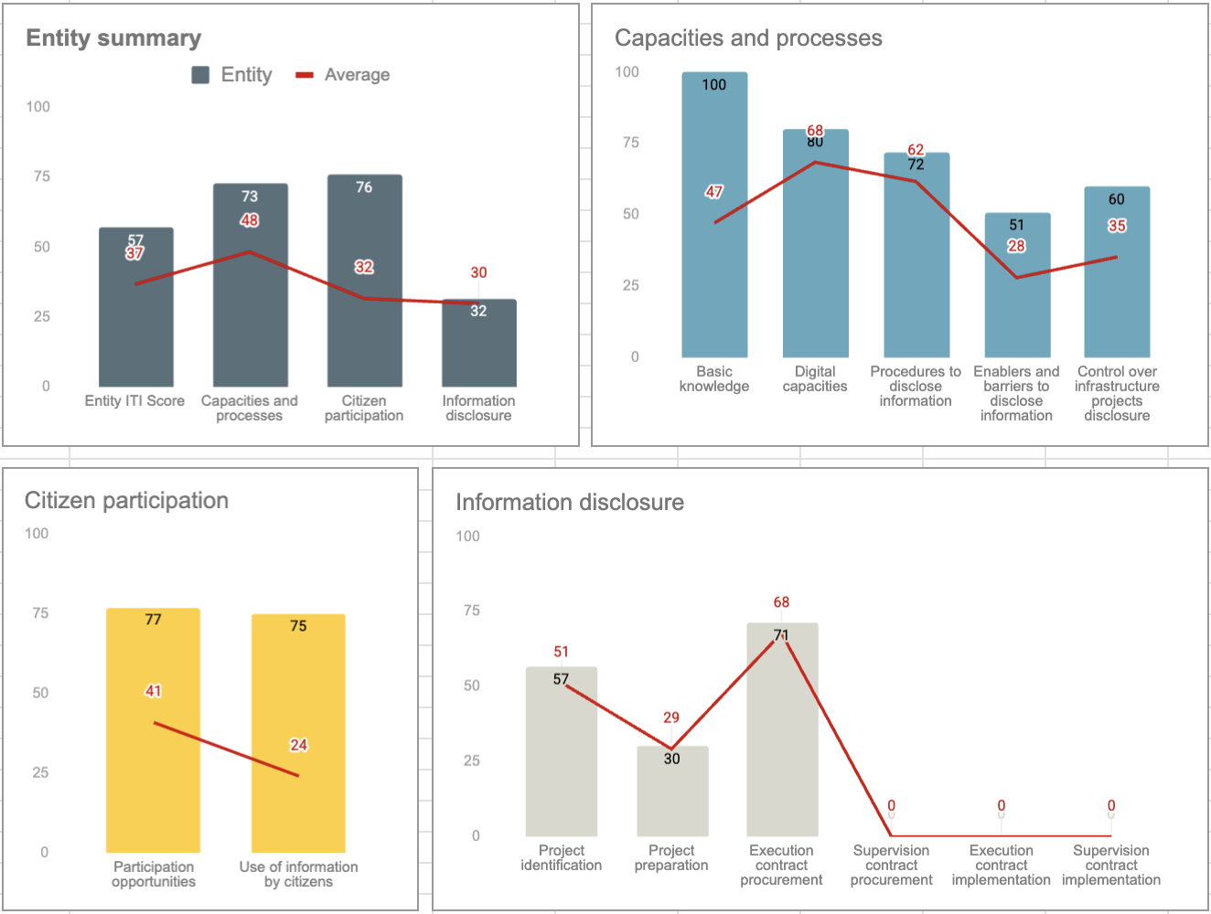

www.infrastructuretransparency.org
cost@infrastructuretransparency.org
Position 2: Rumah Sakit Mandalika
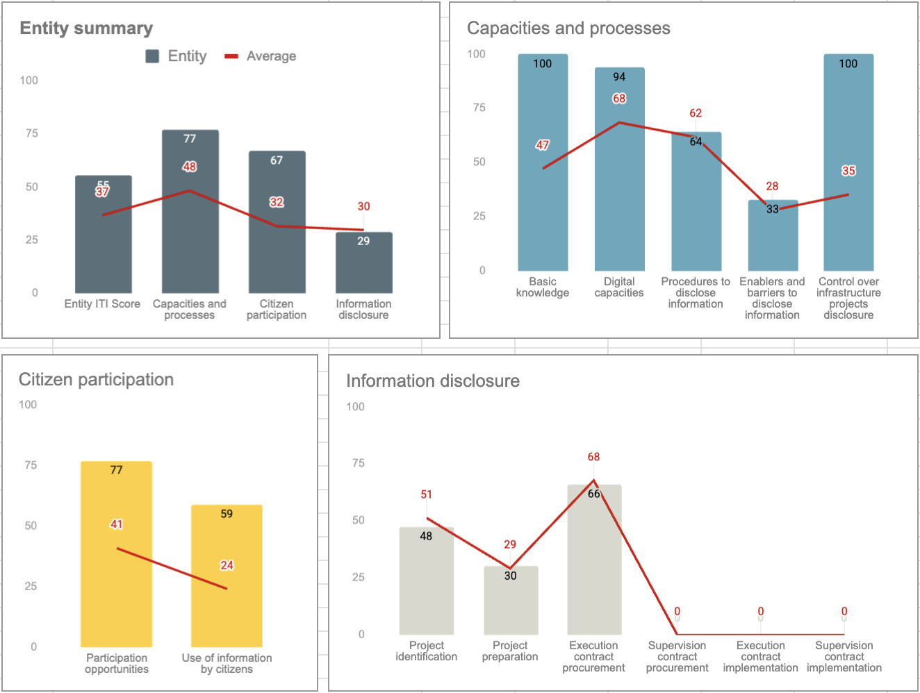

Position 3: Rumah Sakit Jiwa Mutiara Sukma Provinsi
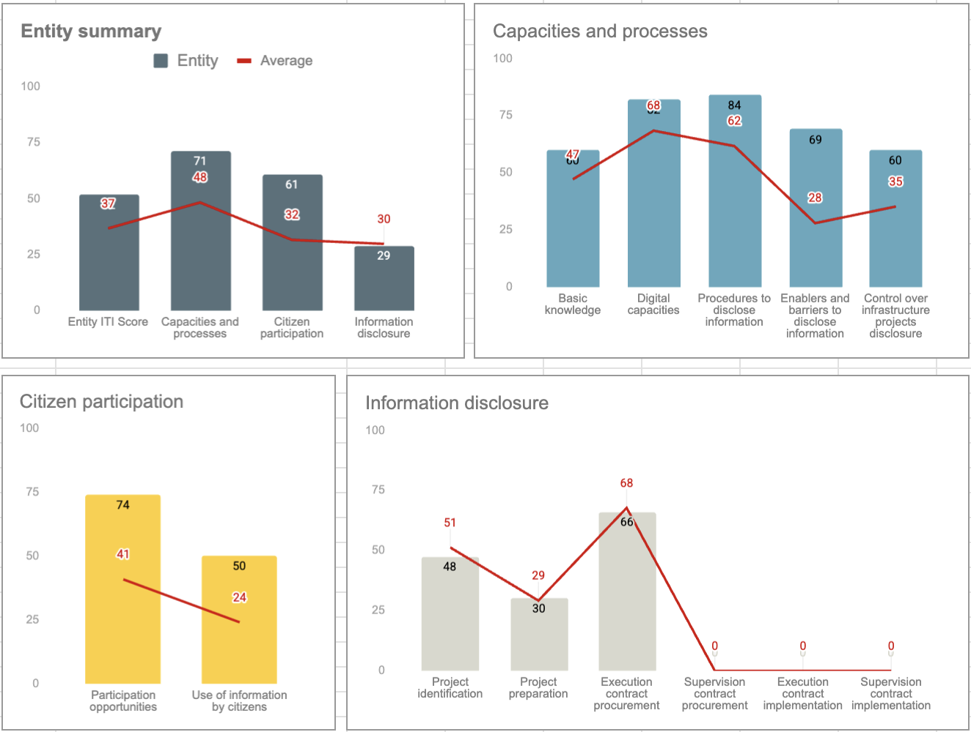
Position 4: Dinas Kelautan dan Perikanan
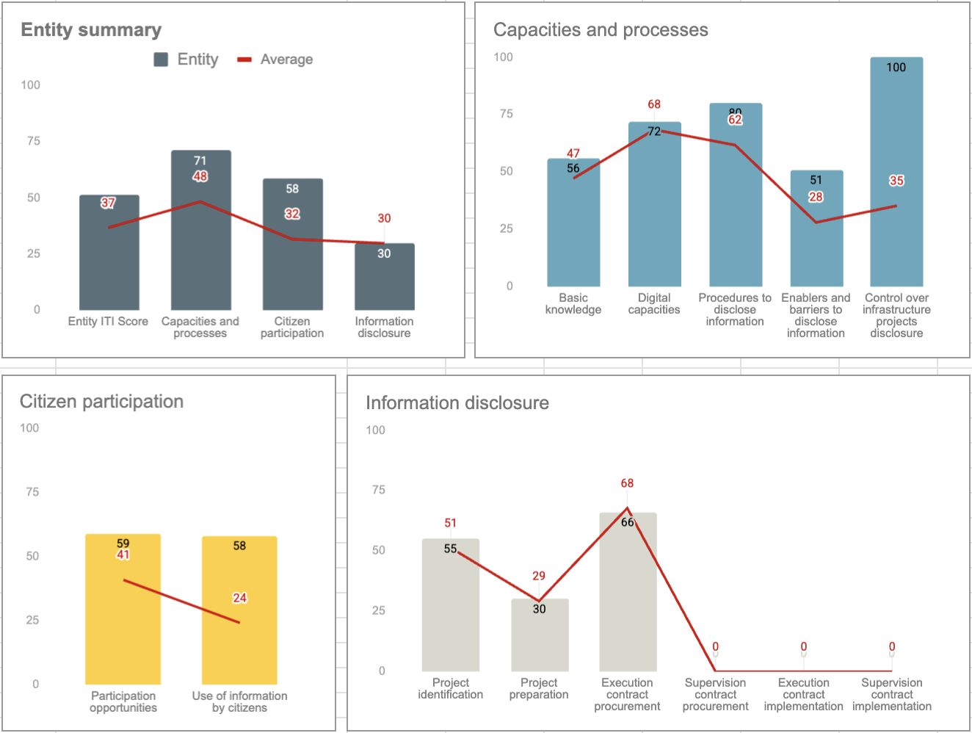
Position 5: Dinas Pekerjaan Umum dan Penataan Ruang (Bidang Sumber Daya Air)
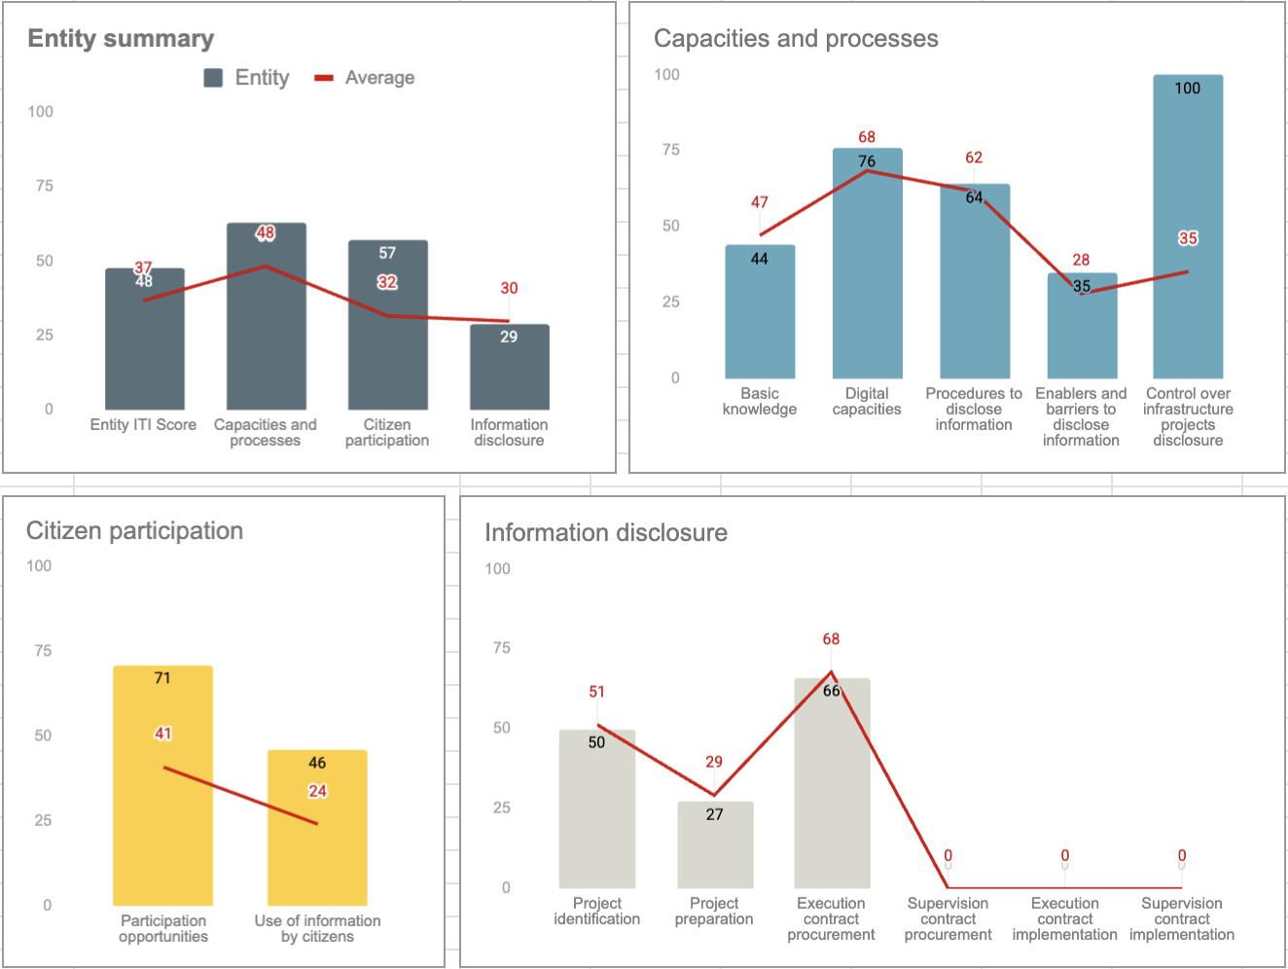
Position 6: Dinas Pertanian dan Perkebunan
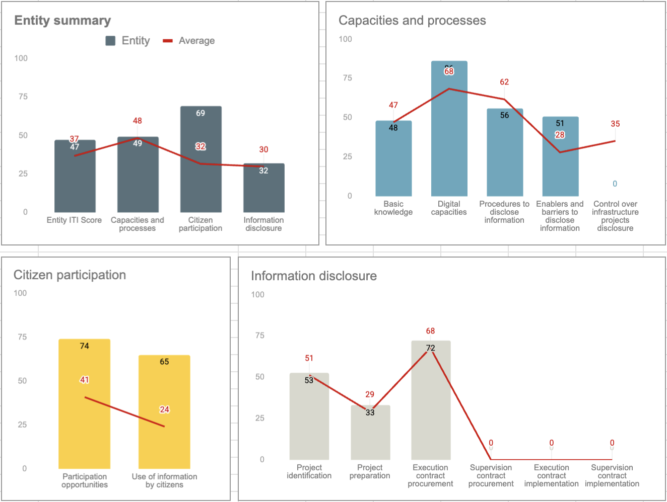

Position 7: Badan Pengelolaan Pendapatan Daerah
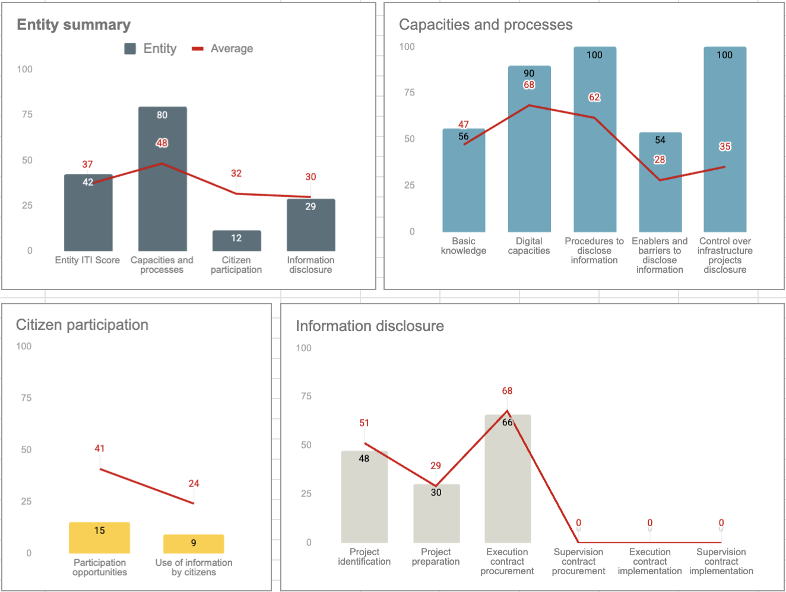

Position 8: Dinas Lingkungan Hidup dan Kehutanan
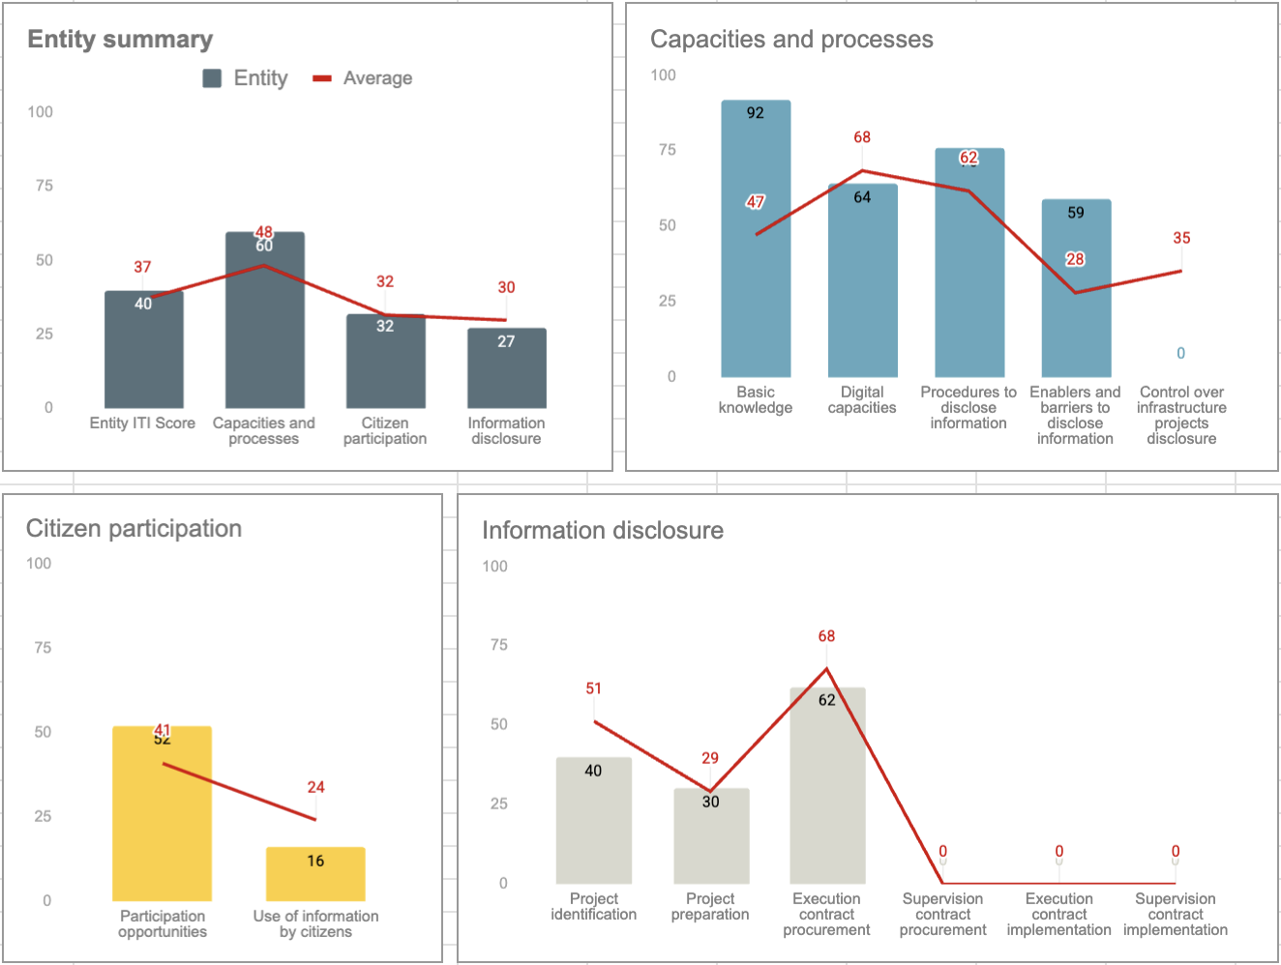

Position 9: Dinas Pendidikan dan Kebudayaan
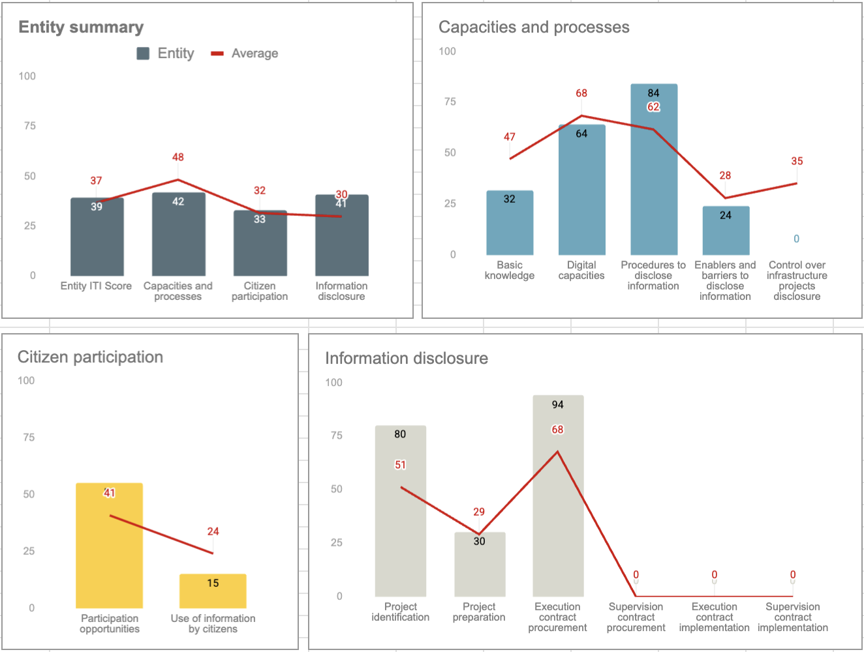

Position 10: Dinas Perindustrian
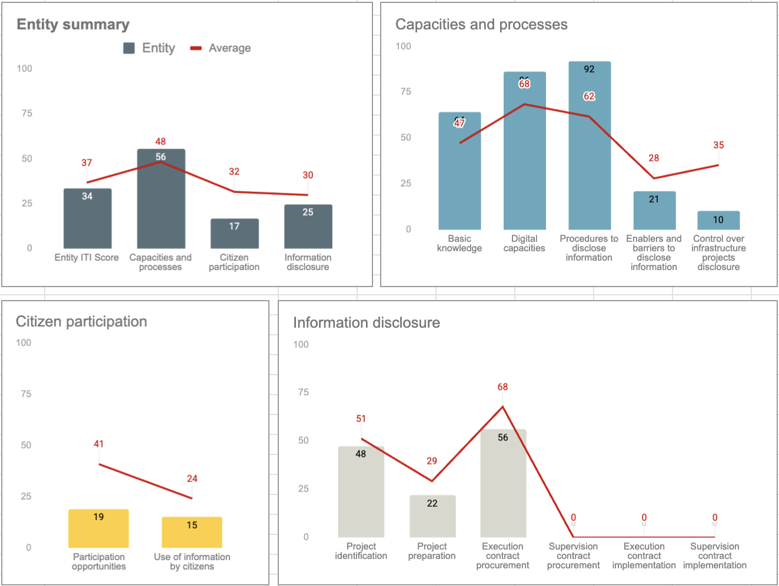

Position 11: Dinas Pemuda dan Olahraga
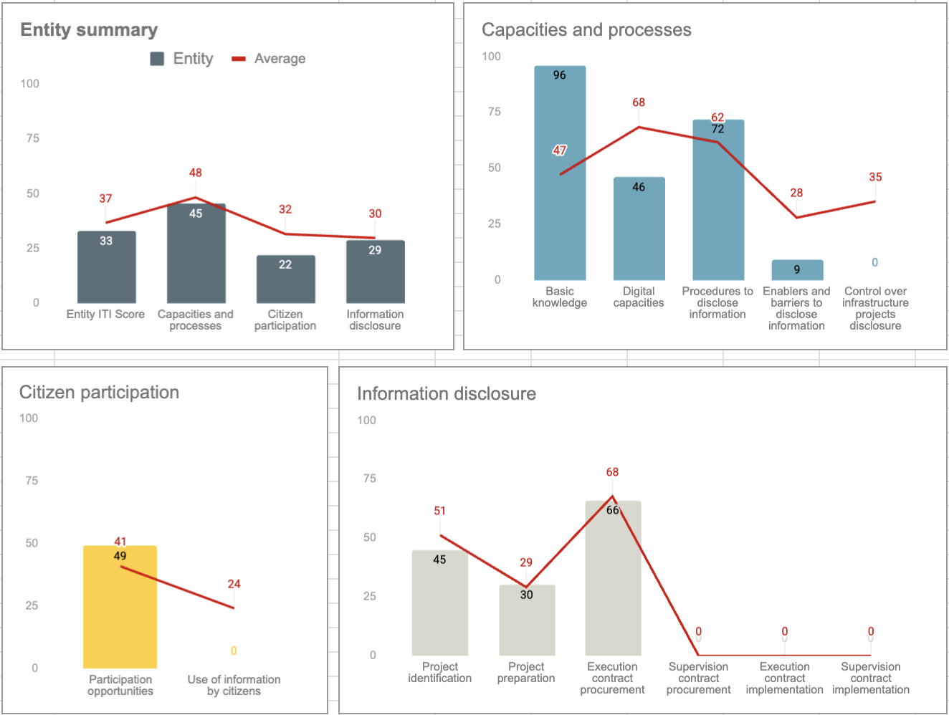

Position 12: Dinas Koperasi Usaha Kecil dan Menengah
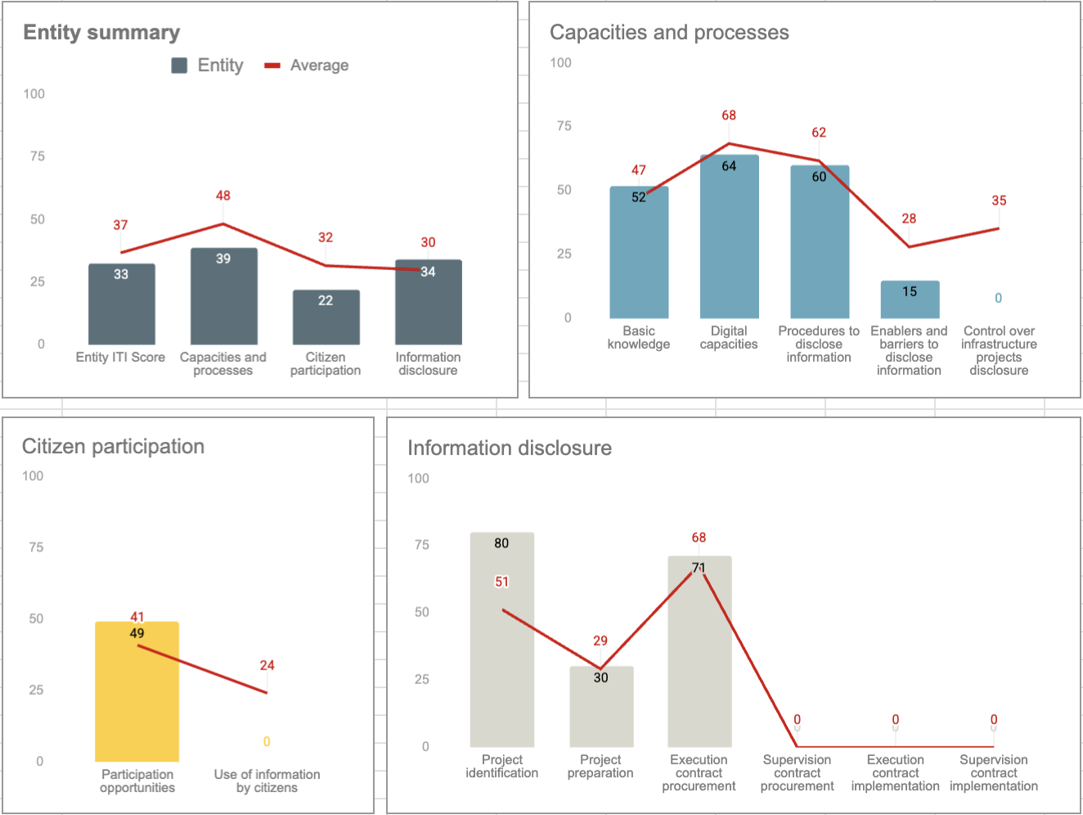

Position 13: Dinas Pariwisata
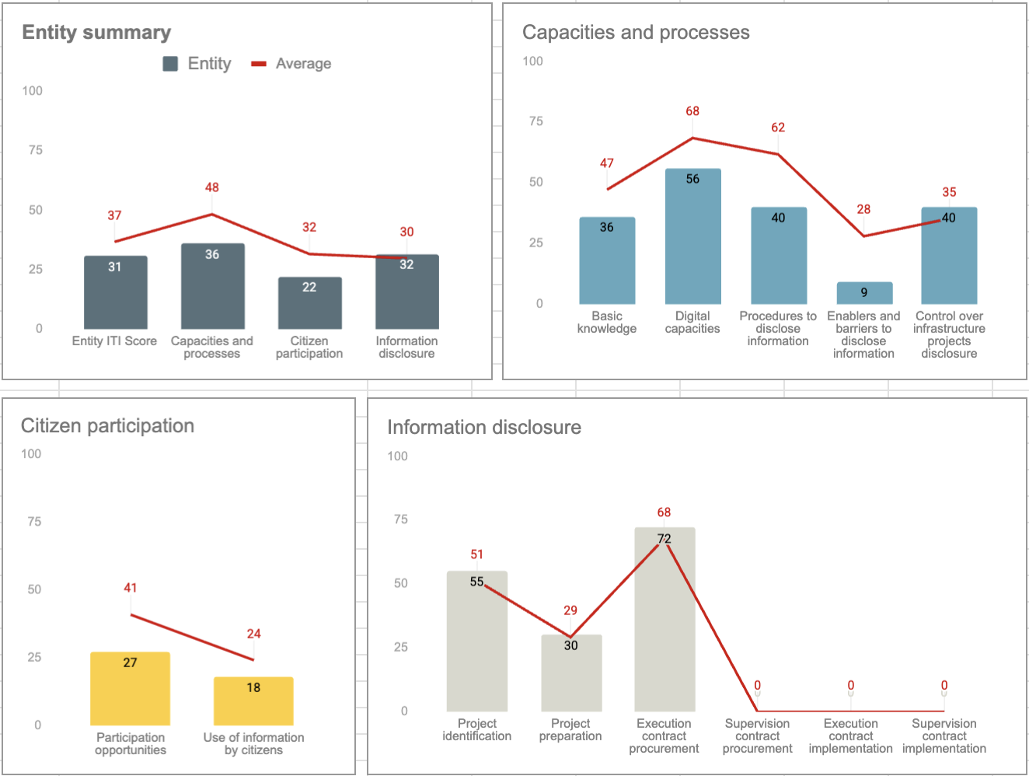

Position 14: Dinas Perumahan dan Permukiman
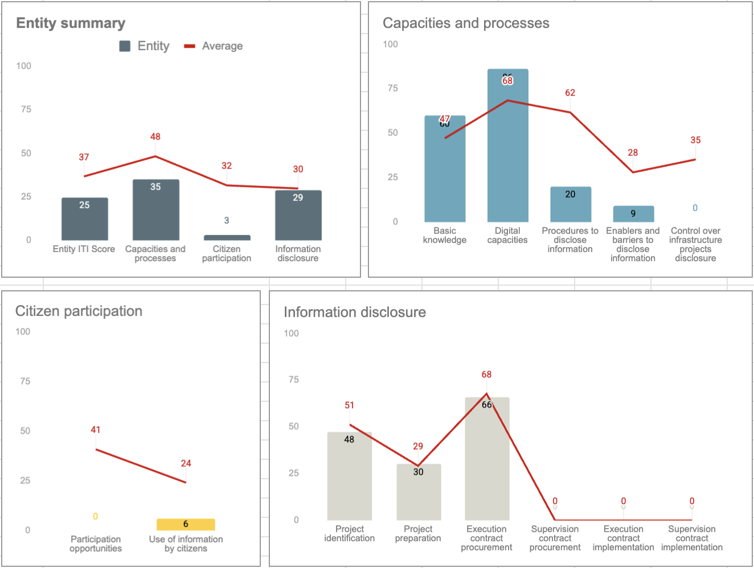

Position 15: Rumah Sakit H. L. Manambai Abdul Kadir
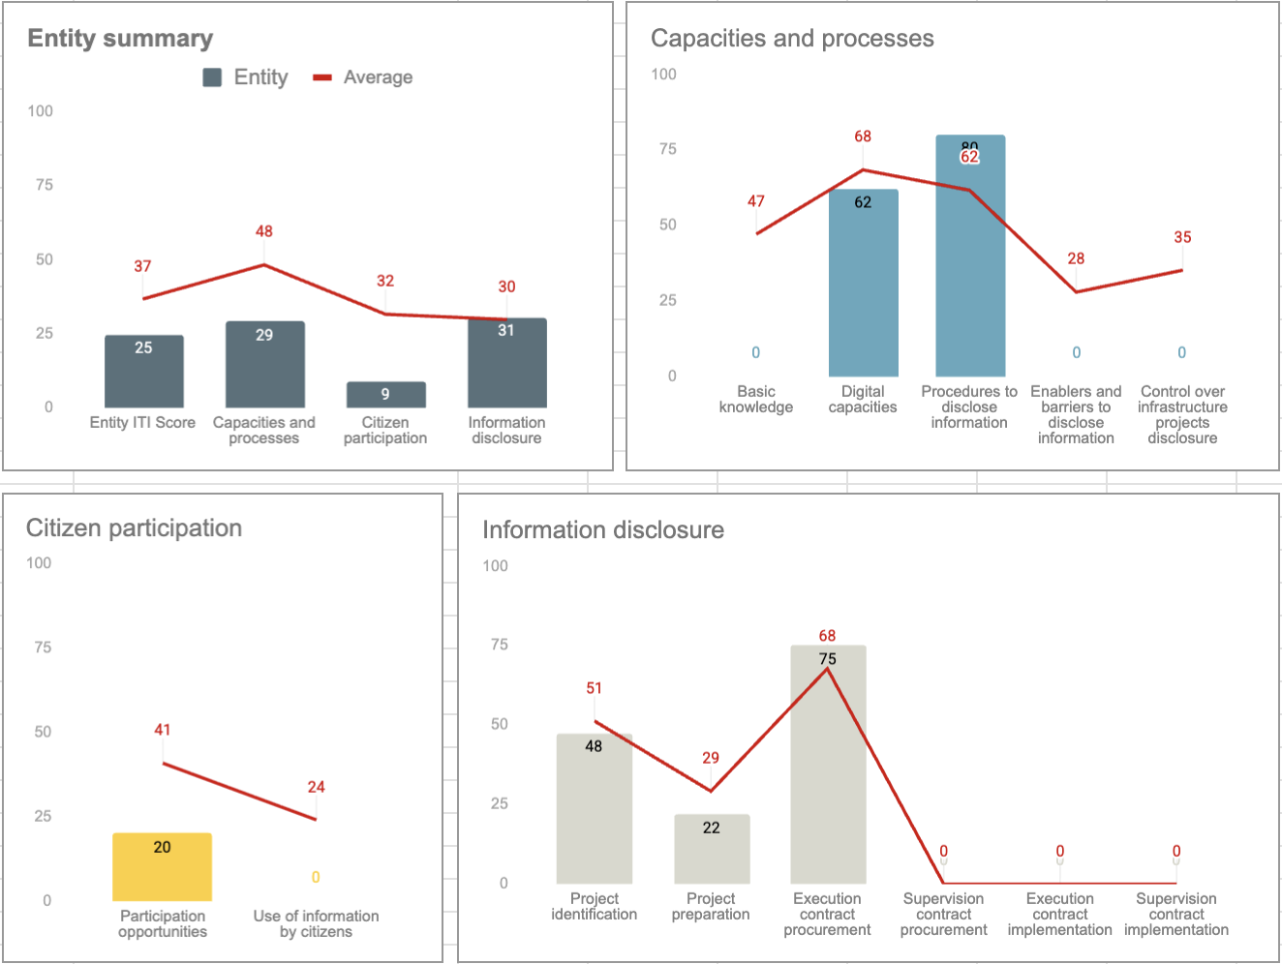

Position 16: Sekretariat Dewan Perwakilan Rakyat Daerah
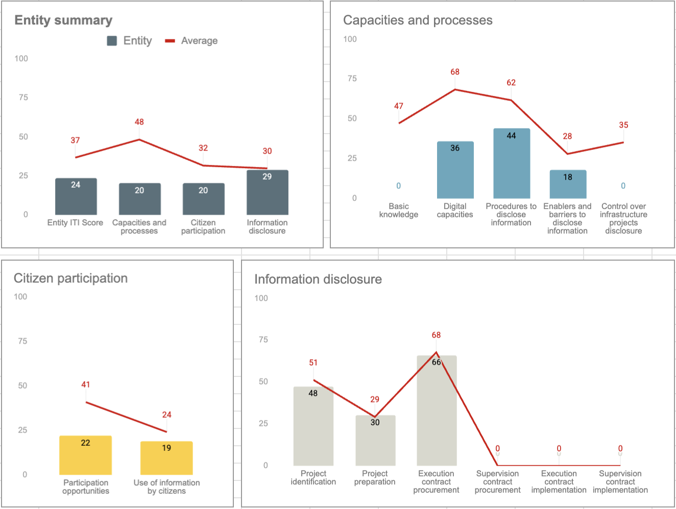

Position 17: RSUD NTB
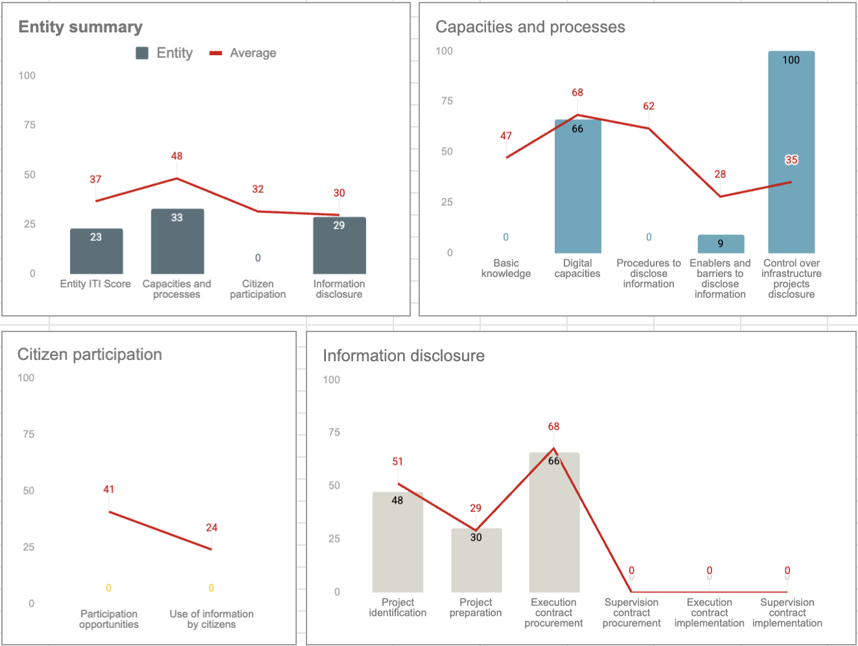

Position 18: Dinas Perpustakaan dan Kearsipan
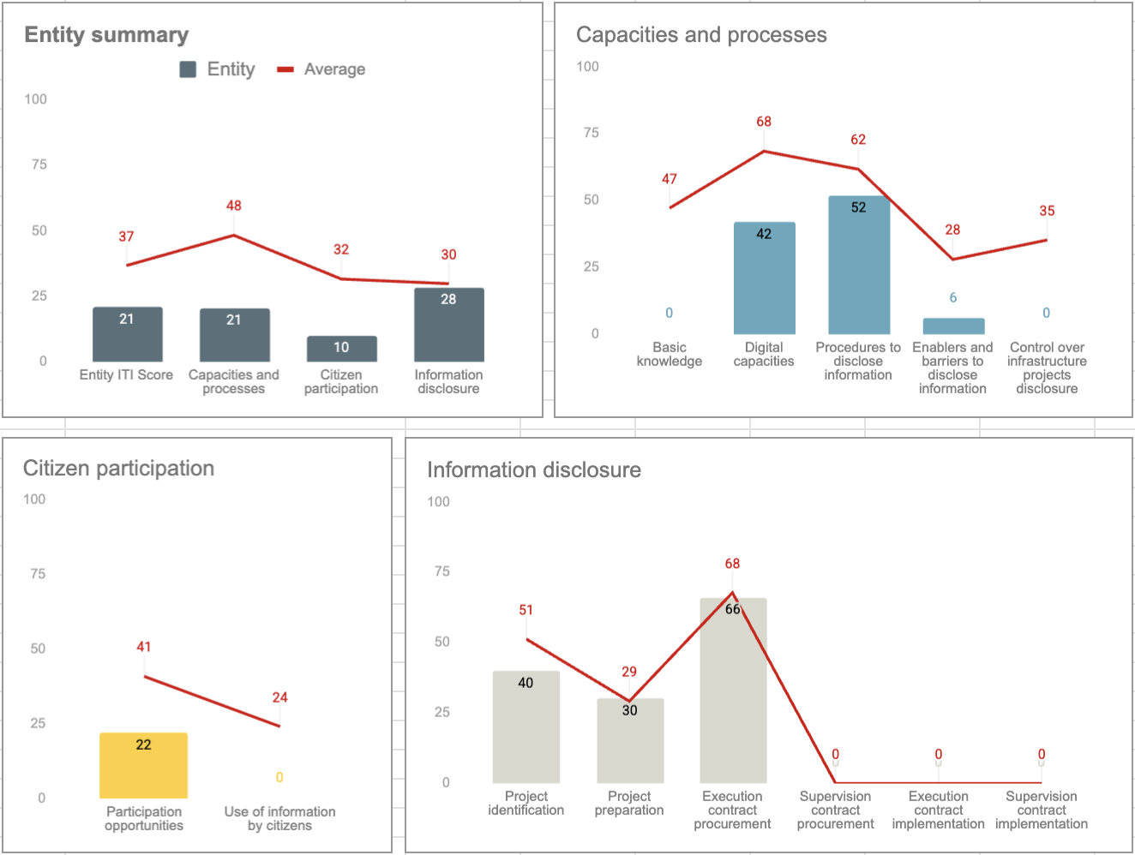

Position 19: Dinas Pekerjaan Umum dan Penataan Ruang (Bidang Cipta Karya)
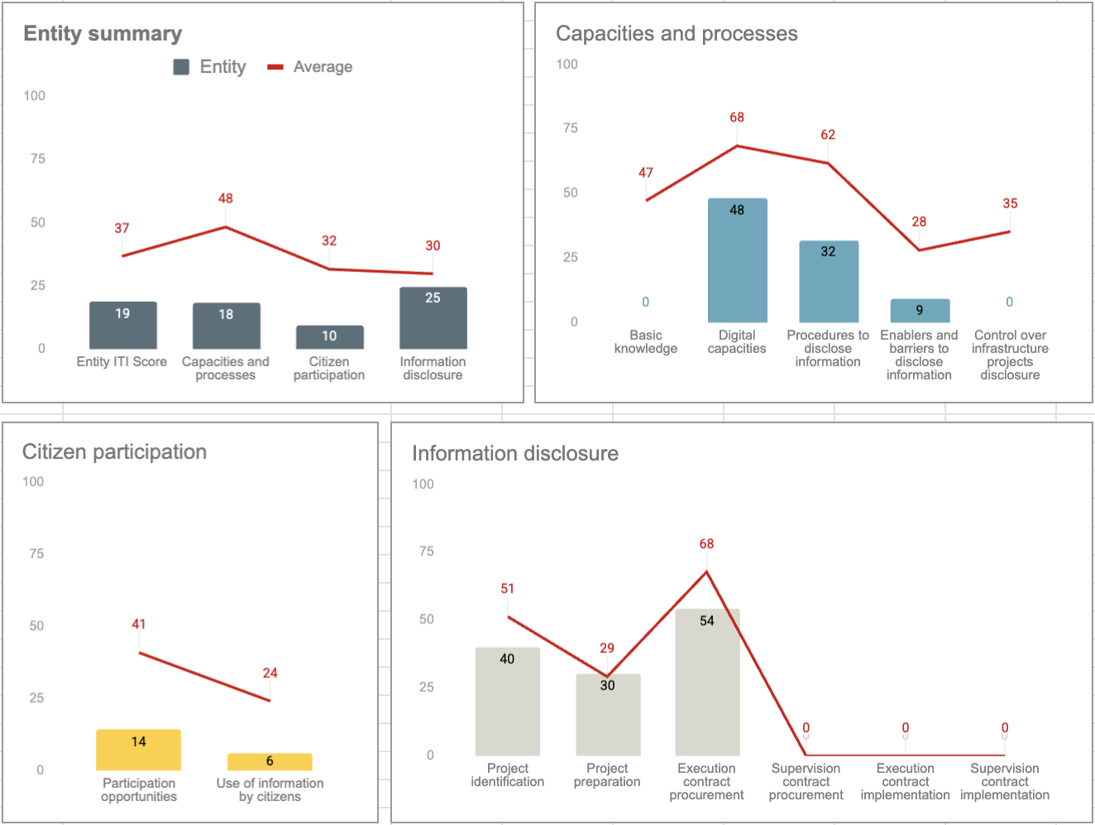

The fact that the ITI is designed to be applied at either a national or sub-national level will not be repeated at every mention.
When used within the context of the term “information disclosure”, “information” may include a combination of raw data points and (more meaningful) processed information.
The ITI survey can also be completed by a small group of officers if the PE believes the required information is under different departments or units.

